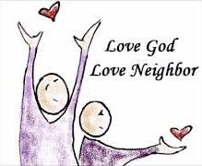

Jesus’ summary of the law in today’s gospel echoes our first reading from Leviticus. We are called not only to love God with heart, soul, and mind, but also to love our neighbor as ourselves. It is out of such deep care that Paul shares the gospel with the Thessalonian community. In the confession of sins, we acknowledge that we have not loved God, neighbor, or self; yet we gather to hear the word of forgiveness and to be strengthened by word and meal to be signs of God’s love and mercy in the world.

The 24th Sunday after Pentecost Proper 25 8 November 2026
Markham Lutheran Church, 3518 W. 160th St., Markham, Illinois 60428
E-mail: markhamlutheranchurch@gmail.com; Tel: 708-331-4885
Website: http://www.Markhamlutheranchurch.org/
Pastor Larry Schneekloth
Confession and Absolution

707 Oh, That the Lord Would Guide My Ways
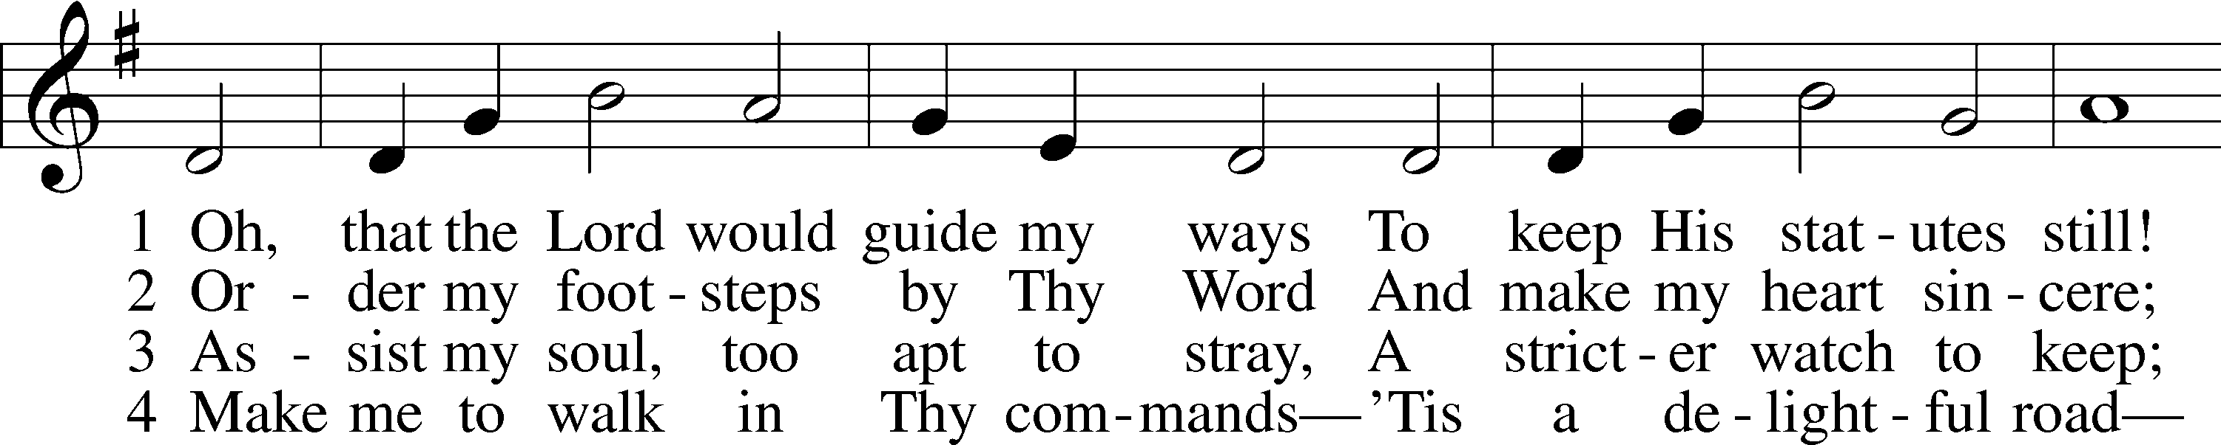
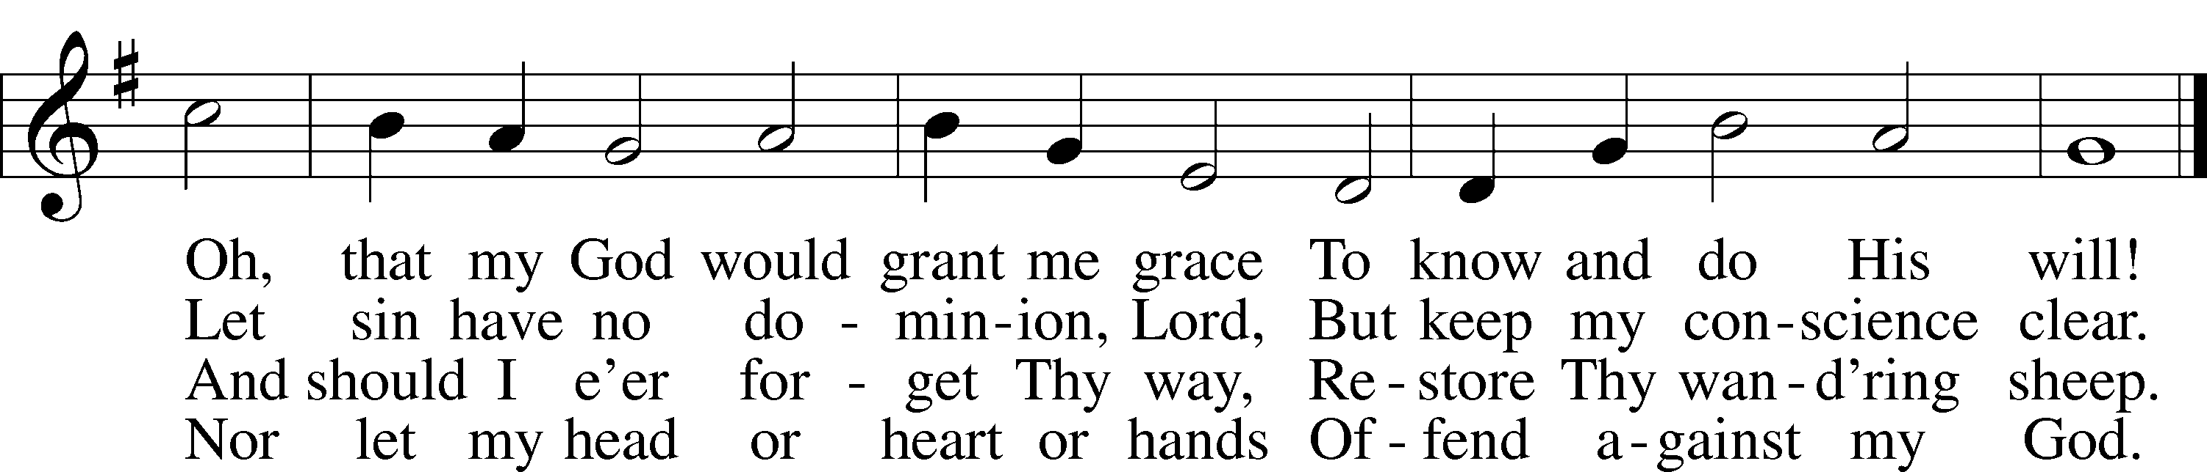

Text: Isaac Watts, 1674–1748, alt. Tune: William H. Havergal, 1793–1870 Text and tune: Public domain

P In the name of the Father and of the T Son and of the Holy Spirit.
C Amen.

P If we say we have no sin, we deceive ourselves, and the truth is not in us.
C But if we confess our sins, God, who is faithful and just, will forgive our sins and cleanse us from all unrighteousness.

Silence for reflection on God’s Word and for self-examination.

P Let us then confess our sins to God our Father.
C Most merciful God, we confess that we are by nature sinful and unclean. We have sinned against You in thought, word, and deed, by what we have done and by what we have left undone. We have not loved You with our whole heart; we have not loved our neighbors as ourselves. We justly deserve Your present and eternal punishment. For the sake of Your Son, Jesus Christ, have mercy on us. Forgive us, renew us, and lead us, so that we may delight in Your will and walk in Your ways to the glory of Your holy name. Amen.
P Almighty God in His mercy has given His Son to die for you and for His sake forgives you all your sins. As a called and ordained servant of Christ, and by His authority, I therefore declare the forgiveness of all your sins in the name of the Father and of the T Son and of the Holy Spirit.
C Amen.

Service of the Word

Kyrie LSB 168
P Lord, you are the strength of our hearts.
C Lord, have mercy.
P Lord, you are the refuge to which we turn.
C Christ, have mercy.
P Lord, you are the love the Father shows us.
C Lord, have mercy.

This Is the Feast LSB 171
A This is the feast of victory for our God. Alleluia.
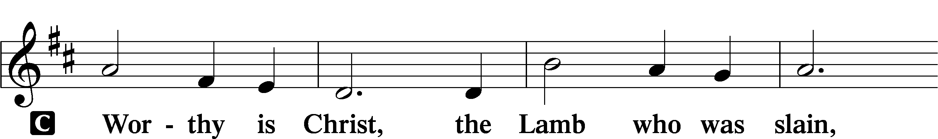
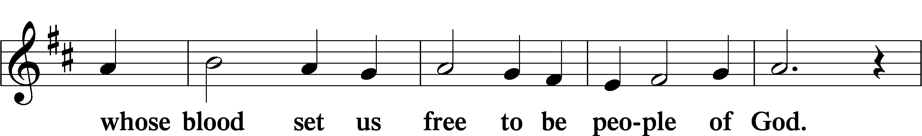
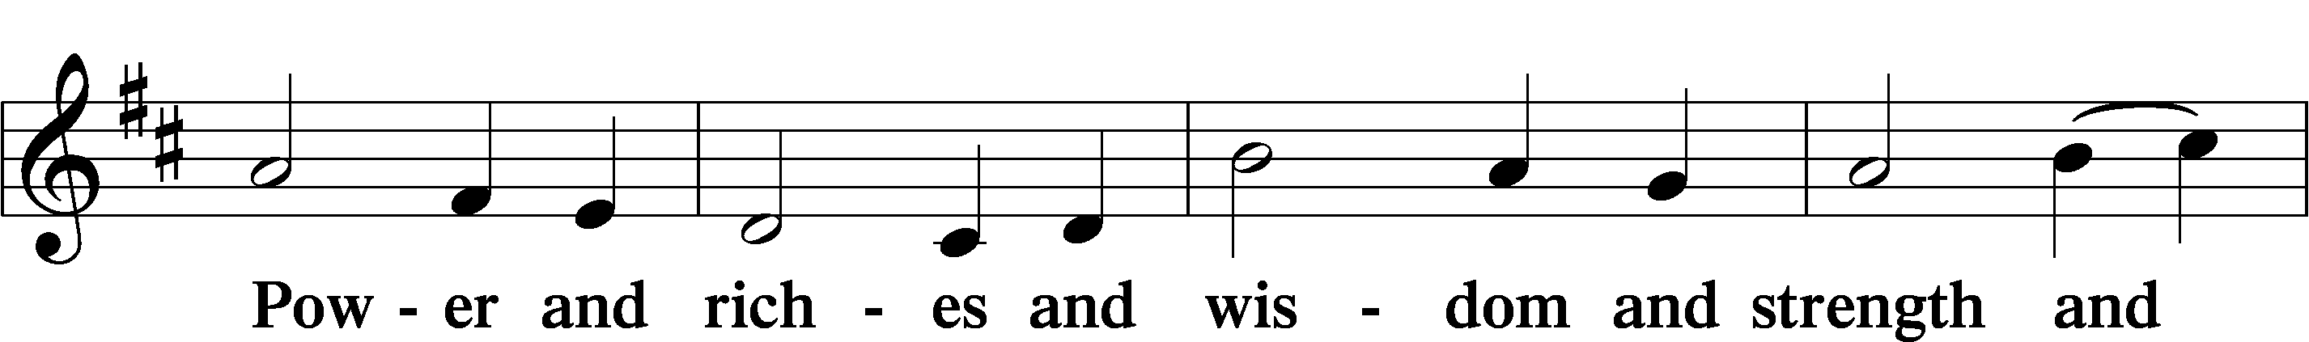
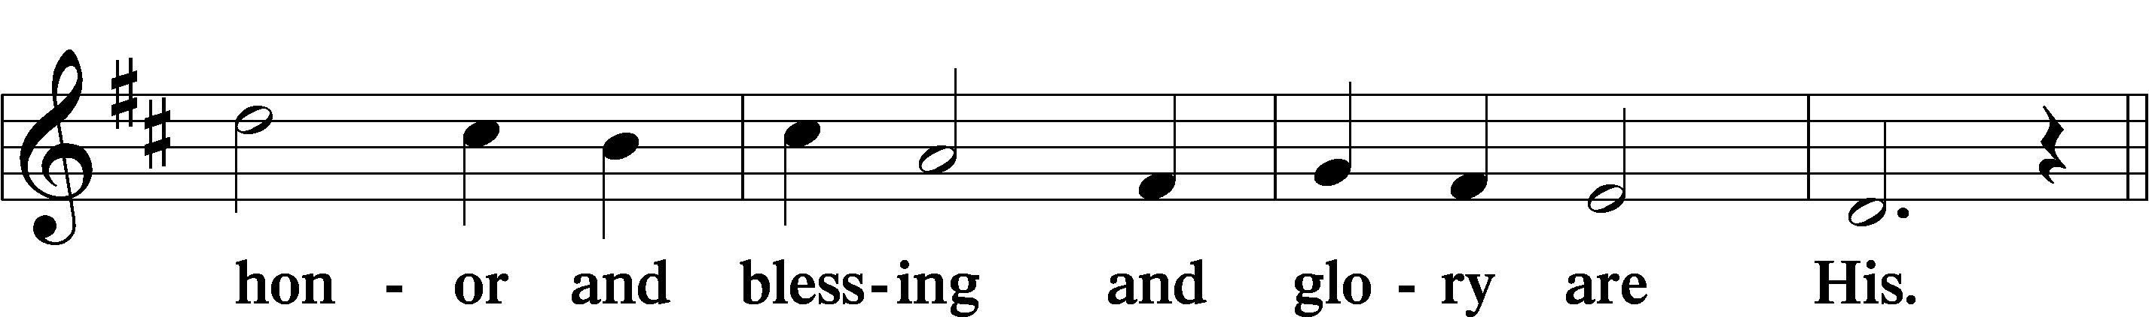
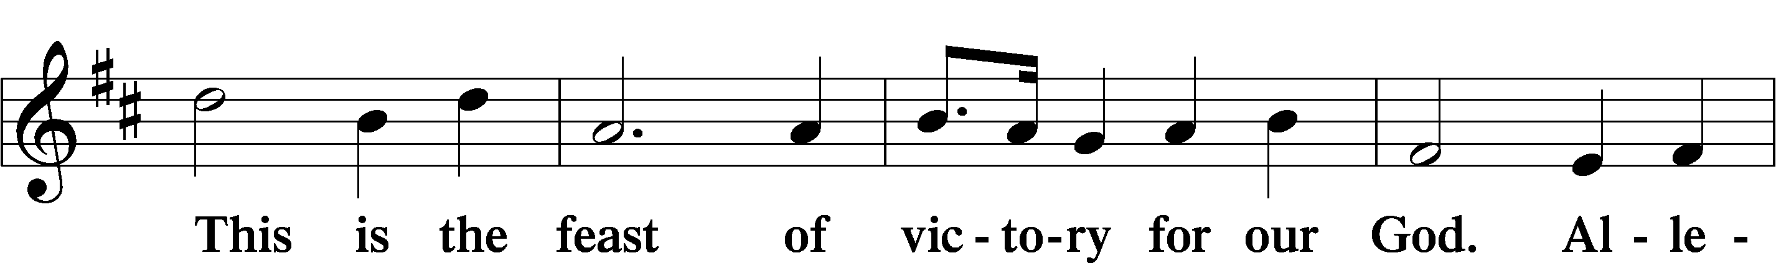
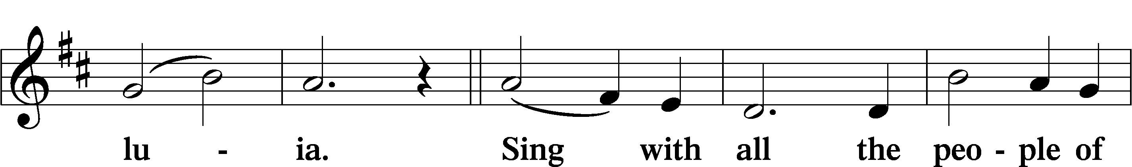
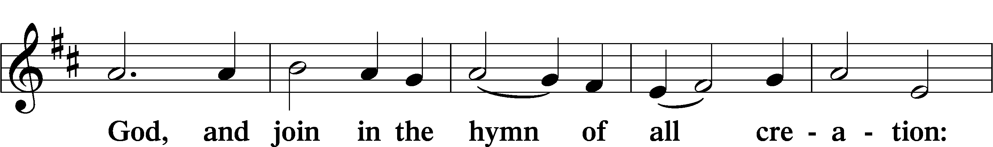
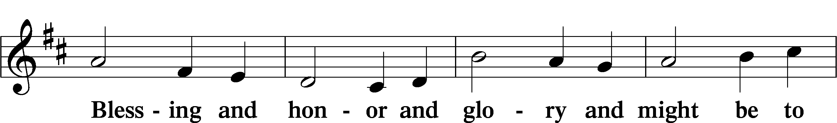
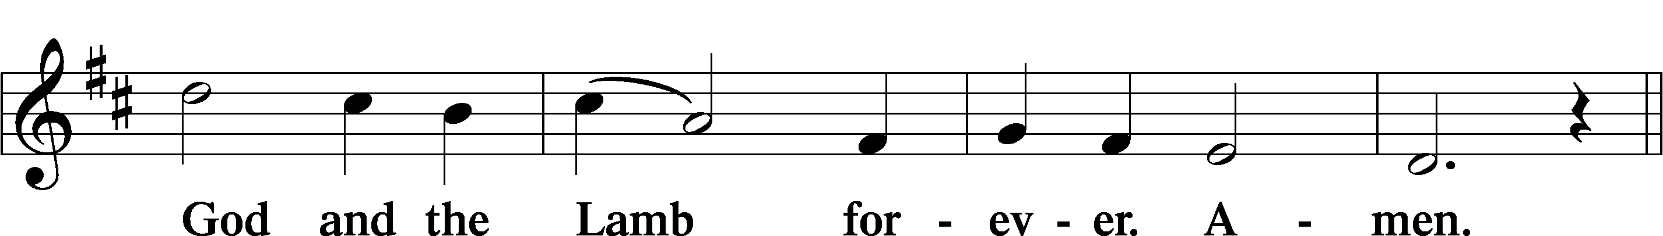
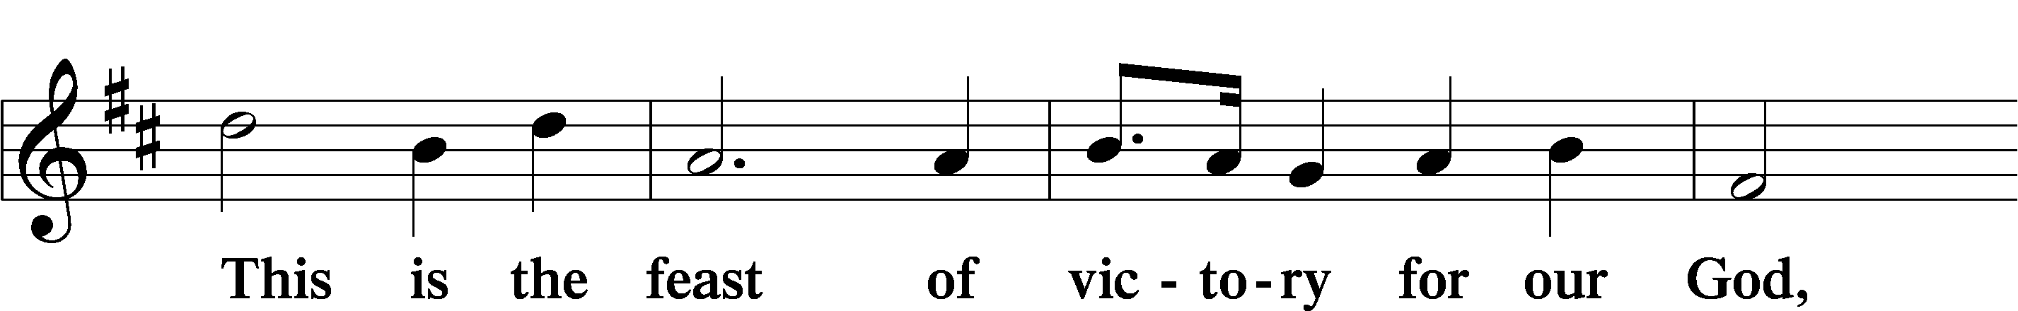
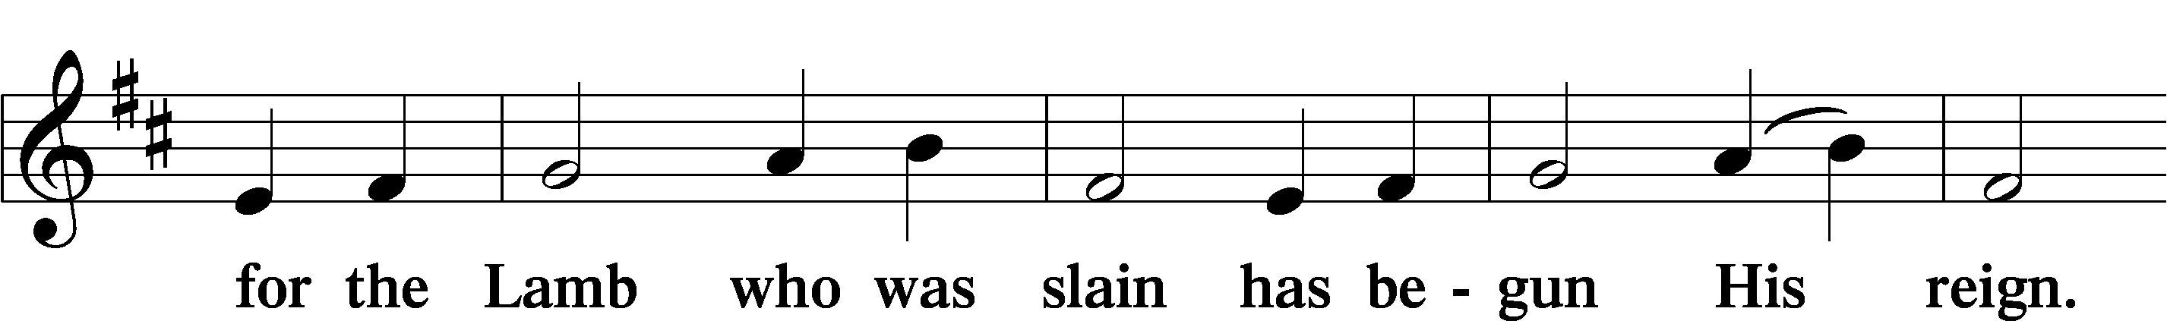
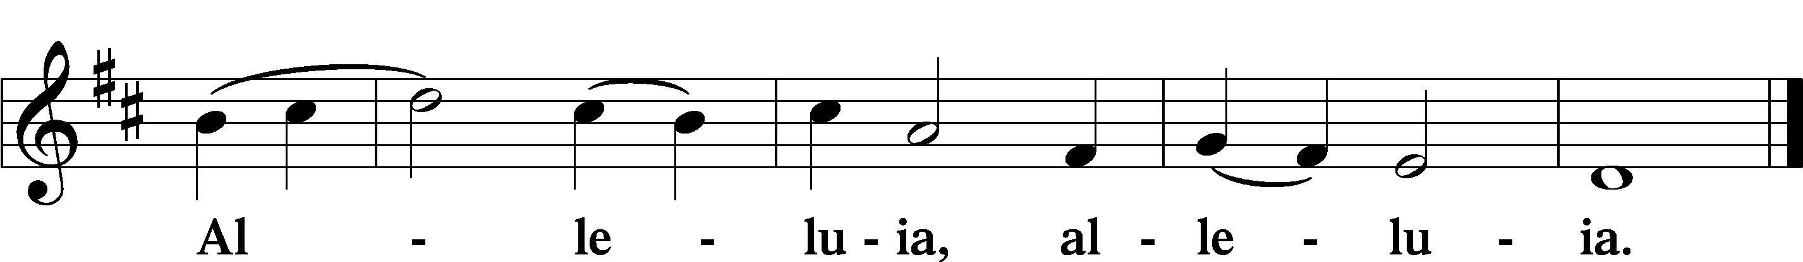

Collect of the Day

P Let us pray.
O God, You have commanded us to love You above all things and our neighbors as ourselves. Grant us the Spirit to think and do what is pleasing in Your sight, that our faith in You may never waver and our love for one another may not falter; through Jesus Christ, Your Son, our Lord, who lives and reigns with You and the Holy Spirit, one God, now and forever.

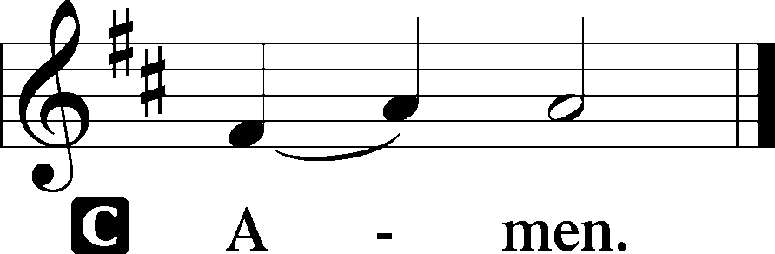

Sit

Old Testament Reading Leviticus 19:1–2, 15–18

The Holiness code in Leviticus urges people to be holy because God is holy. Holiness is lived out as God’s people exercise justice and love in their dealings with one another. We are to love our neighbors as ourselves.

The Lord spoke to Moses, saying: ² “Speak to all the congregation of the Israelites and say to them: You shall be holy, for I the Lord your God am holy… ¹⁵ “You shall not render an unjust judgment; you shall not be partial to the poor or defer to the great: with justice you shall judge your neighbor. ¹⁶ You shall not go around as a slanderer among your people, and you shall not stand idly by when the blood^{[a]} of your neighbor is at stake: I am the Lord. ¹⁷ “You shall not hate in your heart anyone of your kin; you shall reprove your neighbor, or you will incur guilt yourself. ¹⁸ You shall not take vengeance or bear a grudge against any of your people, but you shall love your neighbor as yourself: I am the Lord.
A This is the Word of the Lord.
C Thanks be to God.

Psalm Psalm 1
1Blessèd is the one who walks not in the counsel of the | wicked,*
nor stands in the way of sinners, nor sits in the seat of | scoffers;
2BUT THEIR DELIGHT IS IN THE LAW | OF THE LORD,*
AND ON HIS LAW THEY MEDITATE | DAY AND NIGHT.
3They are like a tree planted by streams of water that yields its fruit in its season,
and its leaf does not | wither.* In all that they do, they | prosper.
4THE WICKED | ARE NOT SO,* BUT ARE LIKE CHAFF THAT THE WIND | DRIVES AWAY.
5Therefore the wicked will not stand in the | judgment,* nor sinners in the congregation of the | righteous;
6FOR THE LORD KNOWS THE WAY OF THE | RIGHTEOUS,*
BUT THE WAY OF THE WICKED WILL | PERISH.

Epistle 1 Thessalonians 2:1–8

Paul uses intimate maternal imagery to depict the caring and nurturing relationship he shares with the Thessalonians. When he first came to their city it was not to benefit himself but share the gospel with them, which was his responsibility as an apostle of Christ.

You yourselves know, brothers and sisters, that our coming to you was not in vain, ² but though we had already suffered and been shamefully mistreated at Philippi, as you know, we had courage in our God to declare to you the gospel of God in spite of great opposition. ³ For our appeal does not spring from deceit or impure motives or trickery, ⁴ but, just as we have been approved by God to be entrusted with the message of the gospel, even so we speak, not to please mortals but to please God, who tests our hearts. ⁵ As you know and as God is our witness, we never came with words of flattery or with a pretext for
greed, ⁶ nor did we seek praise from mortals, whether from you or from others, ⁷ though we might have made demands as apostles of Christ. But we were gentle among you, like a nurse tenderly caring for her own children. ⁸ So deeply do we care for you that we are determined to share with you not only the gospel of God but also our own selves, because you have become very dear to us.
A This is the Word of the Lord.
C Thanks be to God.

Alleluia and Verse LSB 173
C ALLELUIA. LORD, TO WHOM SHALL WE GO?
YOU HAVE THE WORDS OF ETERNAL LIFE. ALLELUIA.

Holy Gospel Matthew 22:34–46
P The Holy Gospel according to St. Matthew.
C Glory to You, O Lord.

When the Pharisees heard that he had silenced the Sadducees, they gathered together, ³⁵ and one of them, an expert in the law, asked him a question to test him. ³⁶ “Teacher, which commandment in the law is the greatest?” ³⁷ He said to him, “ ‘You shall love the Lord your God with all your heart and with all your soul and with all your mind.’ ³⁸ This is the greatest and first commandment. ³⁹ And a second is like it: ‘You shall love your neighbor as yourself.’ ⁴⁰ On these two commandments hang all the Law and the Prophets.” ⁴¹ Now while the Pharisees were gathered together, Jesus asked them this question: ⁴² “What do you think of the Messiah? Whose son is he?” They said to him, “The son of David.” ⁴³ He said to them, “How is it then that David by the Spirit calls him Lord, saying, ⁴⁴ ‘The Lord said to my Lord, “Sit at my right hand, until I put your enemies under your feet” ⁴⁵ “If David thus calls him Lord, how can he be his son?” ⁴⁶ No one was able to give him an answer, nor from that day did anyone dare to ask him any more questions.
P This is the Gospel of the Lord.
C Praise to You, Lord Jesus Christ.
Sermon

Nicene Creed

We believe in one God, the Father, the Almighty, maker of heaven and earth, of all that is, seen and unseen.

We believe in one Lord, Jesus Christ, the only Son of God, eternally begotten of the Father, God from God, Light from Light, true God from true God, begotten, not made, of one Being with the Father; through him all things were made. For us and for our salvation he came down from heaven, was incarnate of the Holy Spirit and the Virgin Mary and became truly human. For our sake he was crucified under Pontius Pilate; he suffered death and was buried. On the third day he rose again in accordance with the Scriptures; he ascended into heaven and is seated at the right hand of the Father. He will come again in glory to judge the living and the dead, and his kingdom will have no end.

We believe in the Holy Spirit, the Lord, the giver of life, who proceeds from the Father and the Son, who with the Father and the Son is worshiped and glorified, who has spoken through the prophets. We believe in one holy catholic and apostolic Church. We acknowledge one baptism for the forgiveness of sins. We look for the resurrection of the dead, and the T life of the world to come. Amen.

The Prayer of the Church
...Lord, in your mercy,
HEAR OUR PRAYER.

(Last petition:) Into your hands we commend ourselves, and all for whom we pray, trusting in your mercy, through Jesus Christ our Lord.
AMEN.

The Peace of the Lord
The peace of the Lord be with you always.
AND ALSO WITH YOU.
(Share the peace of the Lord)
844 Lord of All Nations, Grant Me Grace

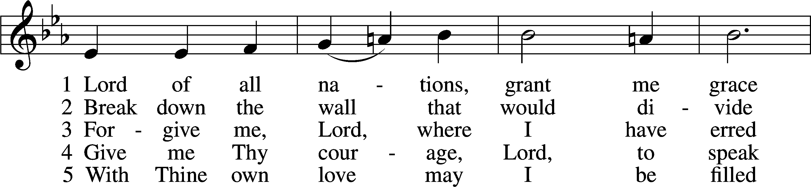
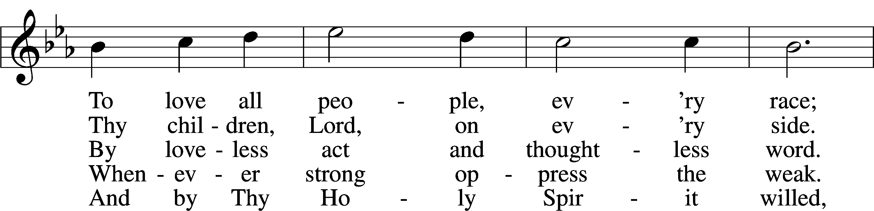
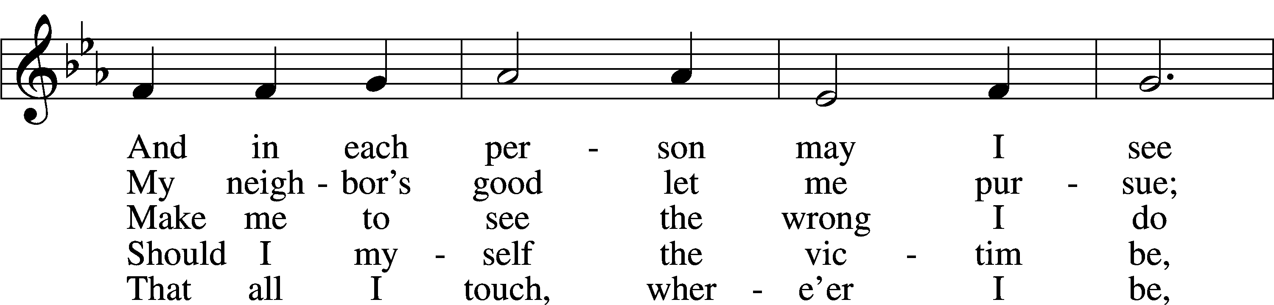
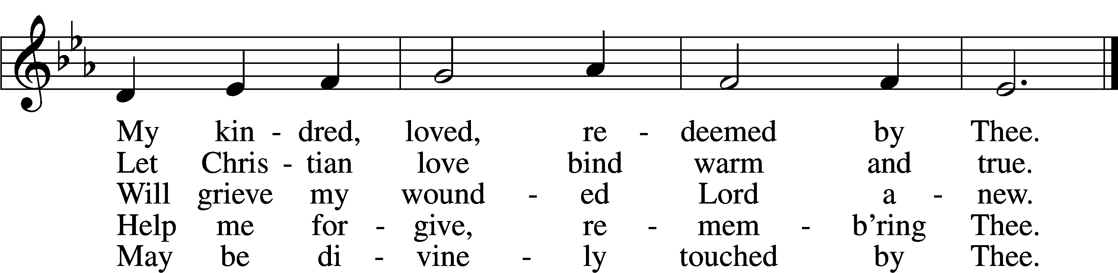

Text: Olive Wise Spannaus, 1916–2018, alt.
Tune: Georg Joseph, 17th cent., adapt.
Text: © 1969 Concordia Publishing House. Used by permission: LSB Hymn License no. 110001341
Tune: Public domain

Service of the Sacrament
The Lord be with you.
AND ALSO WITH YOU.
Lift up your hearts.
WE LIFT THEM TO THE LORD.
Let us give thanks to the Lord our God.
IT IS RIGHT TO GIVE GOD THANKS AND PRAISE.

It is indeed right and salutary that we should at all times and in all places offer thanks and praise to you, O Lord, holy Father, through Christ our Lord; who on this first day of the week overcame death and the grave, and by his glorious resurrection opened to us the way of everlasting life. And so, with the church on earth and the hosts of heaven, we praise your name, and join their unending hymn:

Sanctus LSB 178
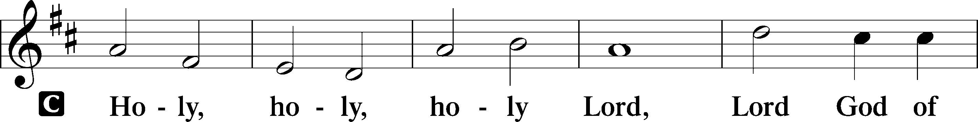
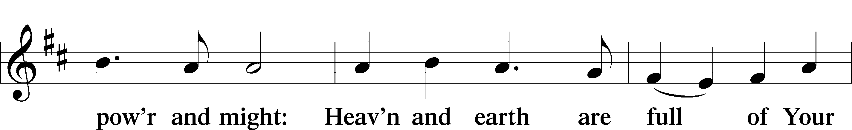
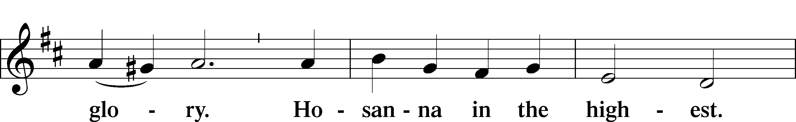
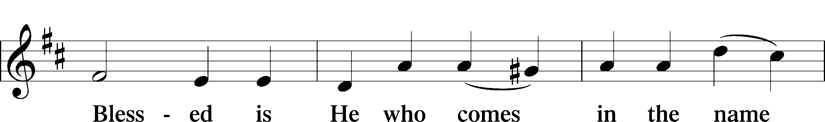
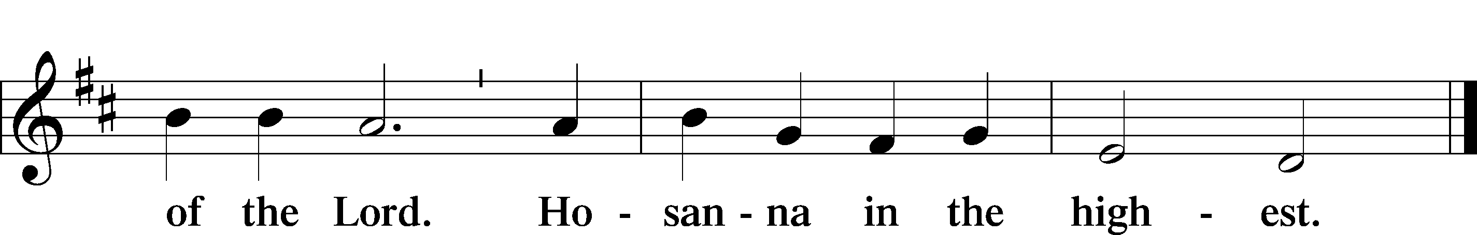

Our Lord Jesus Christ….
As often as we eat this bread, and drink from his cup, we proclaim the Lord’s death until he comes.
CHRIST HAS DIED. CHRIST IS RISEN. CHRIST WILL COME AGAIN.

Join our prayers with those of your servants of every time and place, and unite them with the ceaseless petitions of Jesus Christ, our great High Priest, until he comes as victorious Lord of all.
THROUGH HIM, WITH HIM, IN HIM, IN THE UNITY OF THE HOLY SPIRIT, ALL HONOR AND GLORY IS YOURS, ALMIGHTY FATHER, NOW AND FOREVER. AMEN.

Remember us in your kingdom and teach us to pray: OUR FATHER....

THE HOLY COMMUNION

The Thanksgiving and Dismissal
O give thanks to the Lord, for he is good.
AND HIS MERCY ENDURES FOREVER.

We give you thanks, O Father, for the food with which you have fed us this day: Your holy word, the remembrance of our Baptism, and the Bread and Wine of the Holy Communion. We ask that you continue to strengthen us in our faith in you, and in our fervent love for one another; through Jesus Christ our Lord.
AMEN.

Almighty God bless you, the Father, the T Son, and the Holy Spirit.
AMEN.
Where Charity and Love Prevail

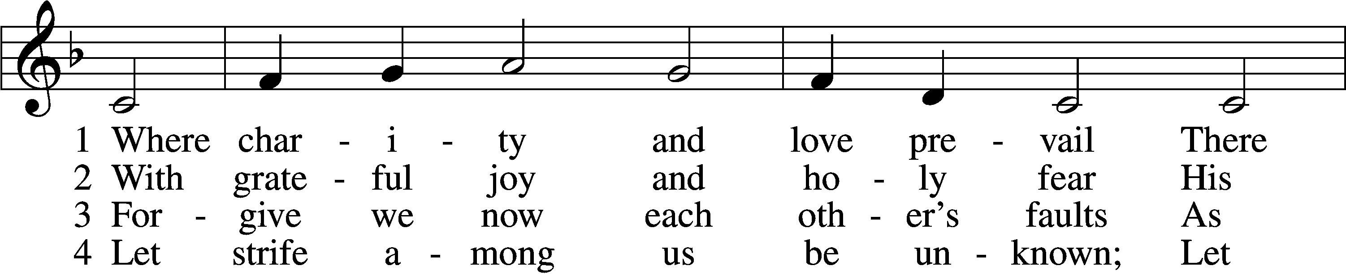
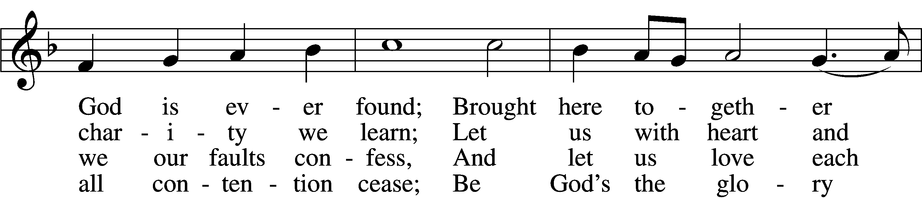
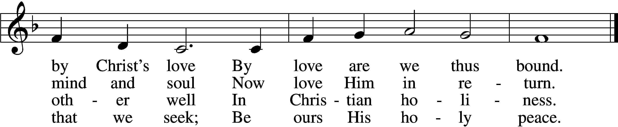

5 Let us recall that in our midst Dwells Christ, His only Son;
As members of His body joined We are in Him made one.

6 For love excludes no race or clan That names the Savior’s name;
His family embraces all Whose Father is the same.

Text: Latin, c. 9th cent.; tr. Omer E. Westendorf, 1916–97, alt. Tune: Lucius Chapin, 1760–1842
Text: © 1960 World Library Publications. Used by permission: LSB Hymn License no. 110001341
Tune: Public domain

Happy birthday this week to Presita Lee ll/14

THIS WEEK IN THE CHURCH CALENDAR
11/11 Martin, Bishop of Tours, 397

Acknowledgments
Divine Service, Setting Two from Lutheran Service Book
Created by Lutheran Service Builder © 2026 Concordia Publishing House.

THIS WEEK IN THE CHURCH CALENDAR
11/11 Martin, Bishop of Tours, 397
Martin of Tours was born in 316 of a pagan family in the Roman province in what is now Hungary. He grew up in Lombardy and at the age of 10 decided to become a catechumen. He served as a soldier in the Roman army but found it increasingly difficult to reconcile Christianity with the military life. Leaving the army (not without accusations of cowardice), he became a hermit. In 360 he went to Hilary, Bishop of Poitiers, and lived in a sort of monastic community. He was consecrated Bishop of Tours in 371, and chose to live not in the episcopal palace but in a cave, with his office in a nearby hut. He traveled widely, evangelizing rural Gaul and founding monasteries. He died at a distant outpost of his diocese, and was buried November 11, 397. Martin Luther was baptized on St. Martin's day and given the name of this saint. St. Martin was one of the first people who was not a martyr to be publicly honored as a saint, and his influence was felt from Ireland to Africa and Asia.

