# Jesus appeared to the disciples a third time by the sea. They were fishing without success. When he told them to cast their nets on the other side, their luck changed; they knew that the Lord was with them! Peter jumped into the water to get to the Lord first, but all heard him say, “Come and have breakfast.” That was the last meal they shared with the Lord before his ascension. In his meal of bread and wine, he meets and blesses us here today.

The 3rd Sunday of Easter 4 May 2025

Markham Lutheran Church, 3518 W. 160th St., Markham, Illinois 60428

E-mail: [markhamlutheranchurch@gmail.com](mailto:markhamlutheranchurch@gmail.com) 708-331-4885

Website: http://www.Markhamlutheranchurch.org/

Pastor Larry Schneekloth

481 Scatter the Darkness, Break the Gloom

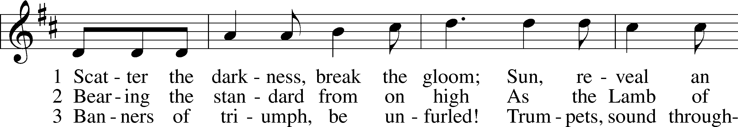

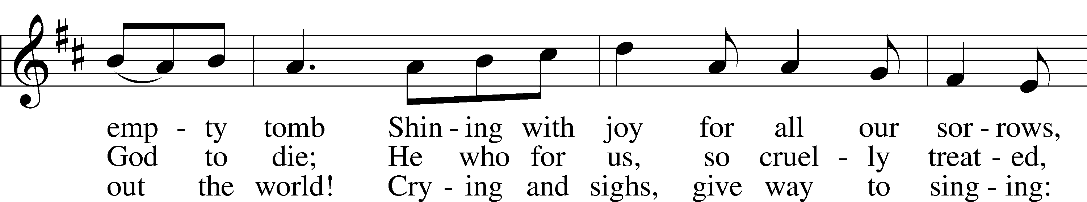

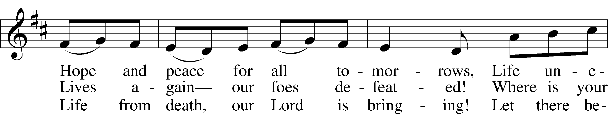

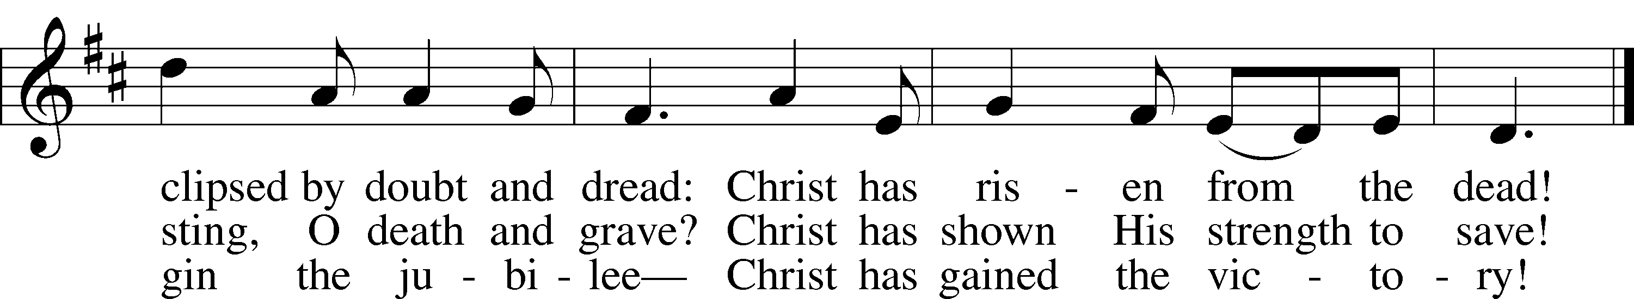

Text: Stephen P. Starke, 1955  
Tune: French  
Text: © 1995 Stephen P. Starke, admin. Concordia Publishing House. Used by permission: LSB Hymn License no. 110001341  
Tune: Public domain

The sign of the cross may be made by all in remembrance of their Baptism.

P In the name of the Father and of the T Son and of the Holy Spirit.

C **Amen.**

# Service of the Word

Kyrie LSB 168

A In peace let us pray to the Lord.

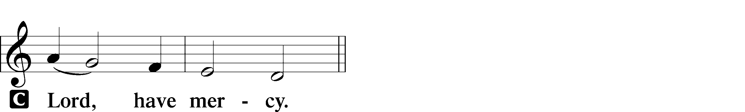

A For the peace from above and for our salvation let us pray to the Lord.

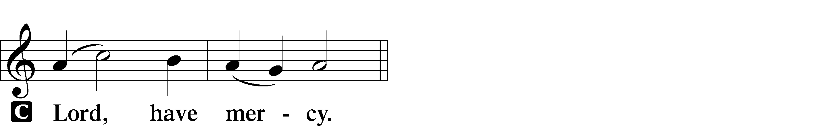

A For the peace of the whole world, for the well-being of the Church of God, and for the unity of all let us pray to the Lord.

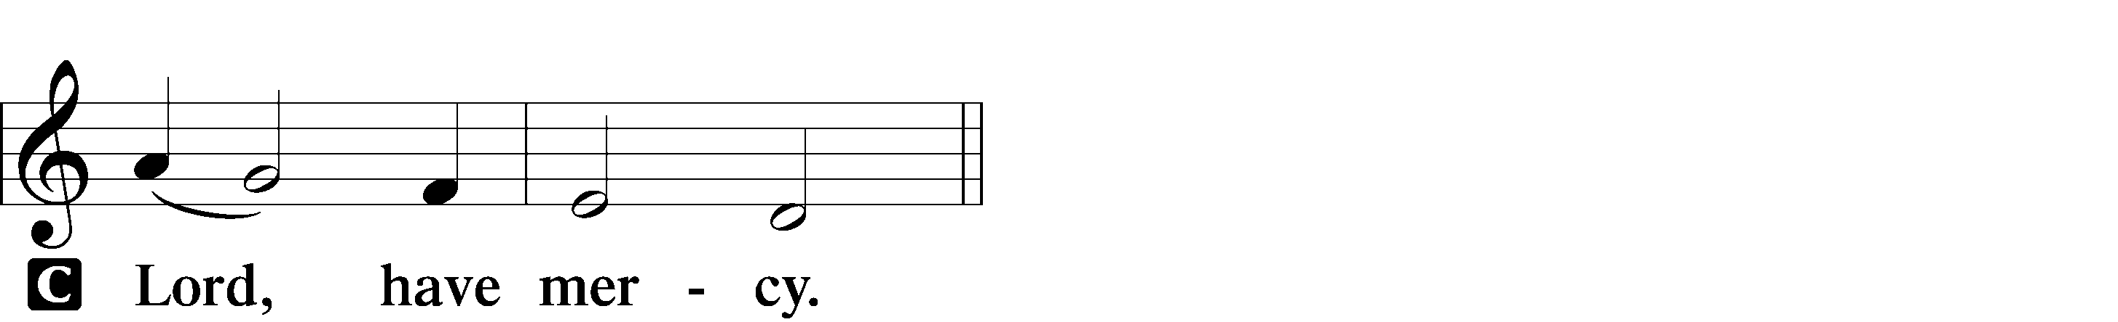

A For this holy house and for all who offer here their worship and praise let us pray to the Lord.

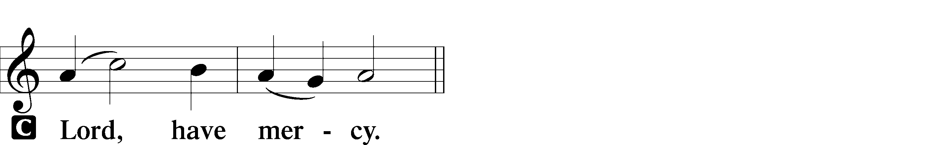

A Help, save, comfort, and defend us, gracious Lord.



Collect of the Day

P Let us pray. O God, through the humiliation of Your Son You raised up the fallen world. Grant to Your faithful people, rescued from the peril of everlasting death, perpetual gladness and eternal joys; through Jesus Christ, our Lord, who lives and reigns with You and the Holy Spirit, one God, now and forever.

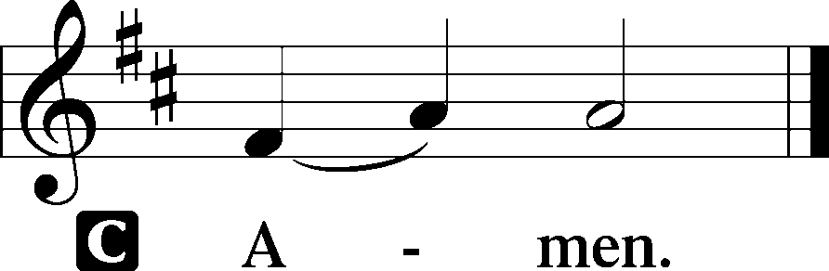

Sit

First Reading Acts 9:1–22

Meanwhile Saul, still breathing threats and murder against the disciples of the Lord, went to the high priest **2**and asked him for letters to the synagogues at Damascus, so that if he found any who belonged to the Way, men or women, he might bring them bound to Jerusalem. **3**Now as he was going along and approaching Damascus, suddenly a light from heaven flashed around him. **4**He fell to the ground and heard a voice saying to him, “Saul, Saul, why do you persecute me?” **5**He asked, “Who are you, Lord?” The reply came, “I am Jesus, whom you are persecuting. **6**But get up and enter the city, and you will be told what you are to do.” **7**The men who were traveling with him stood speechless because they heard the voice but saw no one. **8**Saul got up from the ground, and though his eyes were open, he could see nothing; so they led him by the hand and brought him into Damascus. **9**For three days he was without sight, and neither ate nor drank. **10**Now there was a disciple in Damascus named Ananias. The Lord said to him in a vision, “Ananias.” He answered, “Here I am, Lord.” **11**The Lord said to him, “Get up and go to the street called Straight, and at the house of Judas look for a man of Tarsus named Saul. At this moment he is praying, **12**and he has seen in a vision a man named Ananias come in and lay his hands on him so that he might regain his sight.” **13**But Ananias answered, “Lord, I have heard from many about this man, how much evil he has done to your saints in Jerusalem; **14**and here he has authority from the chief priests to bind all who invoke your name.” **15**But the Lord said to him, “Go, for he is an instrument whom I have chosen to bring my name before Gentiles and kings and before the people of Israel; **16**I myself will show him how much he must suffer for the sake of my

name.” **17**So Ananias went and entered the house. He laid his hands on Saul and said, “Brother Saul, the Lord Jesus, who appeared to you on your way here, has sent me so that you may regain your sight and be filled with the Holy Spirit.” **18**And immediately something like scales fell from his eyes, and his sight was restored. Then he got up and was baptized, **19**and after taking some food, he regained his strength.

A This is the Word of the Lord.

C **Thanks be to God.**

Psalm Psalm 30

1I will extol you, O Lord, for you have | drawn me up*  
 and have not let my foes rejoice | over me.  
**2O LORD MY GOD, I CRIED TO | YOU FOR HELP,*  
 AND YOU HAVE | HEALED ME**.  
3O Lord, you have brought up my soul | from Sheol;*  
 you restored me to life from among those who go down | to the pit.

**4SING PRAISES TO THE LORD, O | YOU HIS SAINTS,*  
 AND GIVE THANKS TO HIS | HOLY NAME.**5For his anger is but for a moment, and his favor is for a | lifetime.*  
Weeping may tarry for the night, but joy comes with the | morning.

**11YOU HAVE TURNED FOR ME MY MOURNING INTO | DANCING;* YOU HAVE LOOSED MY SACKCLOTH  
 AND CLOTHED ME WITH | GLADNESS,**12that my glory may sing your praise and not be | silent.*  
 O Lord my God, I will give thanks to you for- | ever!

Epistle Revelation 5:11–14

**11**Then I looked, and I heard the voice of many angels surrounding the throne and the living creatures and the elders; they numbered myriads of myriads and thousands of thousands, **12**singing with full voice, “Worthy is the Lamb that was slaughtered to receive power and wealth and wisdom and might and honor and glory and blessing!” **13**Then I heard every creature in heaven and on earth and under the earth and in the sea, and all that is in them, singing, “To the one seated on the throne and to the Lamb be blessing and

honor and glory and might forever and ever!” **14**And the four living creatures said, “Amen!” And the elders fell down and worshiped.

A This is the Word of the Lord.

C **Thanks be to God.**

Holy Gospel John 21:1–19

P The Holy Gospel according to St. John.

C **Glory to You, O Lord.**

After these things Jesus showed himself again to the disciples by the Sea of Tiberias; and he showed himself in this way. **2**Gathered there together were Simon Peter, Thomas called the Twin, Nathanael of Cana in Galilee, the sons of Zebedee, and two others of his disciples. **3**Simon Peter said to them, “I am going fishing.” They said to him, “We will go with you.” They went out and got into the boat, but that night they caught nothing. **4**Just after daybreak, Jesus stood on the beach; but the disciples did not know that it was Jesus. **5**Jesus said to them, “Children, you have no fish, have you?” They answered him, “No.” **6**He said to them, “Cast the net to the right side of the boat, and you will find some.” So they cast it, and now they were not able to haul it in because there were so many fish. **7**That disciple whom Jesus loved said to Peter, “It is the Lord!” When Simon Peter heard that it was the Lord, he put on some clothes, for he was naked, and jumped into the sea. **8**But the other disciples came in the boat, dragging the net full of fish, for they were not far from the land, only about a hundred yards off. **9**When they had gone ashore, they saw a charcoal fire there, with fish on it, and bread. **10**Jesus said to them, “Bring some of the fish that you have just caught.” **11**So Simon Peter went aboard and hauled the net ashore, full of large fish, a hundred fifty-three of them; and though there were so many, the net was not torn. **12**Jesus said to them, “Come and have breakfast.” Now none of the disciples dared to ask him, “Who are you?” because they knew it was the Lord. **13**Jesus came and took the bread and gave it to them, and did the same with the fish. **14**This was now the third time that Jesus appeared to the disciples after he was raised from the dead. **15**When they had finished breakfast, Jesus said to Simon Peter, “Simon son of John, do you love me more than these?” He said to him, “Yes, Lord; you know that I

love you.” Jesus said to him, “Feed my lambs.” **16**A second time he said to him, “Simon son of John, do you love me?” He said to him, “Yes, Lord; you know that I love you.” Jesus said to him, “Tend my sheep.” **17**He said to him the third time, “Simon son of John, do you love me?” Peter felt hurt because he said to him the third

time, “Do you love me?” And he said to him, “Lord, you know everything; you know that I love you.” Jesus said to him, “Feed my sheep. **18**Very truly, I tell you, when you were younger, you used to fasten your own belt and to go wherever you wished. But when you grow old, you will stretch out your hands, and someone else will fasten a belt around you and take you where you do not wish to go.” **19**(He said this to indicate the kind of death by which he would glorify God.) After this he said to him, “Follow me.”

P The Gospel of the Lord.

C **Praise to You, Lord Jesus Christ.**

The Homily

633 At the Lamb’s High Feast We Sing

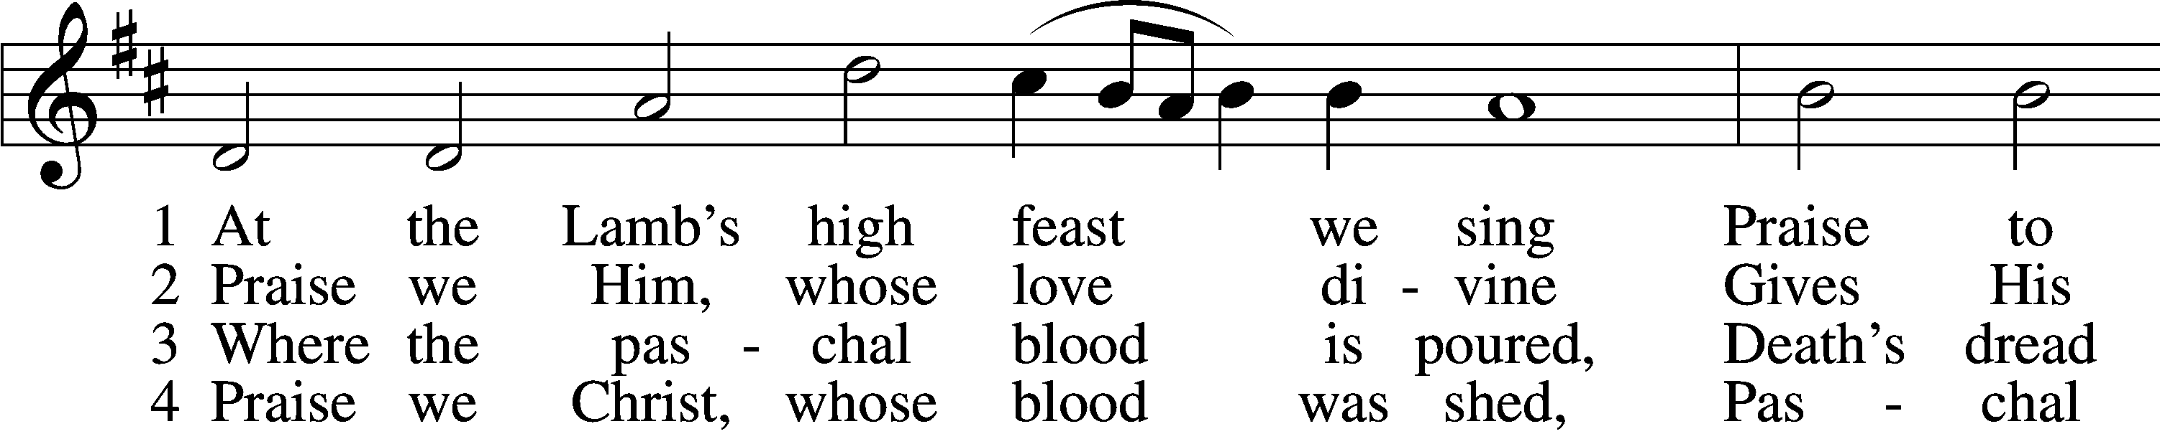

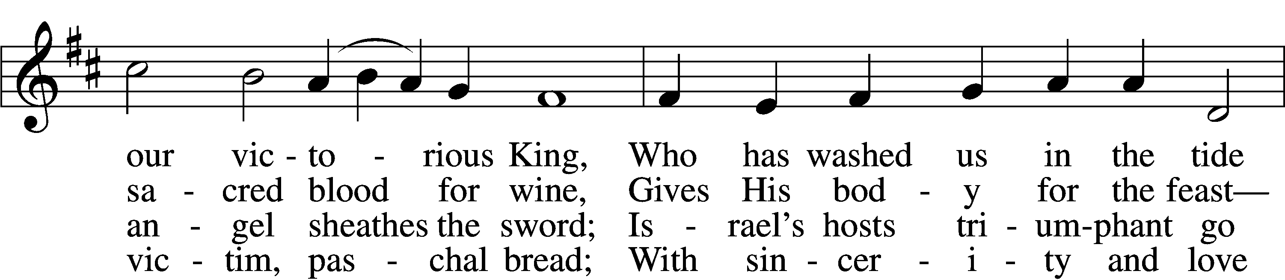

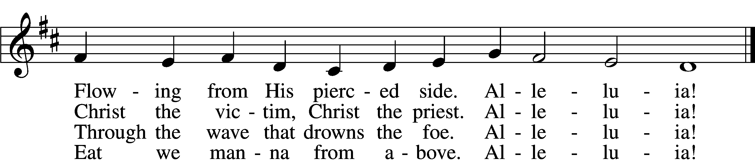

Nicene Creed

**We believe in one God, the Father, the Almighty, maker of heaven and earth, of all that is, seen and unseen.**

**We believe in one Lord, Jesus Christ, the only Son of God, eternally begotten of the Father, God from God, Light from Light, true God from true God, begotten, not made, of one Being with the Father; through him all things were made. For us and for our salvation he came down from heaven, was incarnate of the Holy Spirit and the Virgin Mary and became truly human. For our sake he was crucified under Pontius Pilate; he suffered death and was buried. On the third day he rose again in accordance with the Scriptures; he ascended into heaven and is seated at the right hand of the Father. He will come again in glory to judge the living and the dead, and his kingdom will have no end.**

**We believe in the Holy Spirit, the Lord, the giver of life, who proceeds from the Father and the Son, who with the Father and the Son is worshiped and glorified, who has spoken through the prophets. We believe in one holy catholic and apostolic Church. We acknowledge one baptism for the forgiveness of sins. We look for the resurrection of the dead, and the (+) life of the world to come. Amen**

**The Prayer of the Church**

.... Lord, in your mercy,

**HEAR OUR PRAYR.**

***(****After the last petition)* O Christ, Redeemer of the world, we praise you and confess that you are the Lord, to the glory of God the Father.

**AMEN.**

Christ is risen! Alleluia!

**HE IS RISEN INDEED! ALLELUIA!**

633 At the Lamb’s High Feast We Sing (cont’d)

5 Mighty Victim from the sky, Hell’s fierce pow’rs beneath You lie;  
You have conquered in the fight, You have brought us life and light.  
 Alleluia!

6 Now no more can death appall, Now no more the grave enthrall;  
You have opened paradise, And Your saints in You shall rise.  
 Alleluia!

7 Easter triumph, Easter joy! This alone can sin destroy;  
From sin’s pow’r, Lord, set us free, Newborn souls in You to be.  
 Alleluia!

D 8 Father, who the crown shall give, Savior, by whose death we live,  
Spirit, guide through all our days: Three in One, Your name we praise.  
 Alleluia!

Text: Latin, c. 5th–10th cent.; tr. Robert Campbell, 1814–68, alt.

Tune: Kirchengeseng, 1566, Ivancice

Text and tune: Public domain

# Service of the Sacrament

The Lord be with you.

**AND ALSO WITH YOU.**

Lift up your hearts.

**WE LIFT THEM TO THE LORD.**

Let us give thanks to the Lord our God.

**IT IS RIGHT TO GIVE GOD THANKS AND PRAISE.**

It is truly good, right, and salutary that we should at all times and in all places give thanks to you, holy Lord, almighty Father, everlasting God. And most especially are we bound to praise you on this day for the glorious resurrection of your Son, Jesus Christ, the very Paschal Lamb, who was sacrificed for us and bore the sins of the world. By His dying he has destroyed death, and by his rising again he has restored to us everlasting life. Therefore with Mary Magdalene, Peter and John, and with all the witnesses of the resurrection, with angels and archangels, and with all the company of heaven we praise your name and join their unending hymn:

Sanctus

LSB 178

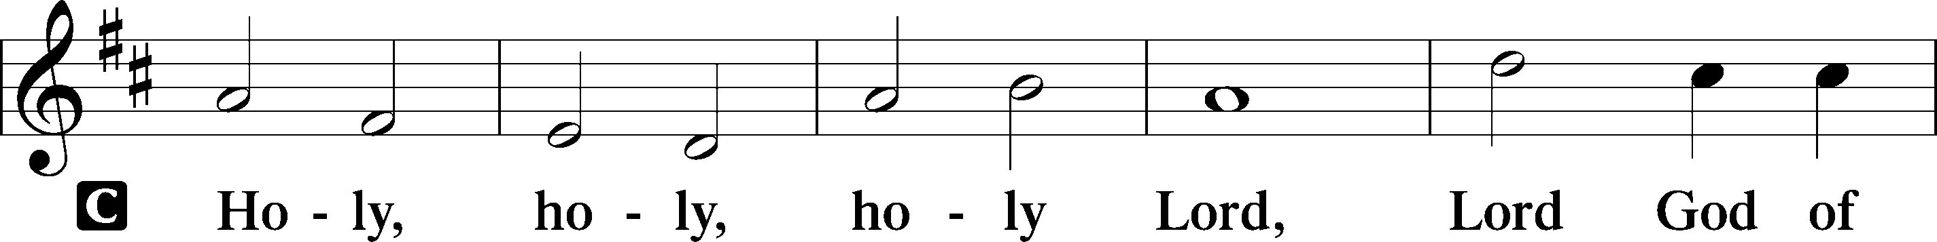

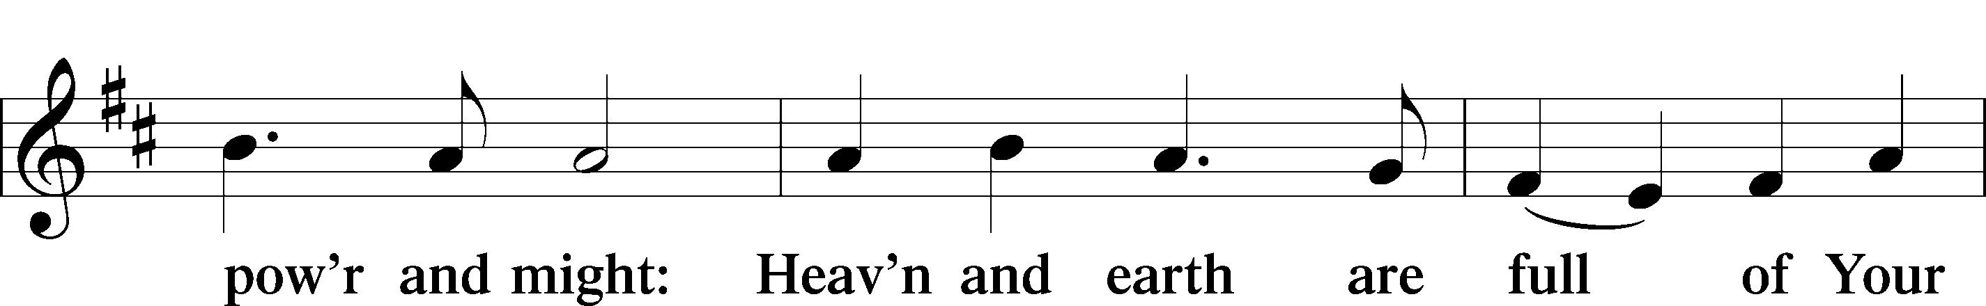

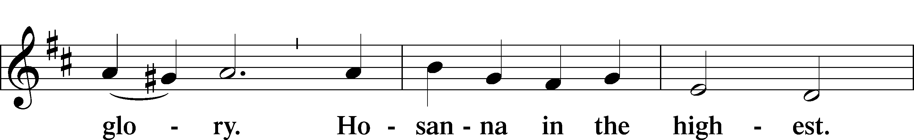

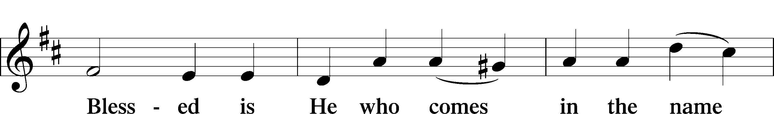

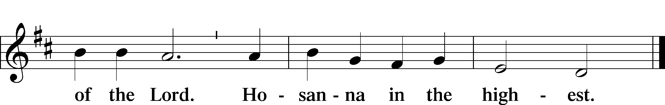

Our Lord Jesus Christ....

As often as we eat this bread and drink from this cup, we proclaim the Lord's death until he comes.

**CHRIST HAS DIED. CHRIST IS RISEN. CHRIST WILL COME AGAIN.**

Join our prayers with those of your servants of every time and every place, and unite them with the petitions of Jesus Christ, our great high priest, until he comes as victorious Lord of all.

**THROUGH HIM, WITH HIM, IN HIM, IN THE UNITY OF THE HOLY SPIRIT, ALL HONOR AND GLORY IS YOURS, ALMIGHTY FATHER, NOW AND FOREVER. AMEN.**

Remember us in your kingdom, and teach us to pray: OUR FATHER…

**The Holy Communion**

Thanksgiving and Dismissal

A O give thanks to the Lord, for he is good.

C **And his mercy endures forever.**

A Let us pray. We give thanks to You, almighty God, that You have refreshed us through the salutary gift of your Body and Blood in the holy Meal. We ask that of your mercy you would strengthen us through the same in faith toward you and in fervent love toward one another; through Jesus Christ, your Son, our Lord, who lives and reigns with you and the Holy Spirit, one God, now and forever.

C **Amen.**

Benediction

P Almighty God bless you, the Father, the (+) Son, and the Holy Spirit.

C **Amen.**

482 This Joyful Eastertide

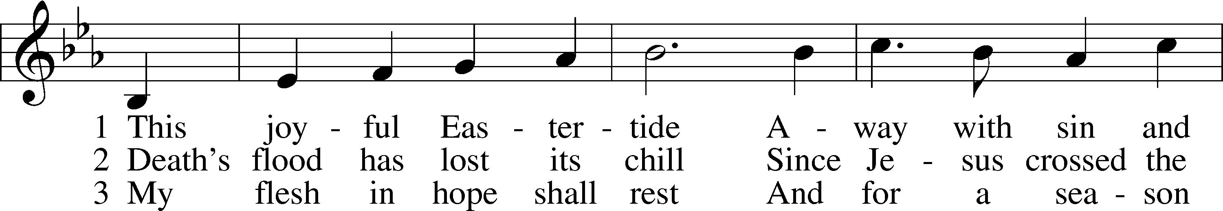

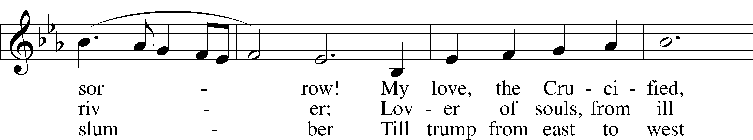

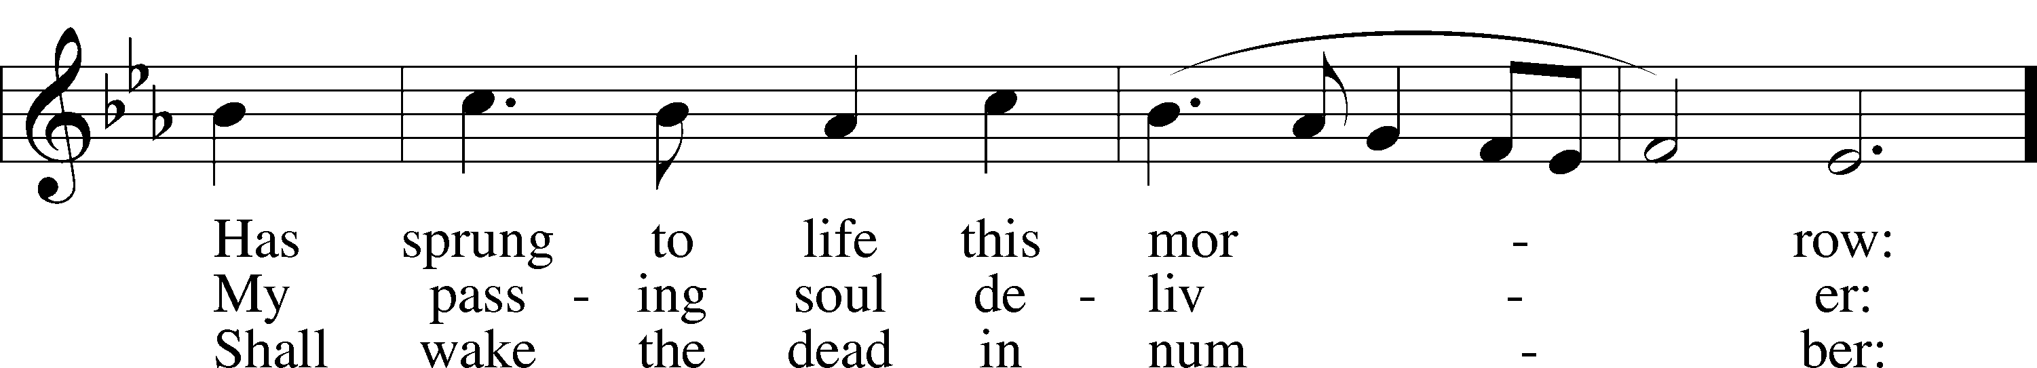

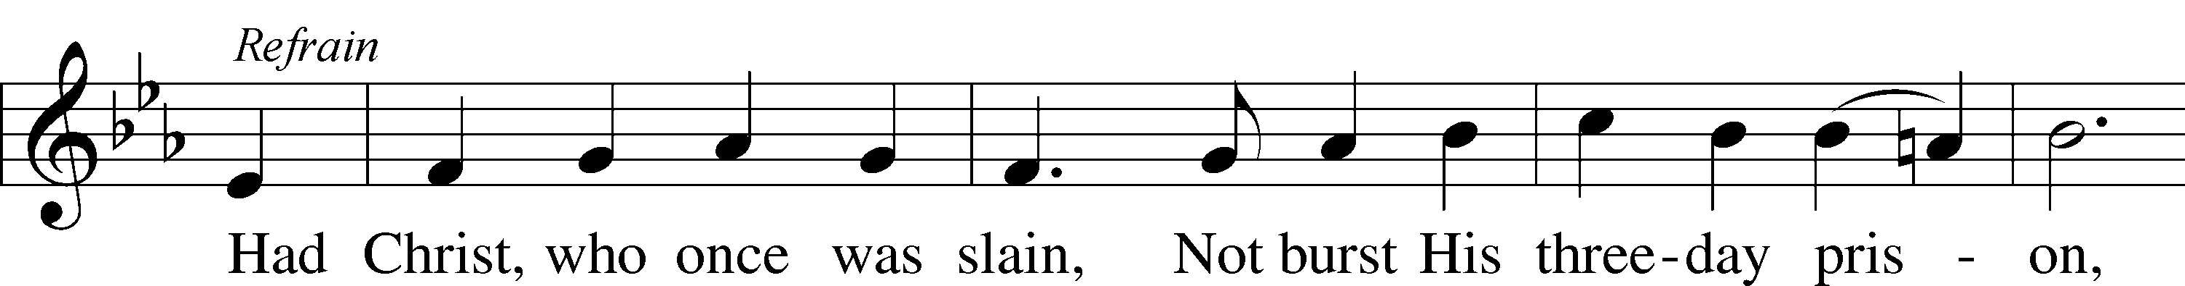

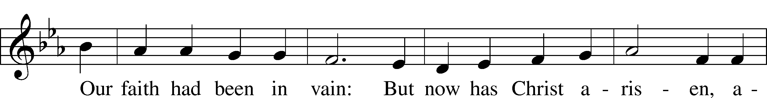

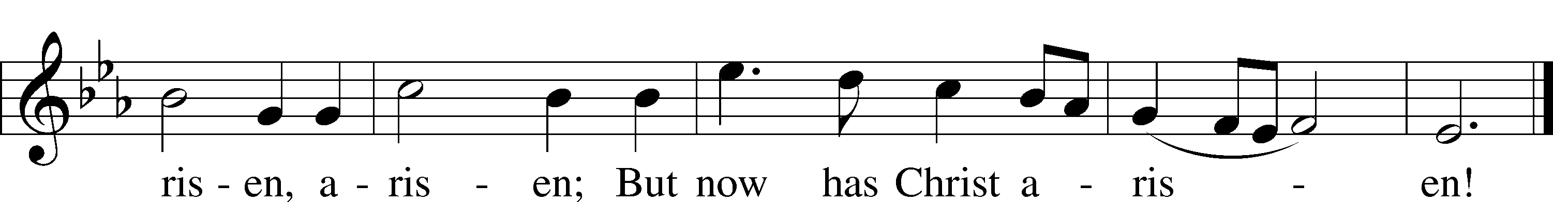

Text: George R. Woodward, 1848–1934

Tune: Davids Psalmen, 1684, Amsterdam

Text and tune: Public domain

Happy Birthday this week to:

Amanda Wiltjer 5/5

Acknowledgments

Divine Service, Setting Two from Lutheran Service Book

Created by Lutheran Service Builder © 2025 Concordia Publishing House.

JOIN US NEXT SUNDAY AS WE CONTINUE TO CELEBRATE THE RESURRECTION OF OUR LORD DURING THE GREAT FIFTY DAYS OF THE EASTER SEASON! CHRIST IS RISEN INDEED! ALLELUIA!

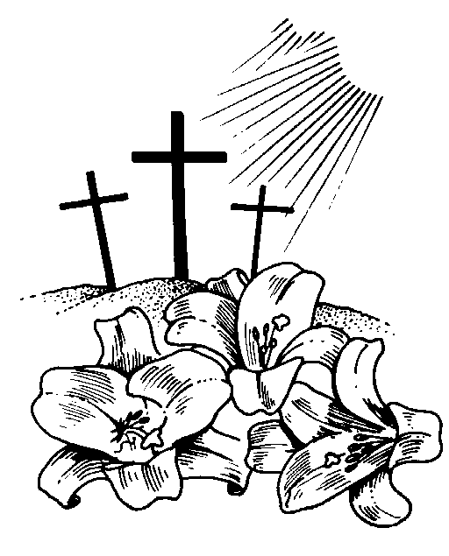

THIS WEEK IN THE CHURCH CALENDAR

**5/4: Monica, Mother of Augustine, 387**

**Monica** (the oldest spelling is Monnica), the mother of Augustine, apparently was a native of Tugaste, North Africa. At the age of 40 she was left a widow with three children. She prayed earnestly for the conversion of the eldest, Augustine, following him to Rome and then to Milan. There she witnessed her son's conversion. She died returning to Africa. In Book IX of his Confession, Augustine writes tenderly of her and of her dying wish to be remembered at the altar of the Lord. Her commemoration developed late in the Middle Ages. The Roman Catholic calendar has moved her commemoration to August 27.

**5/8: Julian of Norwich, renewer of the church, c. 1416**

**Julian** (or Juliana) was most likely a Benedictine nun living in an isolated cell attached to the Carrow Priory in Norwich (Nor-itch), England. Definite facts about her life are sparse. However, when she was about thirty years old, she reported visions that she later compiled into a book, Sixteen Revelations of Divine Love, a classic of medieval mysticism. (This is the first book in the English language known to have been written by a woman.) The visions declared that love was the meaning of religious experience, provided by Christ who is love, for the purpose of love. A prayer hymn attributed to Julian is *Mothering God, You Gave Me Birth.''*

**5/9:Nicolaus Ludwig von Zinzendorf, renewer of the church, hymnwriter, 1760**

**Count Zinzendorf** was born into an aristocratic family and after the death of his father was raised by his Pietistic grandmother. This influence was a lasting one, and he moved away from what he felt was an overly intellectual Lutheranism. When he was twenty-two, a group of Moravians asked permission to live on his lands. He agreed, and they established a settlement they called Herrnhut, or "the Lord's watch." Eventually worldwide Moravian missions emanated from this community. Zinzendorf participated in these missions and is also remembered for writing hymns characteristic of his Pietistic faith, including *Jesus, Still Lead On.*