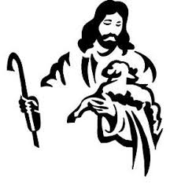
The image of the good shepherd shows us how the risen Christ brings us to life. It is the relationship between the shepherd and the sheep, one of mutual knowledge and love, that gives the shepherd authority. The shepherd’s willingness to lay down his life for the sheep shows his love. The letter of First John illustrates what it means to lay down our lives for one another by the example of sharing our wealth with any in need.

The Fourth Sunday of Easter 21 April 2024
Markham Lutheran Church, 3518 W. 160th St., Markham, Illinois 60428
E-mail: Markhemlutheranchurch@gmail.com 708-331-4885
Website: http://www.Markhamlutheranchurch.org/
Pastor Larry Schneekloth
735 Have No Fear, Little Flock
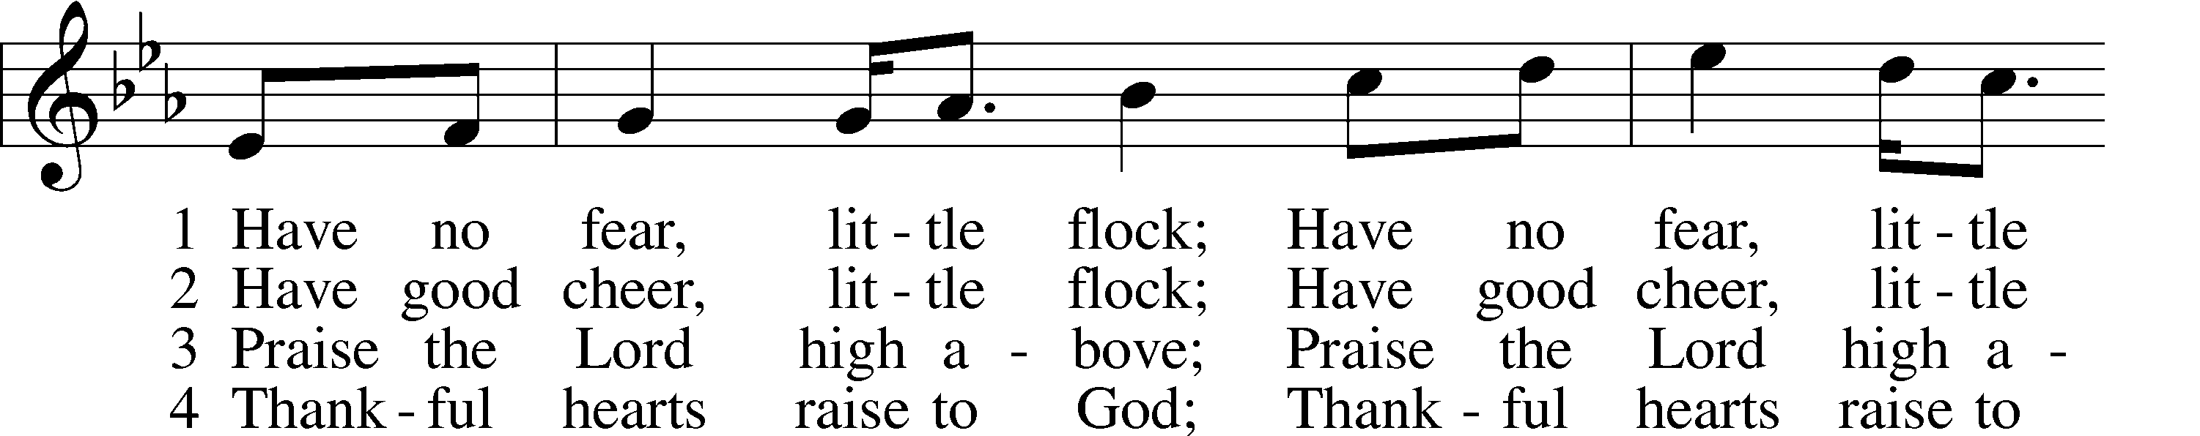
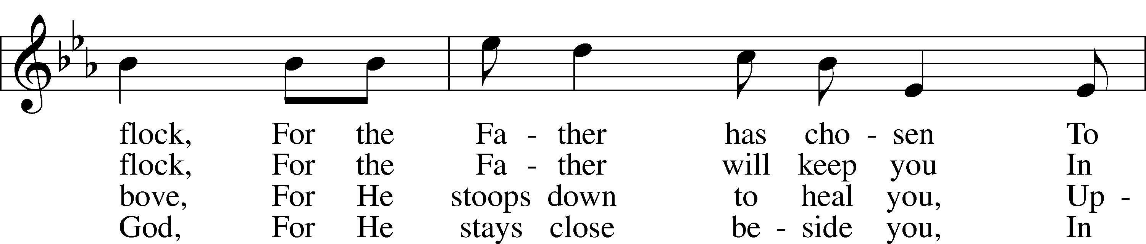
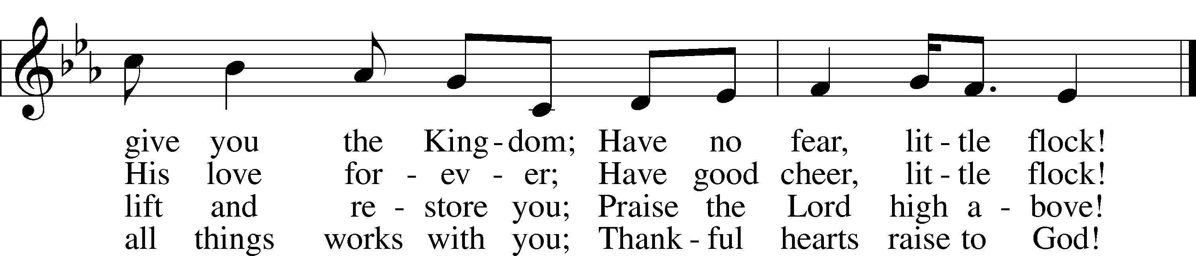

Text (sts. 2–4): Marjorie A. Jillson, 1931–2010
Text (st. 1) and tune: Heinz Werner Zimmermann, 1930
Text and tune: © 1973 Concordia Publishing House. Used by permission: LSB Hymn License no. 110001341

The sign of the cross may be made by all in remembrance of their Baptism.

P In the name of the Father and of the T Son and of the Holy Spirit.
C Amen.

Let us confess our sins to the Lord Jesus, the Good Shepherd of the flock of God.

(a time for personal prayer and confession)

Risen Lord, you have given your life to save us from sin, death, and despair.
YET WE OFTEN LEAVE YOUR FLOCK AND WANDER OFF INTO DANGER.
We know that you alone truly lead us, and care for us.
YET WE OFTEN PUT OUR TRUST IN OTHERS.
You bring us together with your "other sheep" from different races and cultures, countries, and denominations.
YET WE SEEK TO REMAIN SEPARATE AND UNCHANGED. FORGIVE US, GOOD SHEPHERD, AND HELP US TO TRUST YOU ALONE. AMEN.

Christ stands among us, feeding his flock with word and sacrament. He calms our fears, brings us back from our wandering, forgives our sin, and renews our faith. Restored to the fold, we celebrate his saving power. I announce the forgiveness of all your sins, in the name of the Father and of the [+] Son and of the Holy Spirit. Christ is risen! Alleluia!
HE IS RISEN INDEED! ALLELUIA!

Service of the Word

Kyrie LSB 168
A In peace let us pray to the Lord.
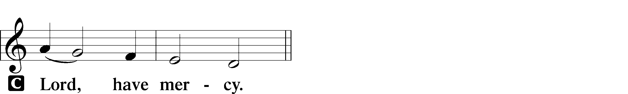

A For the peace from above and for our salvation let us pray to the Lord.
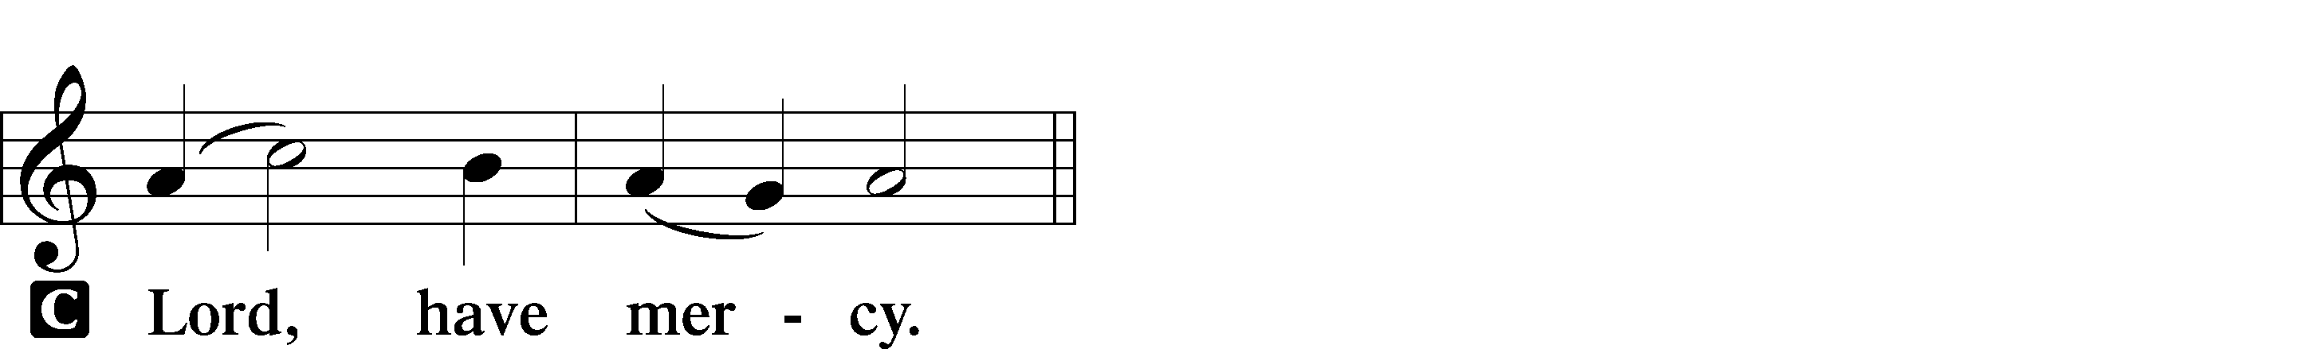

A For the peace of the whole world, for the well-being of the Church of God, and for the unity of all let us pray to the Lord.
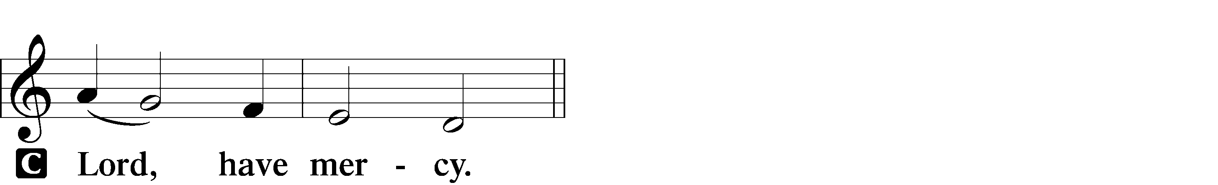

A For this holy house and for all who offer here their worship and praise let us pray to the Lord.
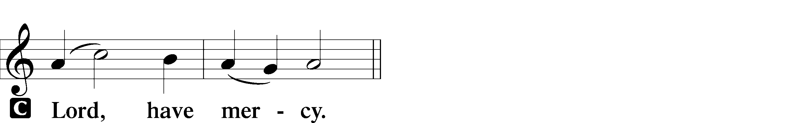

A Help, save, comfort, and defend us, gracious Lord.
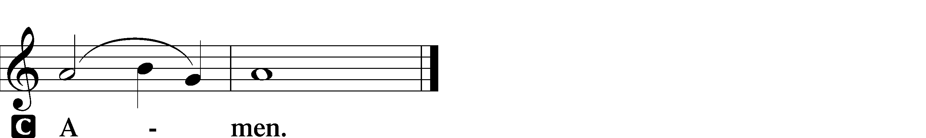

Collect of the Day
P Let us pray.
Almighty God, merciful Father, since You have wakened from death the Shepherd of Your sheep, grant us Your Holy Spirit that when we hear the voice of our Shepherd we may know Him who calls us each by name and follow where He leads; through the same Jesus Christ, Your Son, our Lord, who lives and reigns with You and the Holy Spirit, one God, now and forever.

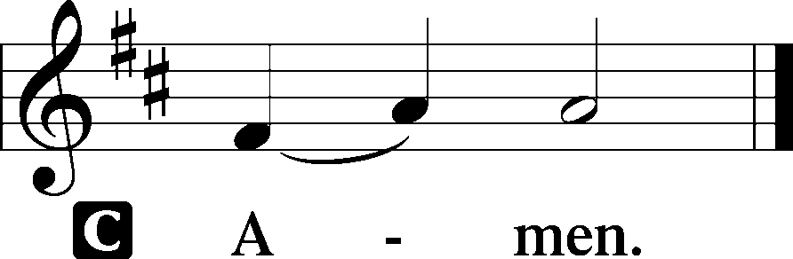

Sit

First Reading Acts 4:1–12

1As they were speaking to the people, the priests and the captain of the temple and the Sadducees came upon them, 2greatly annoyed because they were teaching the people and proclaiming in Jesus the resurrection from the dead. 3And they arrested them and put them in custody until the next day, for it was already evening. 4But many of those who had heard the word believed, and they numbered about five thousand. 5On the next day their rulers and elders and scribes gathered together in Jerusalem, 6with Annas the high priest and Caiaphas and John and Alexander, and all who were of the high-priestly family. 7And when they had set them in the midst, they inquired, “By what power or by what name did you do this?” 8Then Peter, filled with the Holy Spirit, said to them, “Rulers of the people and elders, 9if we are being examined today concerning a good deed done to a crippled man, by what means this man has been healed, 10let it be known to all of you and to all the people of Israel that by the name of Jesus Christ of Nazareth, whom you crucified, whom God raised from the dead—by him this man is standing before you well. 11This Jesus is the stone that was rejected by you, the builders, which has become the cornerstone. 12And there is salvation in no one else, for there is no other name under heaven given among men by which we must be saved.”
A This is the Word of the Lord.
C Thanks be to God.

Psalm Psalm 23
1THE LORD IS MY | SHEPHERD;* I | SHALL NOT WANT.
2HE MAKES ME LIE DOWN IN GREEN | PASTURES.* HE LEADS ME BESIDE STILL | WATERS. 3HE RE- | STORES MY SOUL.* HE LEADS ME IN PATHS OF RIGHTEOUSNESS FOR HIS | NAME’S SAKE. 4EVEN THOUGH I WALK THROUGH THE VALLEY OF THE SHADOW OF DEATH, I WILL FEAR NO EVIL, FOR YOU ARE | WITH ME;* YOUR ROD AND YOUR STAFF, THEY | COMFORT ME. 5YOU PREPARE A TABLE BEFORE ME IN THE PRESENCE OF MY | ENEMIES;* YOU ANOINT MY HEAD WITH OIL; MY CUP | OVERFLOWS.6SURELY GOODNESS AND MERCY SHALL FOLLOW ME ALL THE DAYS | OF MY LIFE,* AND I SHALL DWELL IN THE HOUSE OF THE LORD FOR- | EVER.

Epistle 1 John 3:16–24
We know love by this, that he laid down his life for us—and we ought to lay down our lives for the brothers and sisters. ¹⁷ How does God’s love abide in anyone who has the world’s goods and sees a brother or sister in need and yet refuses help? ¹⁸ Little children, let us love not in word or speech but in deed and truth. ¹⁹ And by this we will know that we are from the truth and will reassure our hearts before him ²⁰ whenever our hearts condemn us, for God is greater than our hearts, and he knows everything. ²¹ Beloved, if our hearts do not condemn us, we have boldness before God, ²² and we receive from him whatever we ask, because we obey his commandments and do what pleases him. ²³ And this is his commandment, that we should believe in the name of his Son Jesus Christ and love one another, just as he has commanded us. ²⁴ All who obey his commandments abide in him, and he abides in them. And by this we know that he abides in us, by the Spirit that he has given us.
A This is the Word of the Lord.
C Thanks be to God.

Alleluia and Verse
P Alleluia! The Lord is my shepherd, I shall not want. Alleluia!
C I shall dwell in the house of the Lord forever. Alleluia.

Holy Gospel John 10:11–18
P The Holy Gospel according to St. John.
C Glory to You, O Lord.
11[Jesus said:] “I am the good shepherd. The good shepherd lays down his life for the sheep. 12He who is a hired hand and not a shepherd, who does not own the sheep, sees the wolf coming and leaves the sheep and flees, and the wolf snatches them and scatters them. 13He flees because he is a hired hand and cares nothing for the sheep. 14I am the good shepherd. I know my own and my own know me, 15just as the Father knows me and I know the Father; and I lay down my life for the sheep. 16And I have other sheep that are not of this fold. I must bring them also, and they will listen to my voice. So there will be one flock, one shepherd. 17For this reason the Father loves me, because I lay down my life that I may take it up again. 18No one takes it from me, but I lay it down of my own accord. I have authority to lay it down, and I have authority to take it up again. This charge I have received from my Father.”
P This is the Gospel of the Lord.
C Praise to You, Lord Jesus Christ.

709 The King of Love My Shepherd Is
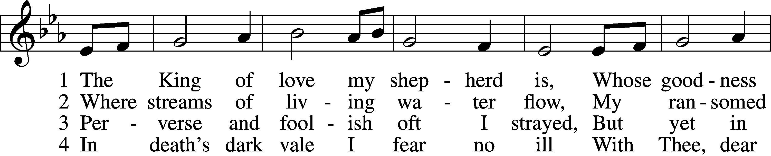
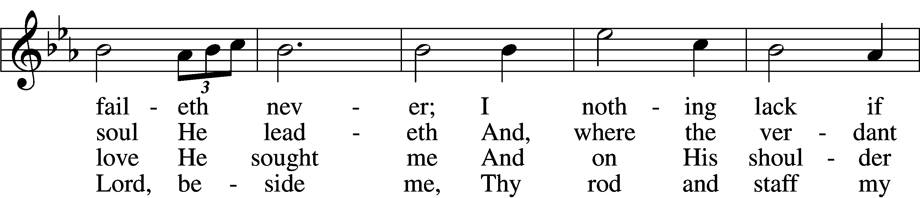
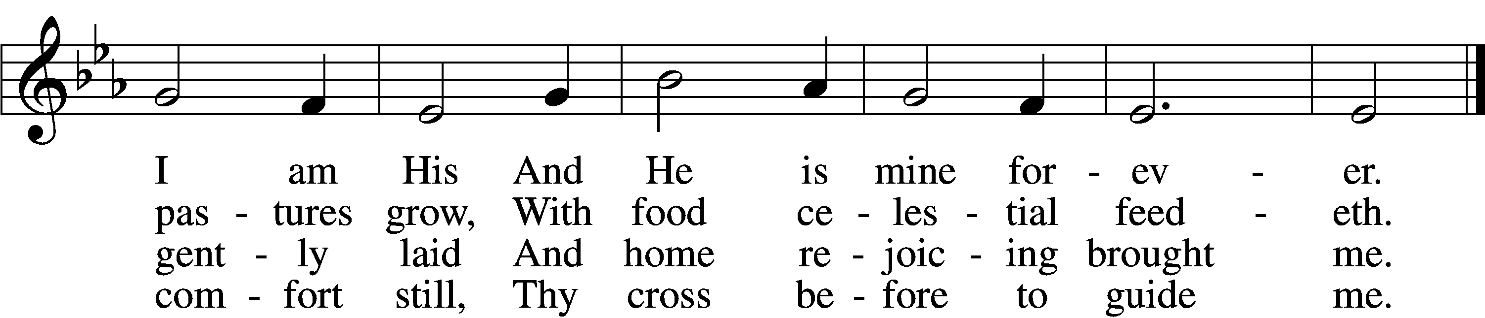

5 Thou spreadst a table in my sight;
Thine unction grace bestoweth;
And, oh, what transport of delight
From Thy pure chalice floweth!

6 And so through all the length of days
Thy goodness faileth never;
Good Shepherd, may I sing Thy praise
Within Thy house forever!

Text: Henry W. Baker, 1821–77
Tune: Irish, c. 18th cent.
Text and tune: Public domain

The Homily

Nicene Creed

We believe in one God, the Father, the Almighty, maker of heaven and earth, of all that is, seen and unseen.

We believe in one Lord, Jesus Christ, the only Son of God, eternally begotten of the Father, God from God, Light from Light, true God from true God, begotten, not made, of one Being with the Father; through him all things were made. For us and for our salvation he came down from heaven, was incarnate of the Holy Spirit and the Virgin Mary and became truly human. For our sake he was crucified under Pontius Pilate; he suffered death and was buried. On the third day he rose again in accordance with the Scriptures; he ascended into heaven and is seated at the right hand of the Father. He will come again in glory to judge the living and the dead, and his kingdom will have no end.

We believe in the Holy Spirit, the Lord, the giver of life, who proceeds from who has spoken through the prophets. We believe in one holy catholic and apostolic Church. We acknowledge one baptism for the forgiveness of sins. We look for the resurrection of the dead, and the (+) life of the world to come.

Prayer of the Church
….Lord, in your mercy,
HEAR OUR PRAYER.

(last petition:) Into your hands we commend ourselves, and all for whom we pray, trusting in your mercy, through Jesus Christ our Lord.
AMEN.

Christ is risen! Alleluia!
CHRIST IS RISEN INDEED! ALLELUIA!

(Share the Peace of the Lord)
740 I Am Jesus’ Little Lamb
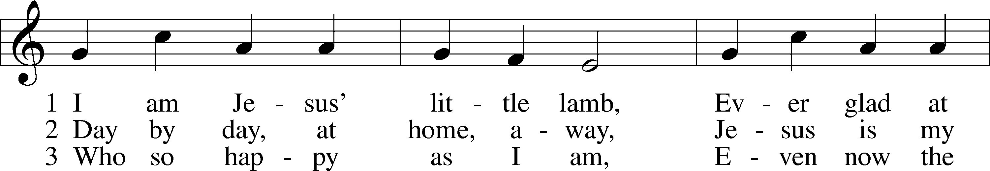
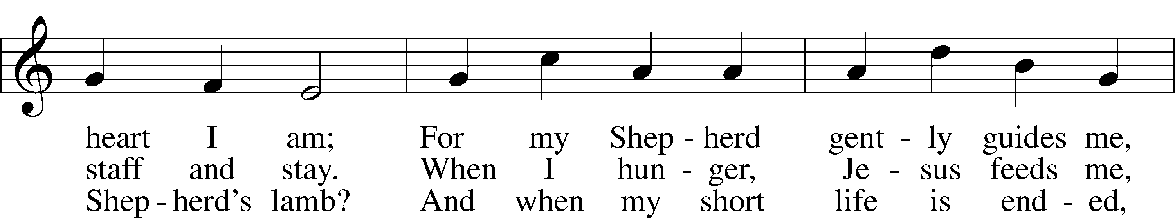
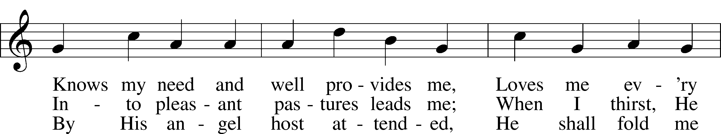
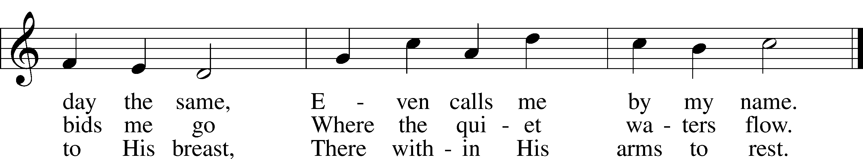

Text: Henrietta L. von Hayn, 1724–82; tr. The Lutheran Hymnal, 1941
Tune: Choral-Buch . . . Brüder-Gemeinen, 1784, Leipzig
Text and tune: Public domain

OUR EASTER COMMUNION

P The Lord be with you.
C And also with you.
P Lift up your hearts.
C We lift them to the Lord.
P Let us give thanks to the Lord our God.
C It is right to give God thanks and praise.

P It is truly good, right, and salutary that we should at all times and in all places give thanks to You, holy Lord, almighty Father, everlasting God. And most especially are we bound to praise You on this day for the glorious resurrection of Your Son, Jesus Christ, the very Paschal Lamb, who was sacrificed for us and bore the sins of the world. By His dying He has destroyed death, and by His rising again He has restored to us everlasting life. Therefore with Mary Magdalene, Peter and John, and with all the witnesses of the resurrection, with angels and archangels, and with all the company of heaven praise your name and join their unending hymn:

Sanctus LSB 178
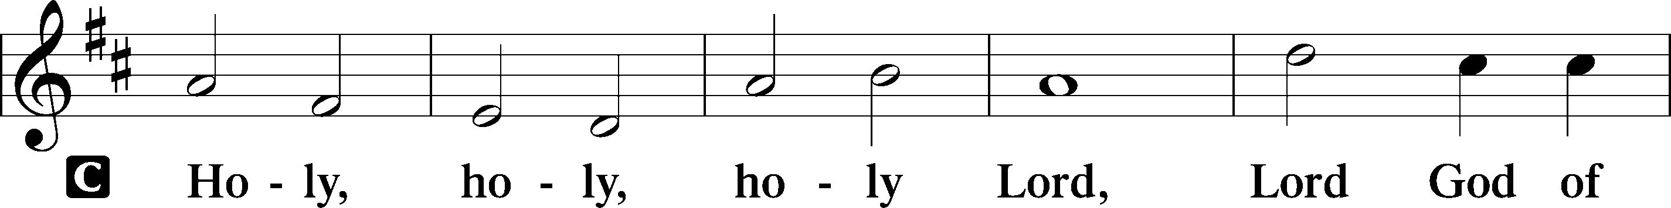
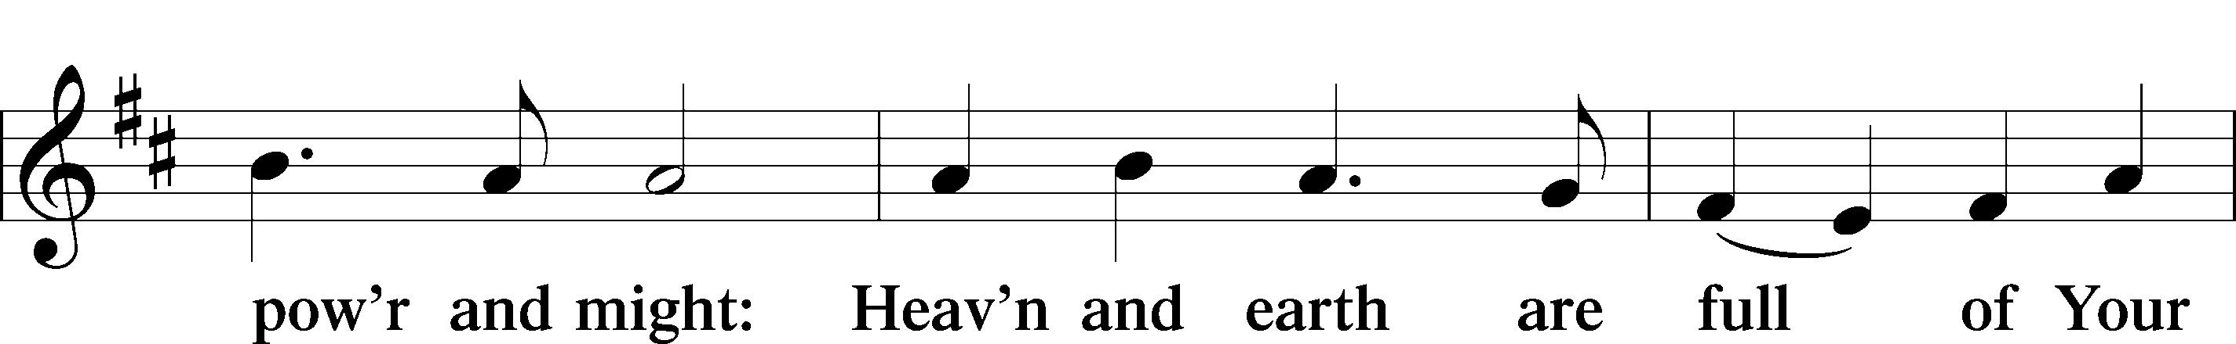
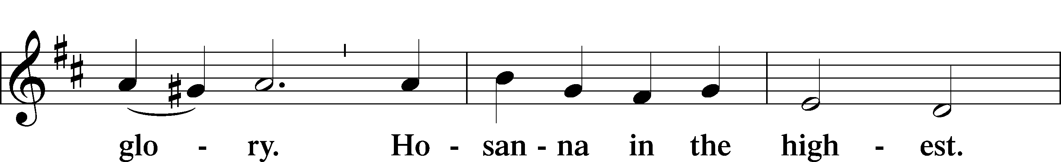
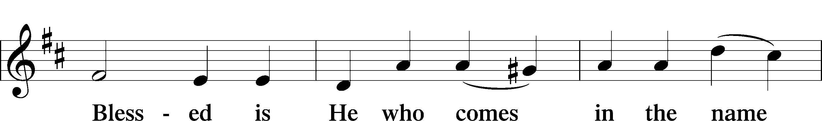
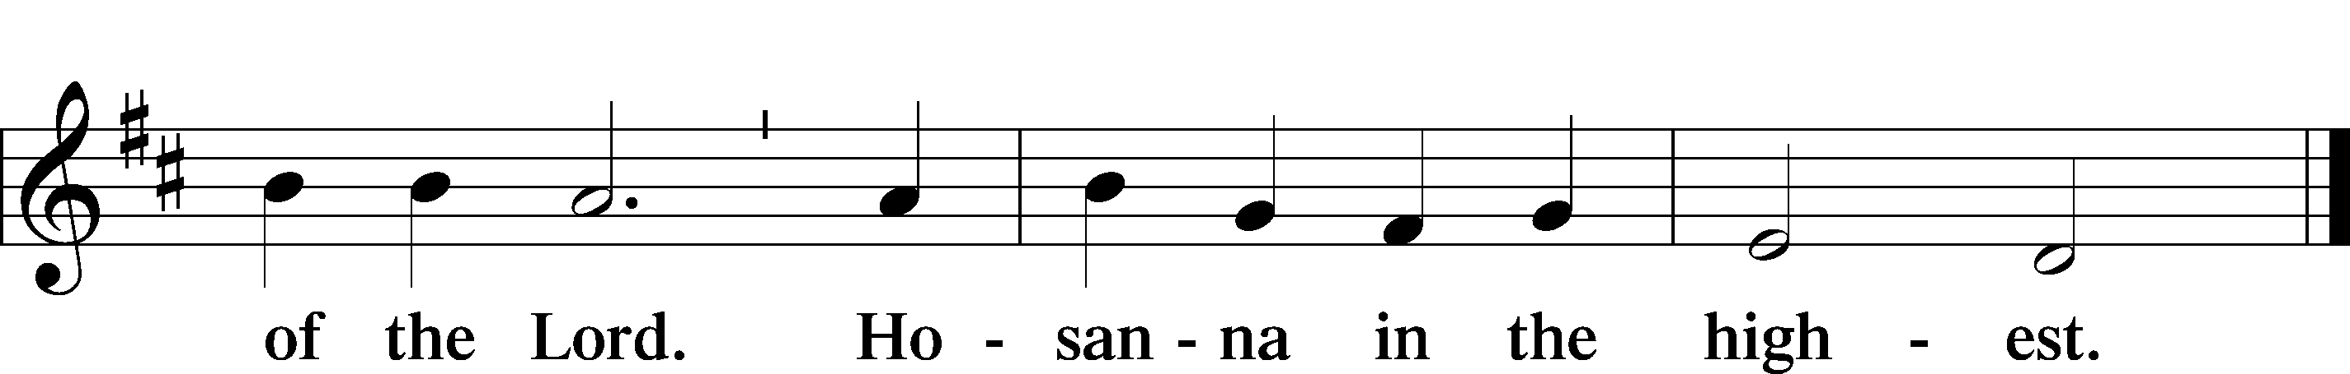

Our Lord Jesus Christ… the Lord’s death until he comes.
CHRIST HAS DIED, CHRIST IS RISEN, CHRIST WILL COME AGAIN.

Join our prayers with those of your servants of every time and place, and unite them with the ceaseless petitions of Jesus Christ, our great High Priest, until he comes as victorious Lord of all.
THROUGH HIM, WITH HIM, IN HIM, IN THE UNITY OF THE HOLY SPIRIT, ALL HONOR AND GLORY IS YOURS, ALMIGHTY FATHER, NOW AND FOREVER. AMEN.

In the words of our Lord we pray: OUR FATHER....

THE HOLY COMMUNION

The Thanksgiving and Closing

O give thanks to the Lord, for he is good,
AND HIS MERCY ENDURES FOREVER.
We give thanks to you, almighty God, that you have refreshed us through your holy Word, and your holy Meal. We ask that you use these gifts to your church to strengthen us; strengthen us in faith toward You and in fervent love toward one another; through Jesus Christ, your Son, our Lord, who lives and reigns with you and the Holy Spirit, one God, now and forever.
AMEN.

Almighty God bless you, the Father, the (+) Son, and the Holy Spirit.
AMEN.

710 The Lord’s My Shepherd, I’ll Not Want
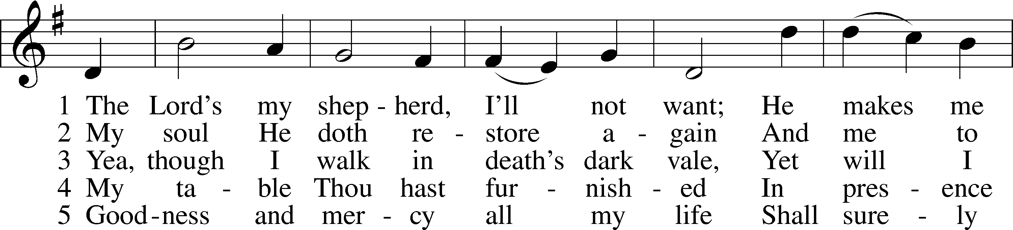
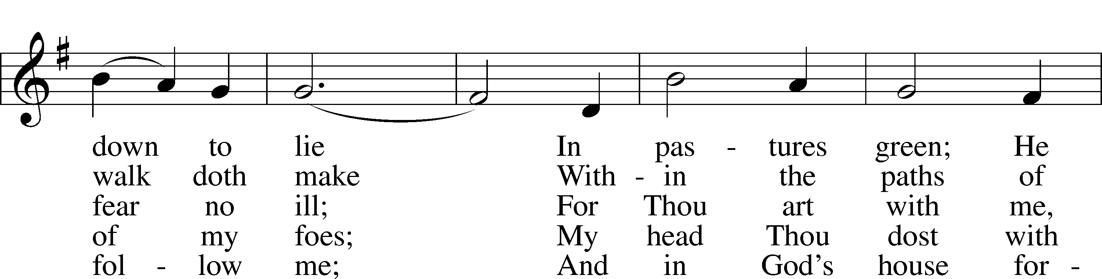
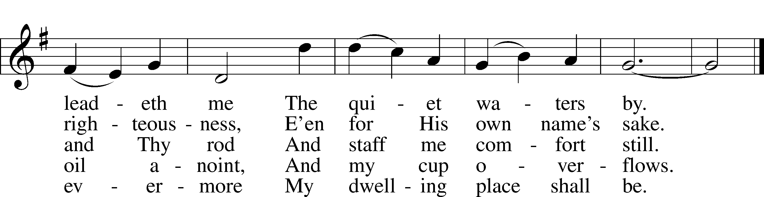

Text: The Psalms of David in Meeter, 1650, Edinburgh
Tune: William Gardiner, 1770–1853
Text and tune: Public domain

HAPPY BIRTHDAY TO:
4/22 Paulie Neeley, Mark Tulp
4/23 Mitchell King
4/25 Kris Findlay
4/26 Alyssa Mankiewicz

Acknowledgments
Divine Service, Setting Two from Lutheran Service Book
Created by Lutheran Service Builder © 2024 Concordia Publishing House.

THIS WEEK IN THE CHURCH CALENDAR
4/21: Anselm, Archbishop of Canterbury, 1109
Anselm was born in Lombardy, c. 1033. He went to a humanistic school in France and became a monk, achieving a reputation as a teacher and spiritual director. When he visited England, he was persuaded to become Archbishop of Canterbury. For much of his career, he was caught in the conflict between church and state. A leading theologian and philosopher, he was the brightest light of learning between Augustine and Thomas Aquinas.
4/23: Toyohiko Kagawa, Renewer of Society, 1960
Kagawa (Kah-GAH-wah) was disinherited by his wealthy Japanese family when he became a Christian. He studied at the Presbyterian Seminary at Kobe, became aware of Christian responsibility in the face of social evils, and spent several years in the slums of Shinkawa. After studying modern social techniques at Princeton, he returned to Japan to devote himself to the improvement of social conditions. Imprisoned in 1940 as a pacifist, he was a leader in the movement for democracy in Japan after the war.
4/25: St. Mark, Evangelist
John Mark, after breaking an association with Paul, became the companion of Peter. Papias, writing about 140 CE, calls Mark the interpreter of Peter. According to tradition, Mark was martyred at Alexandria, and in 829 his relics were moved to Venice. Mark's symbol is a winged lion, suggested by Ezekiel 1:1-10.

