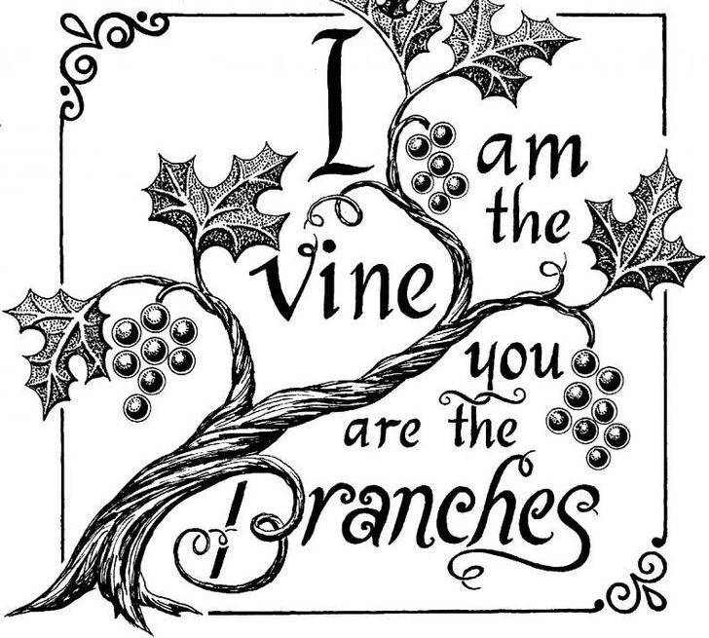
This Sundy’s image of how the risen Christ shares his life with us is the image of the vine. Christ the vine and we the branches are alive in each other, in the mystery of mutual abiding described in the gospel and the first letter of John. Baptism makes us a part of Christ’s living and life-giving self and makes us alive with Christ’s life. As the vine brings food to the branches, Christ feeds us at his holy meal. We are sent out to bear fruit for the life of the world.

The Fifth Sunday of Easter 28 April 2024
Markham Lutheran Church, 3518 W. 160th St., Markham, Illinois 60428
E-mail: Markhemlutheranchurch@gmail.com 708-331-4885
Website: http://www.Markhamlutheranchurch.org/
Pastor Larry Schneekloth
633 At the Lamb’s High Feast We Sing
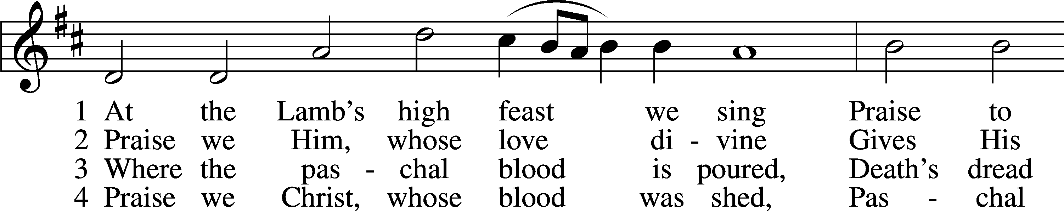
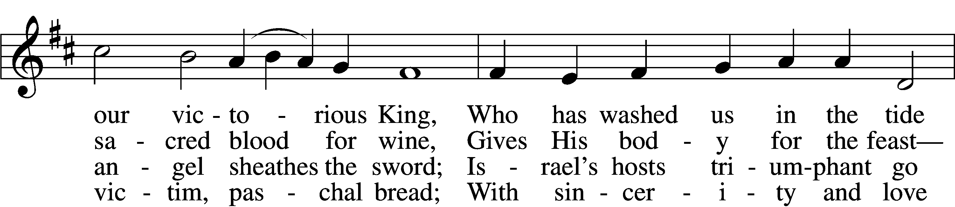
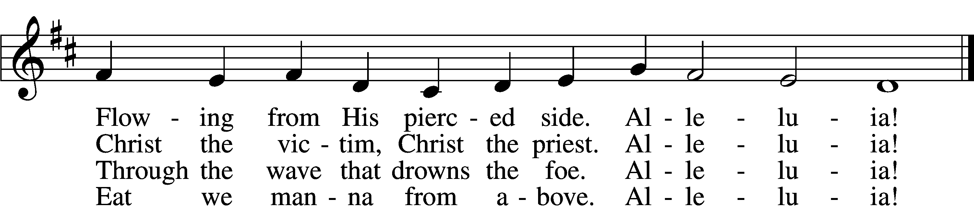

7 Easter triumph, Easter joy! This alone can sin destroy;
From sin’s pow’r, Lord, set us free, Newborn souls in You to be. Alleluia!

D 8 Father, who the crown shall give, Savior, by whose death we live,
Spirit, guide through all our days: Three in One, Your name we praise. Alleluia!

Text: Latin, c. 5th–10th cent.; tr. Robert Campbell, 1814–68, alt. Tune: Kirchengeseng, 1566, Ivancice Text and tune: Public domain

The sign of the cross may be made by all in remembrance of their Baptism.

P In the name of the Father and of the T Son and of the Holy Spirit.
C Amen.

P If we say we have no sin, we deceive ourselves, and the truth is not in us.
C But if we confess our sins, God, who is faithful and just, will forgive our sins and cleanse us from all unrighteousness.

Silence for reflection on God’s Word and for self-examination.

P Let us then confess our sins to God our Father.
C Most merciful God, we confess that we are by nature sinful and unclean. We have sinned against You in thought, word, and deed, by what we have done and by what we have left undone. We have not loved You with our whole heart; we have not loved our neighbors as ourselves. We justly deserve Your present and eternal punishment. For the sake of Your Son, Jesus Christ, have mercy on us. Forgive us, renew us, and lead us, so that we may delight in Your will and walk in Your ways to the glory of Your holy name. Amen.

P Almighty God in His mercy has given His Son to die for you and for His sake forgives you all your sins. As a called and ordained servant of Christ, and by His authority, I therefore announce the forgiveness of all your sins in the name of the Father and of the T Son and of the Holy Spirit.
C Amen.

Service of the Word
Kyrie LSB 168
A In peace let us pray to the Lord.
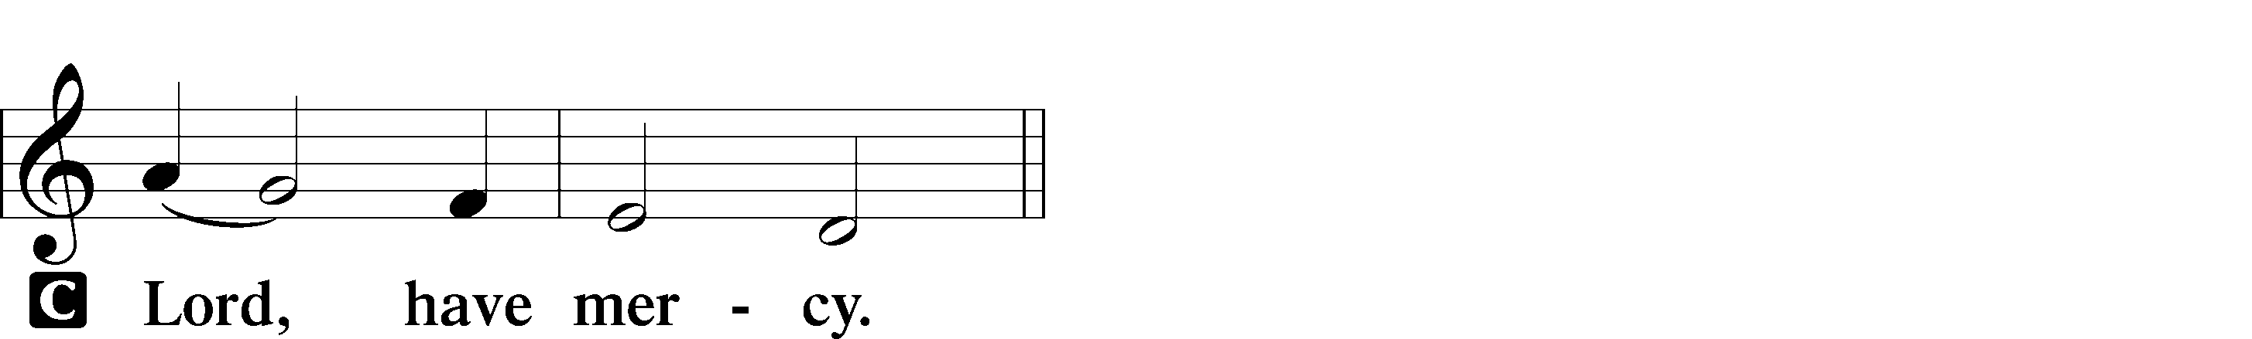

A For the peace from above and for our salvation let us pray to the Lord.
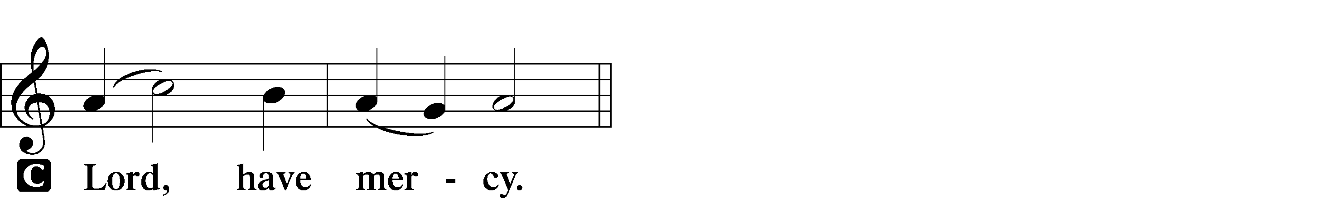

A For the peace of the whole world, for the well-being of the Church of God, and for the unity of all let us pray to the Lord.
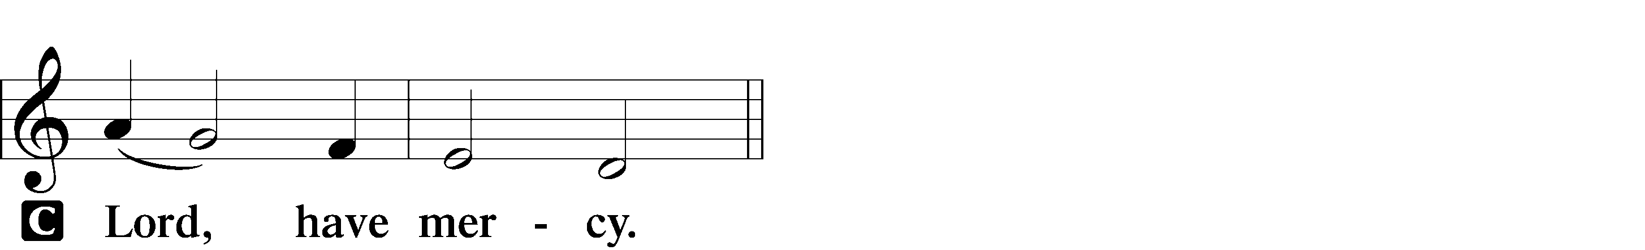

A For this holy house and for all who offer here their worship and praise let us pray to the Lord.
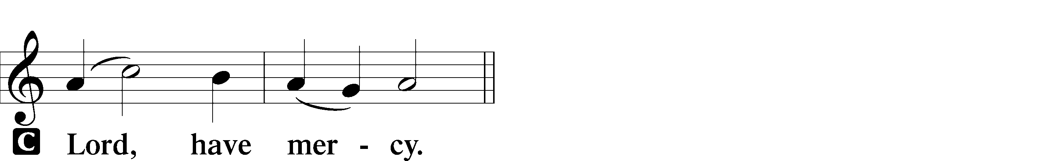

A Help, save, comfort, and defend us, gracious Lord.

Collect of the Day
P Let us pray. O God, You make the minds of Your faithful to be of one will. Grant that we may love what You have commanded and desire what You promise, that among the many changes of this world our hearts may be fixed where true joys are found; through Jesus Christ, Your Son, our Lord, who lives and reigns with You and the Holy Spirit, one God, now and forever.

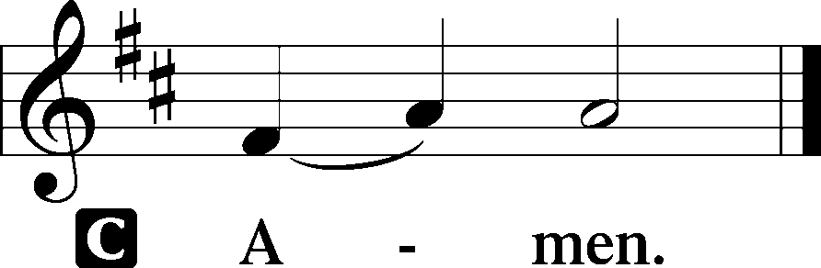

First Reading Acts 8:26–40
26An angel of the Lord said to Philip, “Rise and go toward the south to the road that goes down from Jerusalem to Gaza.” This is a desert place. 27And he rose and went. And there was an Ethiopian, a eunuch, a court official of Candace, queen of the Ethiopians, who was in charge of all her treasure. He had come to Jerusalem to worship 28and was returning, seated in his chariot, and he was reading the prophet Isaiah. 29And the Spirit said to Philip, “Go over and join this chariot.” 30So Philip ran to him and heard him reading Isaiah the prophet and asked, “Do you understand what you are reading?” 31And he said, “How can I, unless someone guides me?” And he invited Philip to come up and sit with him. 32Now the passage of the Scripture that he was reading was this:
“Like a sheep he was led to the slaughter and like a lamb before its shearer is silent,
so he opens not his mouth. 33In his humiliation justice was denied him.
Who can describe his generation? For his life is taken away from the earth.”
34And the eunuch said to Philip, “About whom, I ask you, does the prophet say this, about himself or about someone else?” 35Then Philip opened his mouth, and beginning with this Scripture he told him the good news about Jesus. 36And as they were going along the road they came to some water, and the eunuch said, “See, here is water! What prevents me from being baptized?” 38And he commanded the chariot to stop, and they both went down into the water, Philip and the eunuch, and he baptized him. 39And when they came up out of the water, the Spirit of the Lord carried Philip away, and the eunuch saw him no more, and went on his way rejoicing. 40But Philip found himself at Azotus, and as he passed through he preached the gospel to all the towns until he came to Caesarea.
A This is the Word of the Lord.
C Thanks be to God.

Psalm Psalm 150
1Praise the Lord! Praise God in his sanctu- | ary;* praise him in his mighty | heavens!
2PRAISE HIM FOR HIS | MIGHTY DEEDS;*
PRAISE HIM ACCORDING TO HIS EXCELLENT | GREATNESS!
3Praise him with | trumpet sound;* praise him with | lute and harp!
4PRAISE HIM WITH TAMBOU- | RINE AND DANCE;*
PRAISE HIM WITH | STRINGS AND PIPE!
5Praise him with sounding | cymbals;*
praise him with loud clashing | cymbals!
6LET EVERYTHING THAT HAS BREATH | PRAISE THE LORD!*
PRAISE | THE LORD!
Epistle 1 John 4:1–21
Beloved, do not believe every spirit, but test the spirits to see whether they are from God; for many false prophets have gone out into the world. 2 By this you know the Spirit of God: every spirit that confesses that Jesus Christ has come in the flesh is from God, 3 and every spirit that does not confess Jesus is not from God. And this is the spirit of the antichrist, of which you have heard that it is coming; and now it is already in the world. 4 Little children, you are from God, and have conquered them; for the one who is in you is greater than the one who is in the world. 5 They are from the world; therefore what they say is from the world, and the world listens to them. 6 We are from God. Whoever knows God listens to us, and whoever is not from God does not listen to us. From this we know the spirit of truth and the spirit of error.7 Beloved, let us love one another, because love is from God; everyone who loves is born of God and knows God. 8 Whoever does not love does not know God, for God is love. 9 God’s love was revealed among us in this way: God sent his only Son into the world so that we might live through him. 10 In this is love, not that we loved God but that he loved us and sent his Son to be the
atoning sacrifice for our sins. 11 Beloved, since God loved us so much, we also ought to love one another. 12 No one has ever seen God; if we love one another, God lives in us, and his love is perfected in us.13 By this we know that we abide in him and he in us, because he has given us of his Spirit. 14 And we have seen and do testify that the Father has sent his Son as the Savior of the world. 15 God abides in those who confess that Jesus is the Son of God, and they abide in God. 16 So we have known and believe the love that God has for us. God is love, and those who abide in love abide in God, and God abides in them. 17 Love has been perfected among us in this: that we may have boldness on the day of judgment, because as he is, so are we in this world. 18 There is no fear in love, but perfect love casts out fear; for fear has to do with punishment, and whoever fears has not reached perfection in love. 19 We love because he first loved us. 20 Those who say, “I love God,” and hate their brothers or sisters, are liars; for those who do not love a brother or sister whom they have seen, cannot love God whom they have not seen. 21 The commandment we have from him is this: those who love God must love their brothers and sisters also.
A This is the Word of the Lord.
C Thanks be to God.

Holy Gospel John 15:1–8
P The Holy Gospel according to St. John.
C Glory to You, O Lord.

[Jesus said:] “I am the true vine, and my Father is the vinegrower. ² He removes every branch in me that bears no fruit. Every branch that bears fruit he prunes to make it bear more fruit. ³ You have already been cleansed by the word that I have spoken to you. ⁴ Abide in me as I abide in you. Just as the branch cannot bear fruit by itself unless it abides in the vine, neither can you unless you abide in me. ⁵ I am the vine; you are the branches. Those who abide in me and I in them bear much fruit, because apart from me you can do nothing. ⁶ Whoever does not abide in me is thrown away like a branch and withers; such branches are gathered, thrown into the fire, and burned. ⁷ If you abide in me and my words abide in you, ask for whatever you wish, and it will be done for you. ⁸ My Father is glorified by this, that you bear much fruit and become my disciples.”
P This is the Gospel of the Lord.
C Praise to You, Lord Jesus Christ.
The Homily

611 Chief of Sinners Though I Be
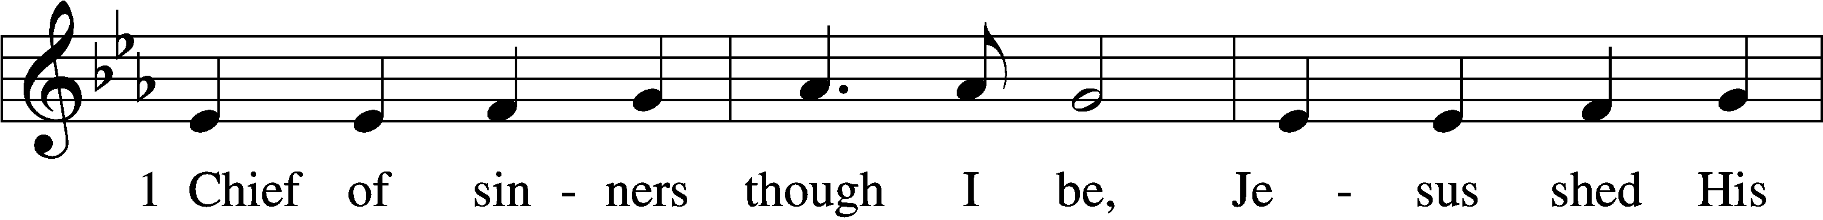
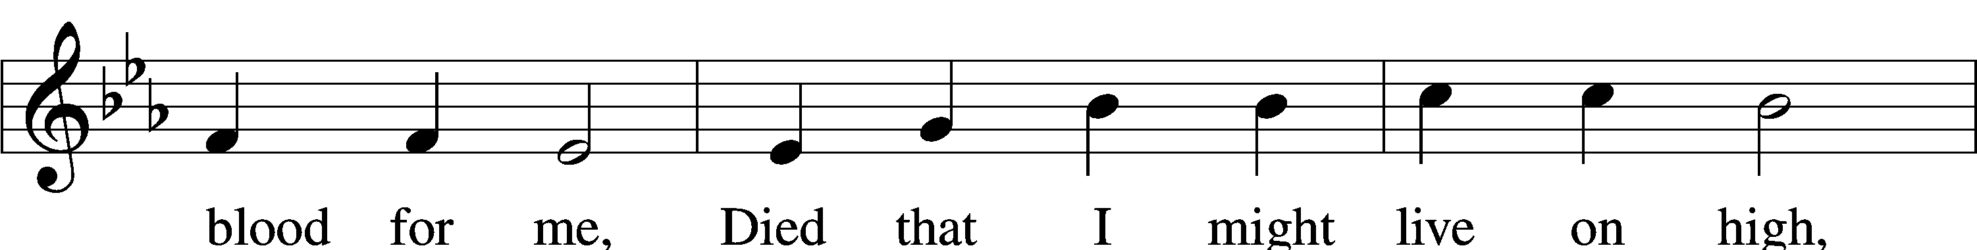
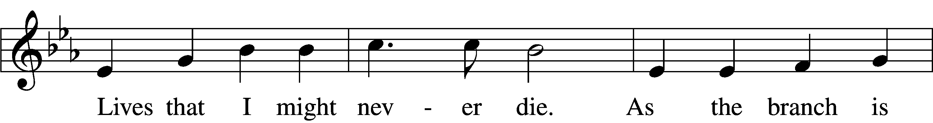
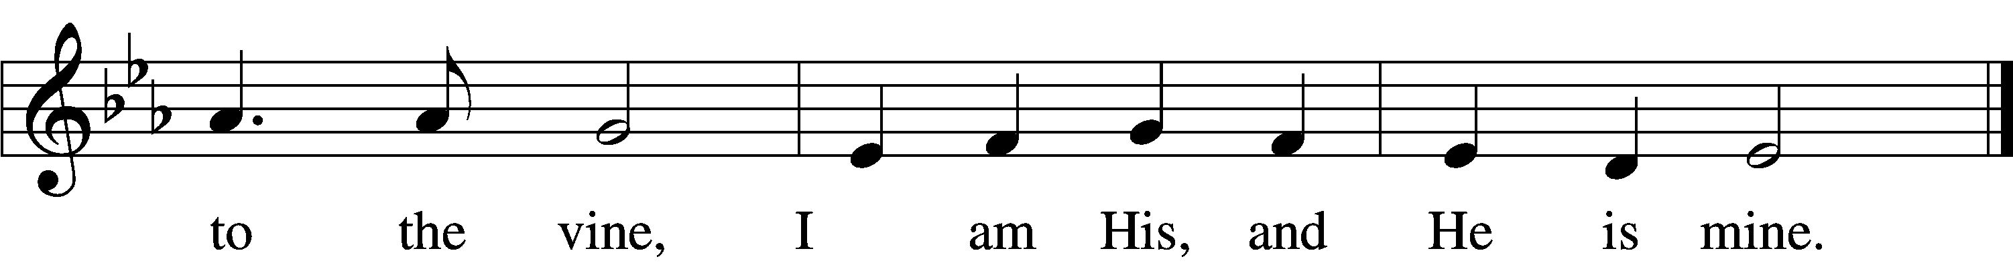
Text: William McComb, 1793–1873, alt.
Tune: Richard Redhead, 1820–1901
Text and tune: Public domain

Nicene Creed

We believe in one God, the Father, the Almighty, maker of heaven and earth, of all that is, seen and unseen.

We believe in one Lord, Jesus Christ, the only Son of God, eternally begotten of the Father, God from God, Light from Light, true God from true God, begotten, not made, of one Being with the Father; through him all things were made. For us and for our salvation he came down from heaven, was incarnate of the Holy Spirit and the Virgin Mary and became truly human. For our sake he was crucified under Pontius Pilate; he suffered death and was buried. On the third day he rose again in accordance with the Scriptures; he ascended into heaven and is seated at the right hand of the Father. He will come again in glory to judge the living and the dead, and his kingdom will have no end.

We believe in the Holy Spirit, the Lord, the giver of life, who proceeds from who has spoken through the prophets. We believe in one holy catholic and apostolic Church. We acknowledge one baptism for the forgiveness of sins. We look for the resurrection of the dead, and the (+) life of the world to come.

Prayer of the Church
….Lord, in your mercy,
HEAR OUR PRAYER.

(last petition:) Into your hands we commend ourselves, and all for whom we pray, trusting in your mercy, through Jesus Christ our Lord.
AMEN.

Christ is risen! Alleluia!
CHRIST IS RISEN INDEED! ALLELUIA!

(Share the Peace of the Lord)

595 O Blessed Spring
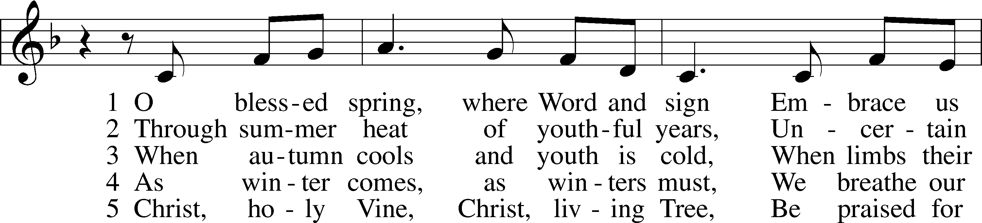
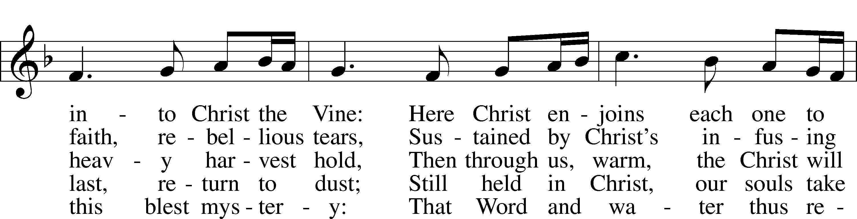
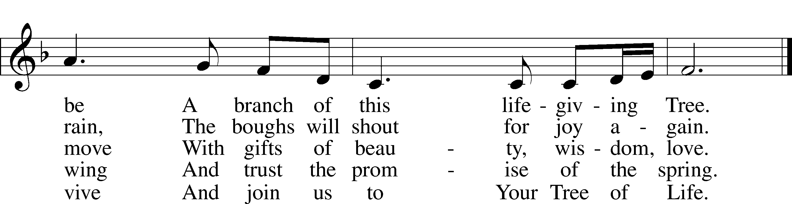

Text: Susan Palo Cherwien, 1953
Tune: English
Text: © 1993 Susan Palo Cherwien, admin. Augsburg Fortress. Used by permission: LSB Hymn License no. 110001341
Tune: Public domain

OUR EASTER COMMUNION
P The Lord be with you.
C And also with you.
P Lift up your hearts.
C We lift them to the Lord.
P Let us give thanks to the Lord our God.
C It is right to give God thanks and praise.

P It is truly good, right, and salutary that we should at all times and in all places give thanks to You, holy Lord, almighty Father, everlasting God. And most especially are we bound to praise You on this day for the glorious resurrection of Your Son, Jesus Christ, the very Paschal Lamb, who was sacrificed for us and bore the sins of the world. By His dying He has destroyed death, and by His rising again He has restored to us everlasting life. Therefore with Mary Magdalene, Peter and John, and with all the witnesses of the resurrection, with angels and archangels, and with all the company of heaven praise your name and join their unending hymn:

Sanctus LSB 178
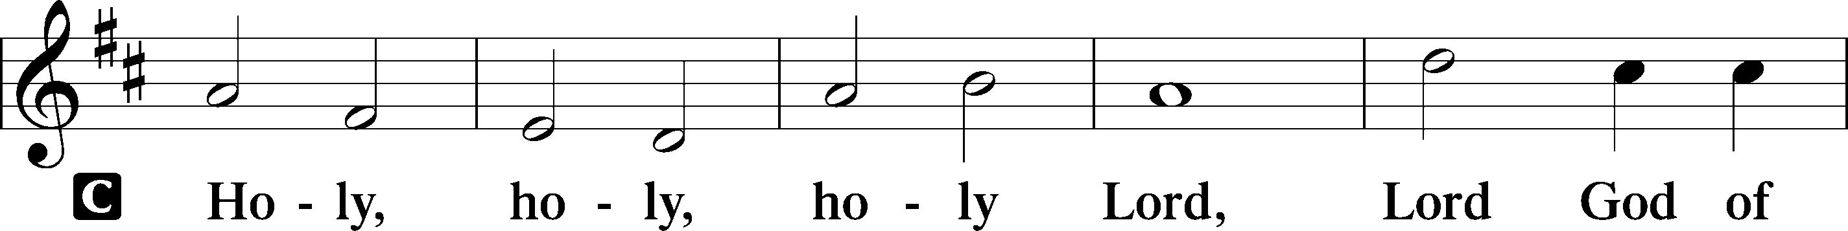
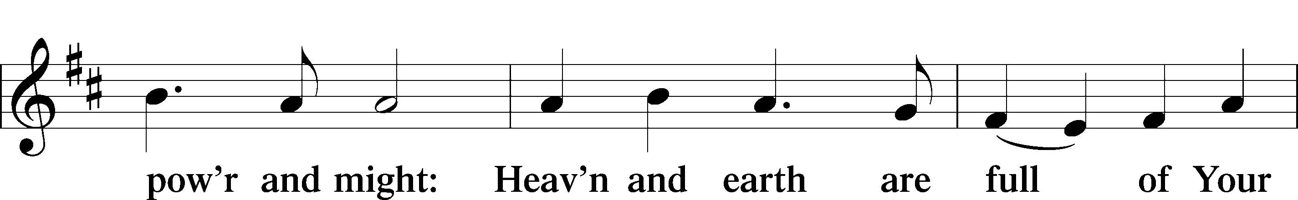
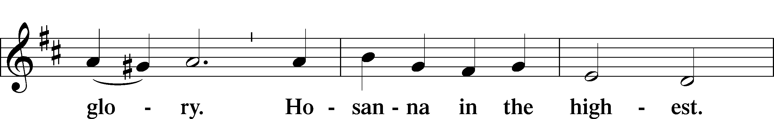
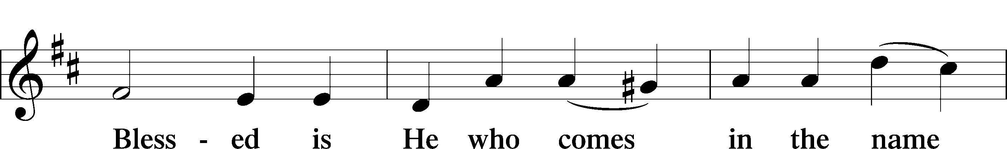
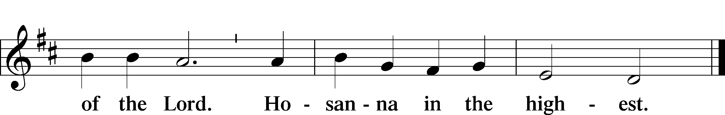

Our Lord Jesus Christ… the Lord’s death until he comes.
CHRIST HAS DIED, CHRIST IS RISEN, CHRIST WILL COME AGAIN.

Join our prayers with those of your servants of every time and place, and unite them with the ceaseless petitions of Jesus Christ, our great High Priest, until he comes as victorious Lord of all.
THROUGH HIM, WITH HIM, IN HIM, IN THE UNITY OF THE HOLY SPIRIT, ALL HONOR AND GLORY IS YOURS, ALMIGHTY FATHER, NOW AND FOREVER. AMEN.

In the words of our Lord we pray: OUR FATHER....

THE HOLY COMMUNION

The Thanksgiving and Closing

O give thanks to the Lord, for he is good,
AND HIS MERCY ENDURES FOREVER.
We give thanks to you, almighty God, that you have refreshed us through your holy Word, and your holy Meal. We ask that you use these gifts to your church to strengthen us; strengthen us in faith toward You and in fervent love toward one another; through Jesus Christ, your Son, our Lord, who lives and reigns with you and the Holy Spirit, one God, now and forever.
AMEN.

Almighty God bless you, the Father, the (+) Son, and the Holy Spirit.
AMEN.

Hymn 474 Alleluia! Jesus Is Risen (over)

EASTER IS NOT JUST ONE DAY IN OUR CALENDAR—WE CONTINUE TO CELEBRATE THE RESURRECTION OF OUR LORD DURING THE GREAT SEVEN WEEKS OF EASTER. WORSHIP WITH US EACH WEEK; REJOICE WITH US, FOR THE LORD IS RISEN! HE IS RISEN INDEED! ALLELUIA!

HAPPY BIRTHDAY TO:
4/29 Joshua Kustra
5/2 Luke Phillips

Acknowledgments
Divine Service, Setting Two from Lutheran Service Book
Created by Lutheran Service Builder © 2024 Concordia Publishing House.

474 Alleluia! Jesus Is Risen
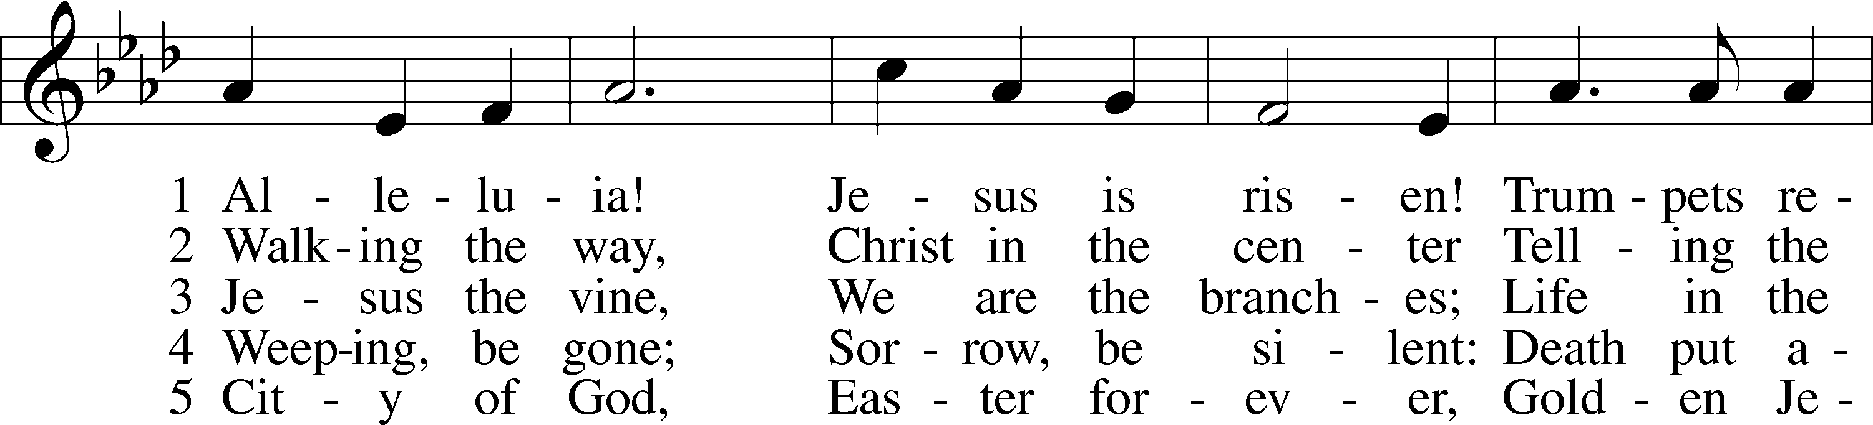
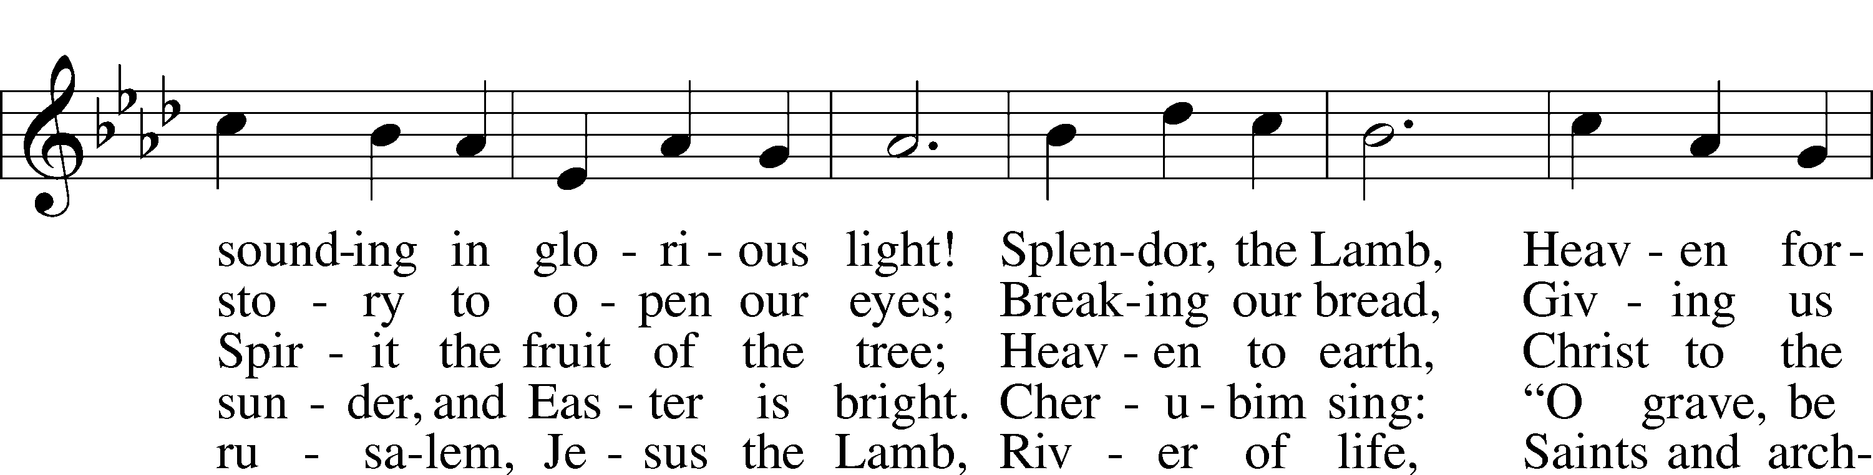
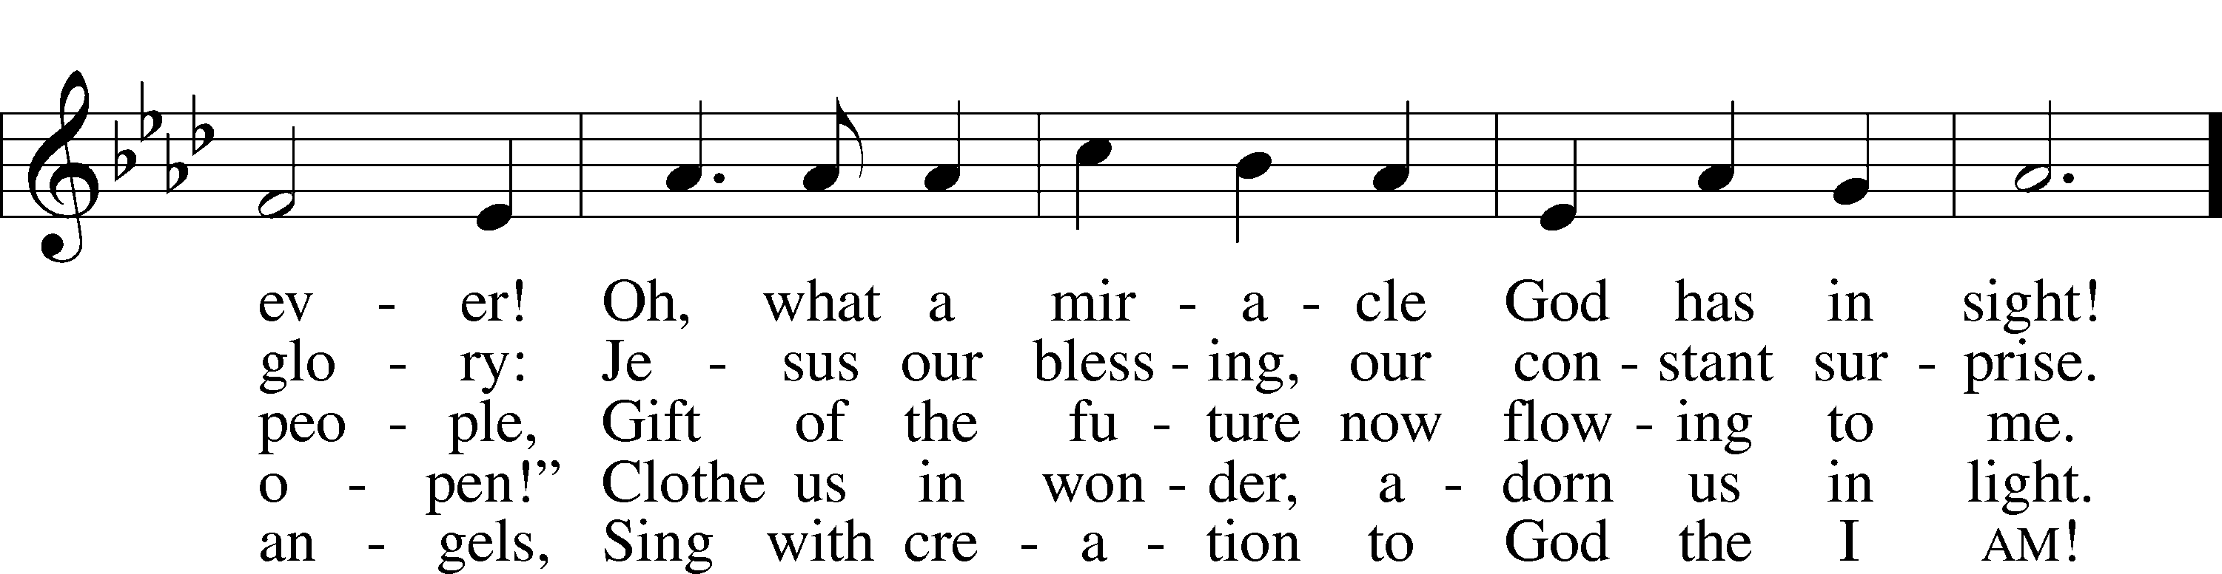
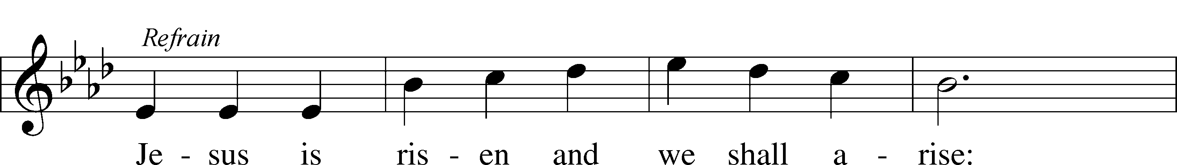
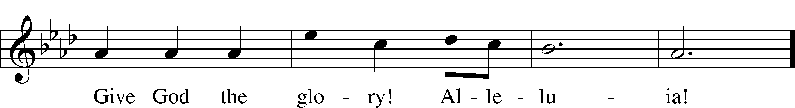

Text: Herbert F. Brokering, 1926–2009
Tune: David N. Johnson, 1922–87
Text: © 1995 Augsburg Fortress. Used by permission: LSB Hymn License no. 110001341
Tune: © 1968 Augsburg Publishing House. Used by permission: LSB Hymn License no. 110001341

THIS WEEK IN THE CHURCH CALENDAR

4/29: Catherine of Siena, teacher, 1380
Catherine was born in Siena in 1346. At an early age she had visions of Christ and decided to devote her life to God. After living in a closed-off room in her family's house for three years, she emerged to involve herself in a life of doing good works. She carried on a voluminous correspondence with leaders of church and state, persuading Gregory XI to return from Avignon to Rome. She was a woman of boundless energy who dealt effectively with rulers, diplomats, and leaders of all kinds and was also loved by the common people. She died in Rome at the age of 33. Highly regarded in northern Europe, her name was retained on a number of Lutheran calendars. The Roman Catholic calendar observes her feast day on April 29, the day of her death.
5/1: St. Philip and St. James, Apostles
Philip, like Peter and Andrew, was born at Bethsaida and was one of the first disciples of Jesus. After he became an apostle, he brought Nathaniel to Jesus. Philip may have been of Greek ancestry (his name is Greek), for when "certain Greeks" wanted to see Jesus, they came to Philip. According to tradition, Philip was martyred in Phrygia. James, the son of Alphaeus, is traditionally called "the less" to distinguish him from James the brother of John, and from James the brother of the Lord. Philip and James are commemorated together because the supposed remains of the two saints were placed in the Church of the Apostles in Rome on this day in 561.
5/2: Athanasius, Bishop of Alexandria, 373
Athanasius was born in Alexandria, c. 295. At the Council of Nicaea in 325 while still a deacon, he defended the divinity of Christ, and from that time on championed Christian orthodoxy against Arianism. Consecrated Bishop of Alexandria in 328, his 45-year episcopate was one of turmoil caused by civil authorities, heretical churchmen and his own rigid temperament. By his tireless defense of the faith, he earned the title, Father of Orthodoxy. The Athanasian Creed is named for him.

5/2: Elisabeth Cecelia von Meseritz Cruciger (also spelled Kreuziger, Creutziger etc.), Poet and Hymnographer, 1535
Elisabeth von Meseritz Kreuziger or Cruciger was the first female poet and hymn writer of the Protestant Reformation. She was a friend of Martin and Katherina “Katie” Luther. Frau Cruciger was born into a noble family in Meseritz in Farther Pomerania, and while still a child entered Marienbusch Abbey, a Premonstratesian house (The Order of the Canons of Prémontré) in Treptow an der Rega. She and her family got to know the ideas of the Reformation through Johannes Bugenhagen, and converted to Lutheranism. During the persecutions of Lutherans in Poland, the family removed Elisabeth from the abbey and in 1522 moved to Wittenberg. They lived in Bugenhagen's household. In 1524 Elisabeth married the theologian Caspar Cruciger the Elder, a student and assistant of Luther. They had one daughter, Elisabeth Cruciger the Younger (who married rector Kegel and then, on his death, Luther's son Hans in Eisleben), and one son, Caspar Cruciger the Younger. She died in Wittenberg.
5/4: Monica, Mother of Augustine, 387
Monica (the oldest spelling is Monnica), the mother of Augustine, apparently was a native of Tugaste, North Africa. At the age of 40 she was left a widow with three children. She prayed earnestly for the conversion of the eldest, Augustine, following him to Rome and then to Milan. There she witnessed her son's conversion. She died returning to Africa. In Book IX of his Confession, Augustine writes tenderly of her and of her dying wish to be remembered at the altar of the Lord. Her commemoration developed late in the Middle Ages. The Roman Catholic calendar has moved her commemoration to August 27.

691 Fruitful Trees, the Spirit’s Sowing
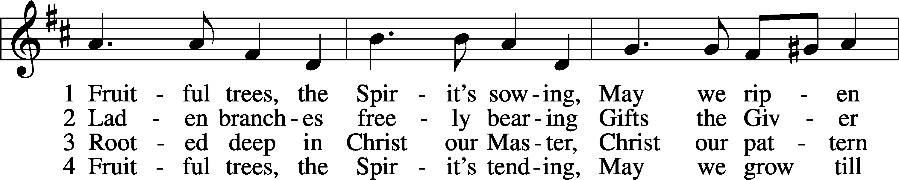
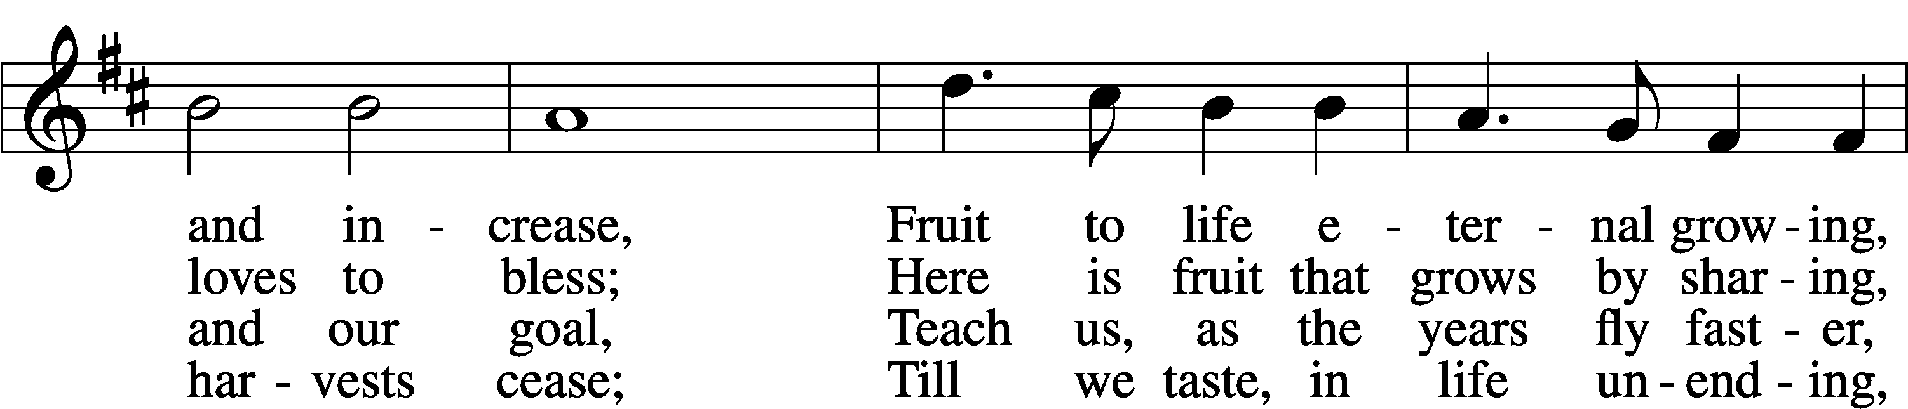
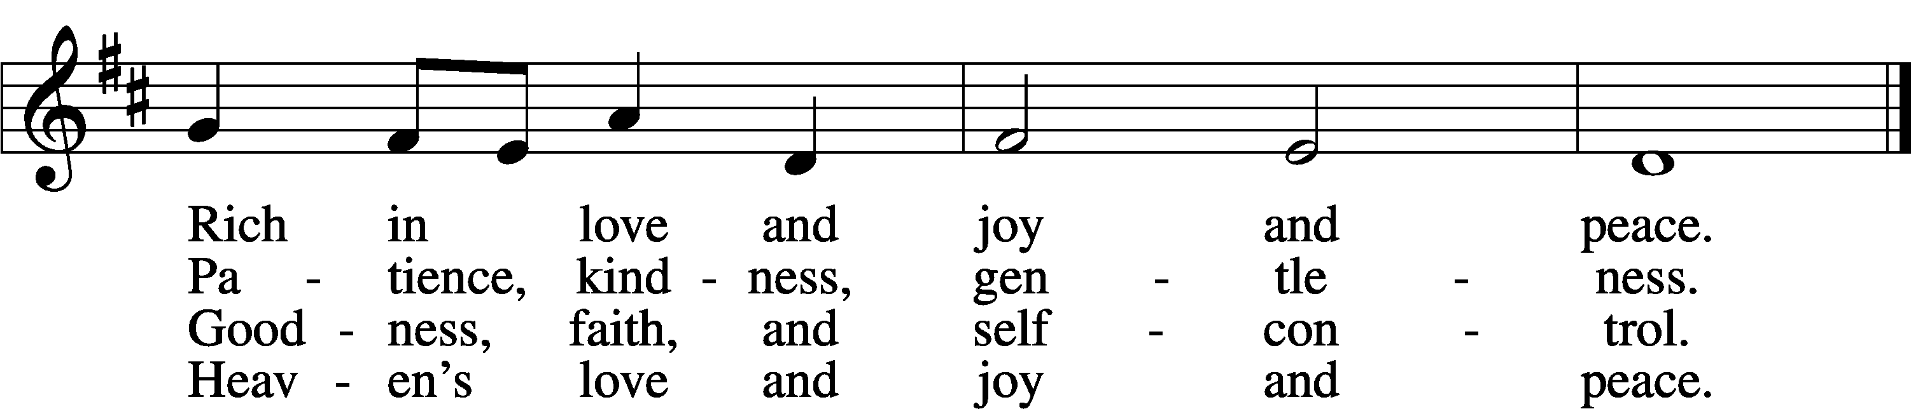

Text: Timothy Dudley-Smith, 1926
Tune: Ralph C. Schultz, 1932
Text: © 1984 Hope Publishing Co. Used by permission: LSB Hymn License no. 110001341
Tune: © 1980 Concordia Publishing House. Used by permission: LSB Hymn License no. 110001341

