
Jesus begins his public ministry by calling fishers to leave their nets and follow him. In Jesus the kingdom of God has come near. We who have walked in darkness have seen a great light. We see this light most profoundly in the cross—as God suffers with us and all who are oppressed by sickness, sin, or evil. Light dawns for us as we gather around the word, the font, and the holy table. We are then sent to share the good news that others may be “caught” in the net of God’s grace and mercy.

The 3rd Sunday after the Epiphany 25 January 2026
Markham Lutheran Church, 3518 W. 160th St., Markham, Illinois 60428
E-mail: markhamlutheranchurch@gmail.com
Website: http://www.Markhamlutheranchurch.org/
Pastor Larry Schneekloth
Service of the Word

412 The People That in Darkness Sat
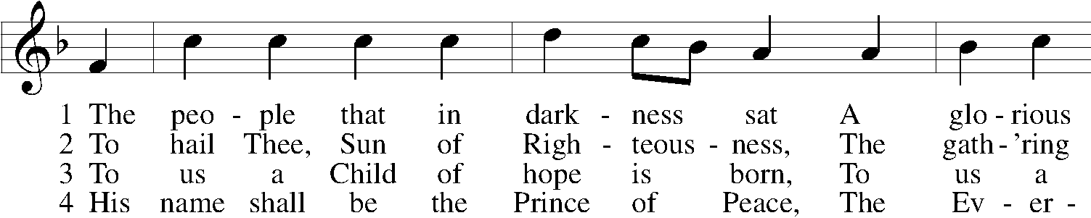
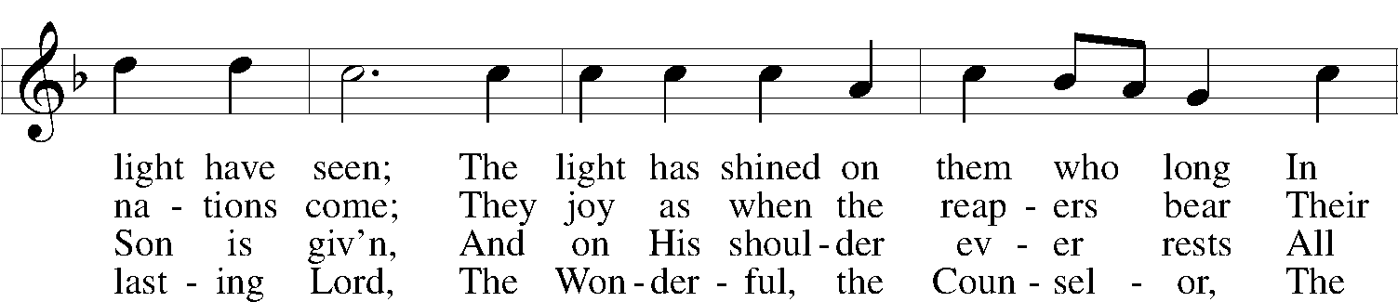
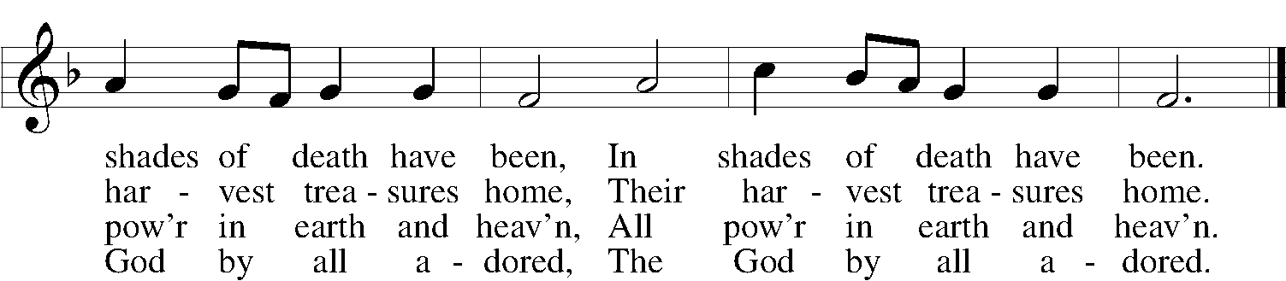

5 His righteous government and pow’r Shall over all extend;
On judgment and on justice based, His reign shall have no end,
His reign shall have no end.

D 6 Lord Jesus, reign in us, we pray, And make us Thine alone,
Who with the Father ever art And Holy Spirit, one,
And Holy Spirit, one.

Text: John Morison, 1749–98, alt.
Tune: Nicolaus Herman, c. 1480–1561
Text and tune: Public domain

P In the name of the Father and of the T Son and of the Holy Spirit.
C Amen.

Kyrie LSB 168
A In peace let us pray to the Lord.


A For the peace from above and for our salvation let us pray to the Lord.


A For the peace of the whole world, for the well-being of the Church of God, and for the unity of all let us pray to the Lord.


A For this holy house and for all who offer here their worship and praise let us pray to the Lord.


A Help, save, comfort, and defend us, gracious Lord.


Collect of the Day
P Let us pray. Almighty and everlasting God, you sent your Son to proclaim your kingdom, and to teach with authority. Anoint us with the power of your Spirit, that we, too, may bring good news to the afflicted, bind up the broken-hearted, and proclaim liberty to the captives; through Jesus Christ, our Lord.
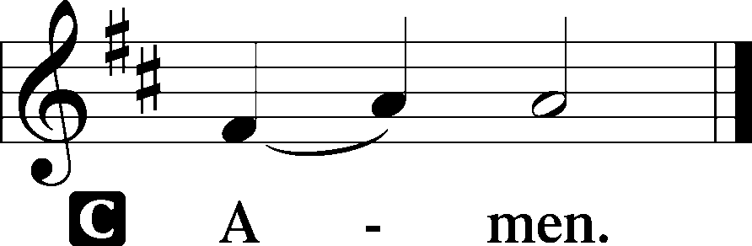

Old Testament Reading Isaiah 9:1–4

But there will be no gloom for those who were in anguish. In the former time he brought into contempt the land of Zebulun and the land of Naphtali, but in the latter time he will make glorious the way of the sea, the land beyond the Jordan, Galilee of the nations. ² The people who walked in darkness have seen a great light; those who lived in a land of deep darkness—on them light has shined. ³ You have multiplied exultation; you have increased its joy; they rejoice before you as with joy at the harvest, as people exult when dividing plunder. ⁴ For the yoke of their burden and the bar across their shoulders, the rod of their oppressor, you have broken as on the day of Midian.
A This is the Word of the Lord.
C Thanks be to God.

Psalm Psalm 27:1, 4–9
1The Lord is my light and my salvation; whom | shall I fear?*
The Lord is the stronghold of my life; of whom shall I | be afraid?
4ONE THING HAVE I ASKED OF THE LORD,
THAT WILL I SEEK | AFTER:*
THAT I MAY DWELL IN THE HOUSE OF THE LORD ALL THE DAYS OF MY LIFE, TO GAZE UPON THE BEAUTY OF THE LORD
AND TO INQUIRE IN HIS | TEMPLE.
5For he will hide me in his shelter in the day of | trouble;*
he will conceal me under the cover of his tent; he will lift me high up- | on a rock.
6AND NOW MY HEAD SHALL BE LIFTED UP ABOVE MY ENEMIES ALL AROUND ME, AND I WILL OFFER IN HIS TENT SACRIFICES WITH | SHOUTS OF JOY;*
I WILL SING AND MAKE MELODY | TO THE LORD.
7Hear, O Lord, when I | cry aloud;* be gracious to me and | answer me!
8YOU HAVE SAID, | “SEEK MY FACE.”*
MY HEART SAYS TO YOU, “YOUR FACE, LORD, | DO I SEEK.”
9Hide not your face from me. Turn not your servant away in | anger,*
O you who have been my help.
CAST ME NOT OFF; FORSAKE ME NOT, O GOD OF MY SAL- | VATION!

Epistle 1 Corinthians 1:10–18

¹⁰ Now I appeal to you, brothers and sisters, by the name of our Lord Jesus Christ, that all of you be in agreement and that there be no divisions among you but that you be knit together in the same mind and the same purpose. ¹¹ For it has been made clear to me by Chloe’s people that there are quarrels among you, my brothers and sisters. ¹² What I mean is that each of you says, “I belong to Paul,” or “I belong to Apollos,” or “I belong to Cephas,” or “I belong to Christ.” ¹³ Has Christ been divided? Was Paul crucified for you? Or were you baptized in the name of Paul? ¹⁴ I thank God that I baptized none of you except Crispus and Gaius, ¹⁵ so that no one can say that you were baptized in my name. ¹⁶ I did baptize also the household of Stephanas; beyond that, I do not know whether I baptized anyone else. ¹⁷ For Christ did not send me to baptize but to proclaim the gospel—and not with eloquent wisdom, so that the cross of Christ might not be emptied of its power. ¹⁸ For the message about the cross is foolishness to those who are perishing, but to us who are being saved it is the power of God. A This is the Word of the Lord.
C Thanks be to God.

Alleluia and Verse LSB 173
C ALLELUIA. LORD, TO WHOM SHALL WE GO?
YOU HAVE THE WORDS OF ETERNAL LIFE. ALLELUIA.

Holy Gospel Matthew 4:12–25
P The Holy Gospel according to St. Matthew.
C Glory to You, O Lord.

¹² Now when Jesus heard that John had been arrested, he withdrew to Galilee. ¹³ He left Nazareth and made his home in Capernaum by the sea, in the territory of Zebulun and Naphtali, ¹⁴ so that what had been spoken through the prophet Isaiah might be fulfilled: ¹⁵ “Land of Zebulun, land of Naphtali, on the road by the sea, across the Jordan, Galilee of the gentiles—¹⁶ the people who sat in darkness have seen a great light, and for those who sat in the region and shadow of death light has dawned.” ¹⁷ From that time Jesus began to proclaim, “Repent, for the kingdom of heaven has come near.” ¹⁸ As he walked by the Sea of Galilee, he saw two brothers, Simon, who is called Peter, and Andrew his brother, casting a net into the sea—for they were fishers. ¹⁹ And he said to them, “Follow me, and I will make you fishers of people.” ²⁰ Immediately they left their nets and followed him.
²¹ As he went from there, he saw two other brothers, James son of Zebedee and his brother John, in the boat with their father Zebedee, mending their nets, and he called them. ²² Immediately they left the boat and their father and followed him. ²³ Jesus went throughout all Galilee, teaching in their synagogues and proclaiming the good news of the kingdom and curing every disease and every sickness among the people. ²⁴ So his fame spread throughout all Syria, and they brought to him all the sick, those who were afflicted with various diseases and pains, people possessed by demons or having epilepsy or afflicted with paralysis, and he cured them. ²⁵ And great crowds followed him from Galilee, the Decapolis, Jerusalem, Judea, and from beyond the Jordan.
P This is the Gospel of the Lord.
C Praise to You, Lord Jesus Christ.

The Homily

The Prayer of the Church
...Lord, in your mercy,
HEAR OUR PRAYER.

(Last petition:) Into your hands we commend ourselves, and all for whom we pray, trusting in your mercy, through Jesus Christ our Lord.
AMEN

839 O Christ, Our True and Only Light
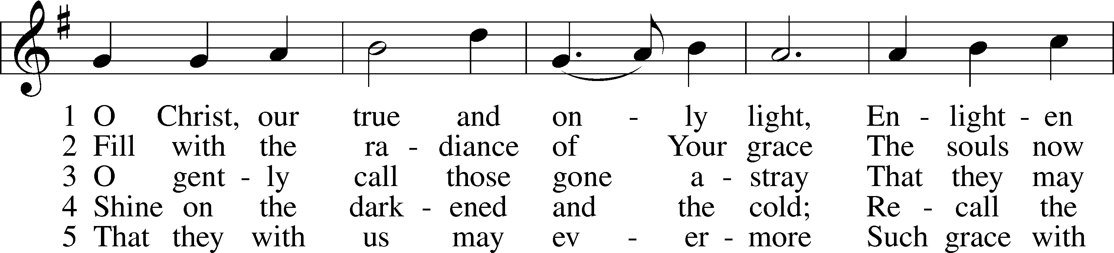
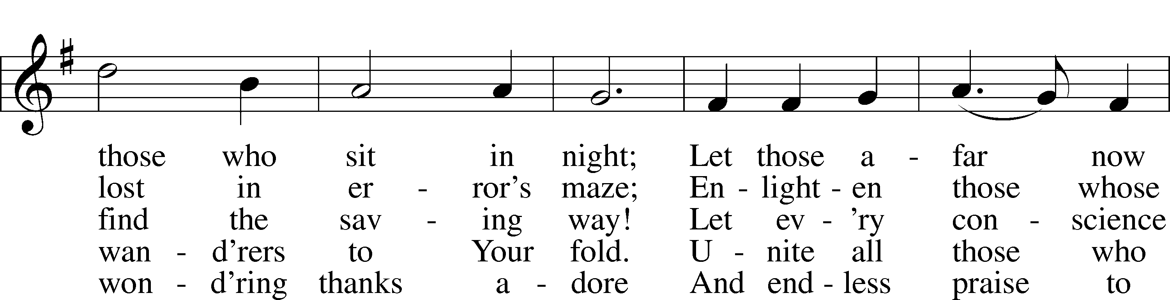
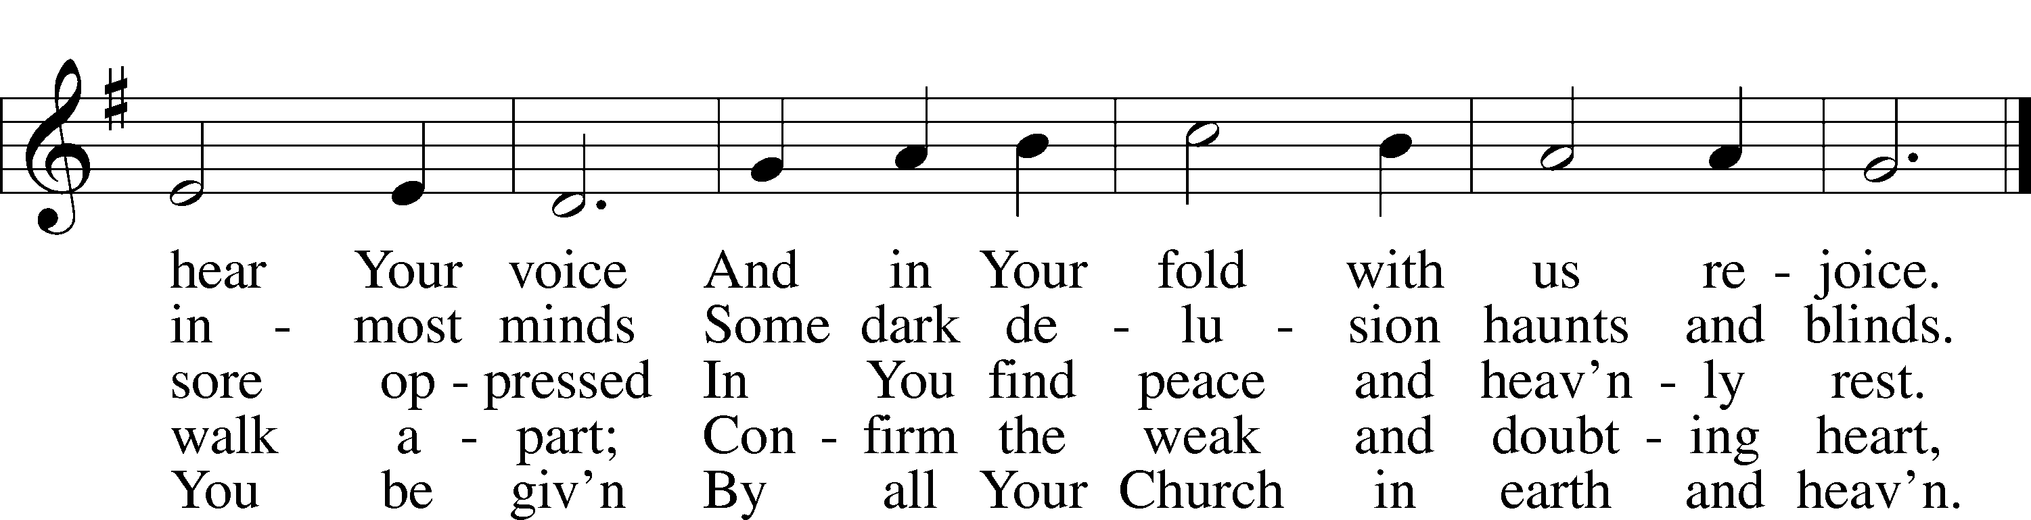

Text: Johann Heermann, 1585–1647; tr. Catherine Winkworth, 1827–78, alt.
Tune: Andächtige Haus-Kirche, 1676, Nürnberg
Text and tune: Public domain

Service of the Sacrament

The Lord be with you.
AND ALSO WITH YOU.
Lift up your hearts.
WE LIFT THEM TO THE LORD.
Let us give thanks to the Lord our God.
IT IS RIGHT TO GIVE GOD THANKS AND PRAISE.

It is indeed right and salutary that we should at all times and in all places offer thanks and praise to you, O Lord, holy Father, through Christ our Lord. Sharing our life, he lived among us to reveal your glory and love, that our darkness should give way to his own brilliant light. And so, with the Church on earth and the hosts of heaven, we praise your name and join their unending hymn:

Sanctus LSB 178
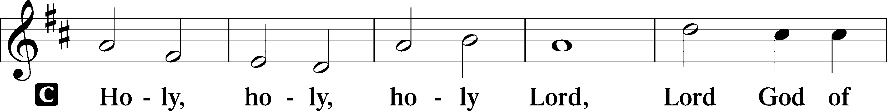
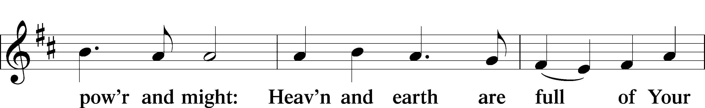
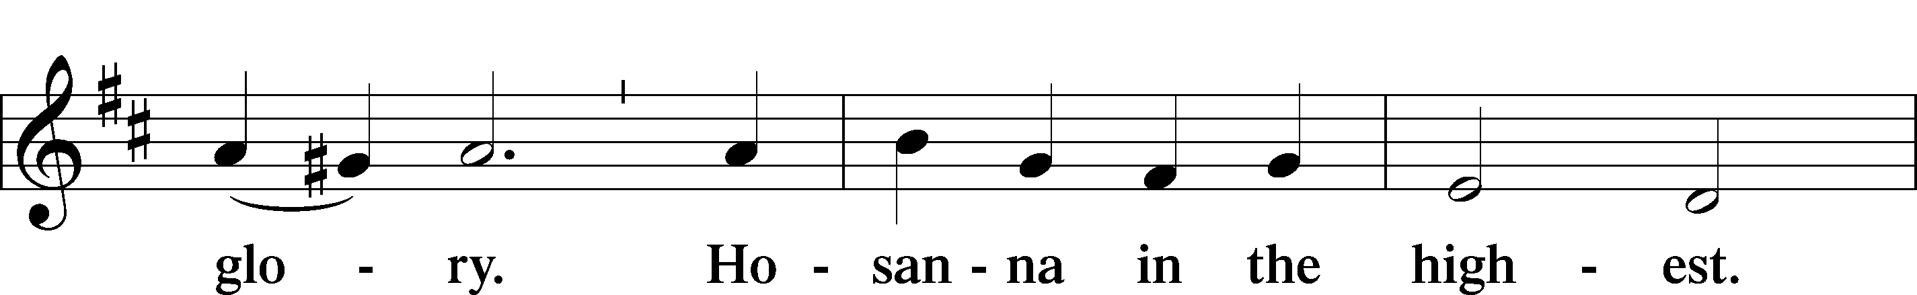
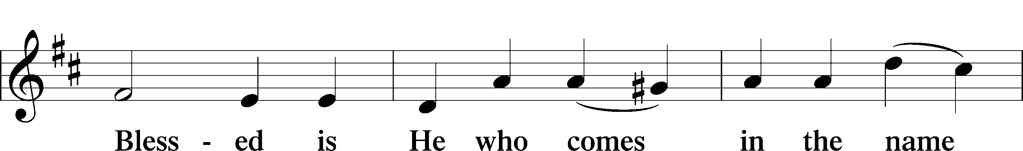
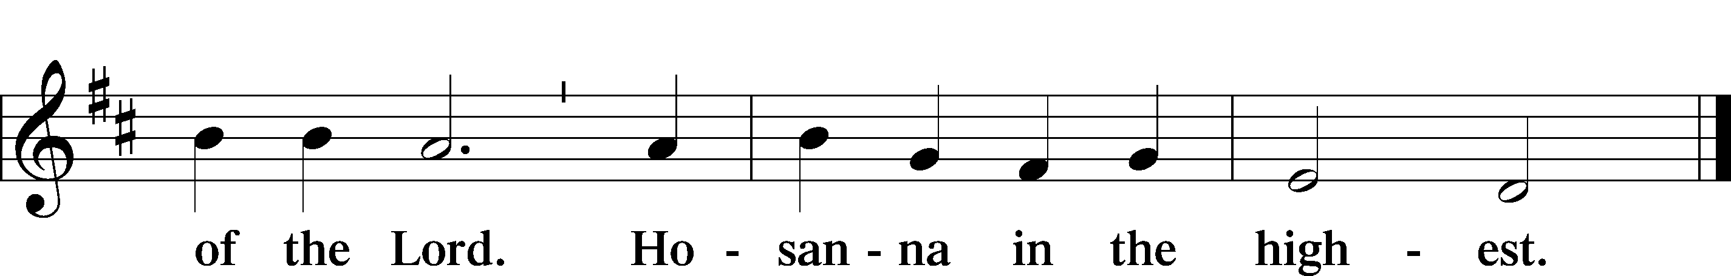

Our Lord Jesus Christ...

As often as we eat this bread and drink from this cup, we proclaim the Lord's death until he comes.
CHRIST HAS DIED. CHRIST IS RISEN. CHRIST WILL COME AGAIN.

Join our prayers with those of your servants of every time and place, and unite them with the ceaseless petitions of Jesus Christ, our great High Priest, until he comes as victorious Lord of all.
THROUGH HIM, WITH HIM, IN HIM, IN THE UNITY OF THE HOLY SPIRIT, ALL HONOR AND GLORY IS YOURS, ALMIGHTY FATHER, NOW AND FOREVER. AMEN.

Remember us in your kingdom and teach us to pray:
OUR FATHER....

The Holy Communion

The Thanksgiving and Closing

O give thanks to the Lord, for he is good,
AND HIS MERCY ENDURES FOREVER.

We give thanks to you, almighty God, that you have refreshed us with your word, with a remembrance of the blessings of our Baptism, and with the Body and Blood of Christ in the Holy Communion. We ask that through these sacramental gifts you would strengthen us in faith and obedience to you, and in fervent love for one another; through Jesus Christ our Lord.
AMEN.

Benediction

The Lord bless you and keep you;
the Lord make his face to shine upon you and be gracious to you;
the Lord lift up his countenance upon you and give you peace, in the name of the Father, and of the Son, and of the Holy Spirit.
C Amen.

Closing Hymn 810 O God of God, O Light of Light

810 O God of God, O Light of Light
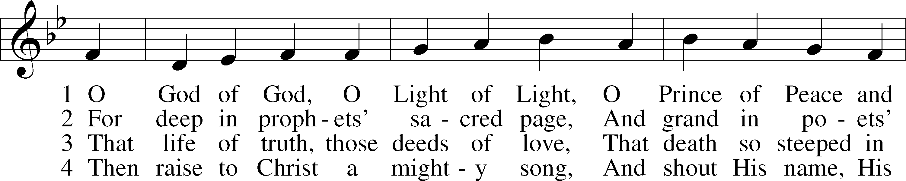
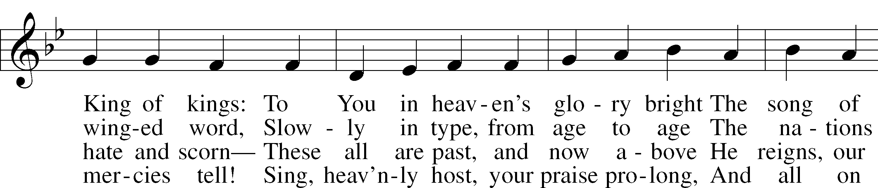
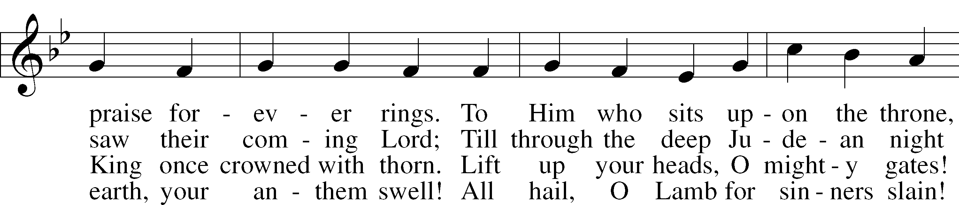
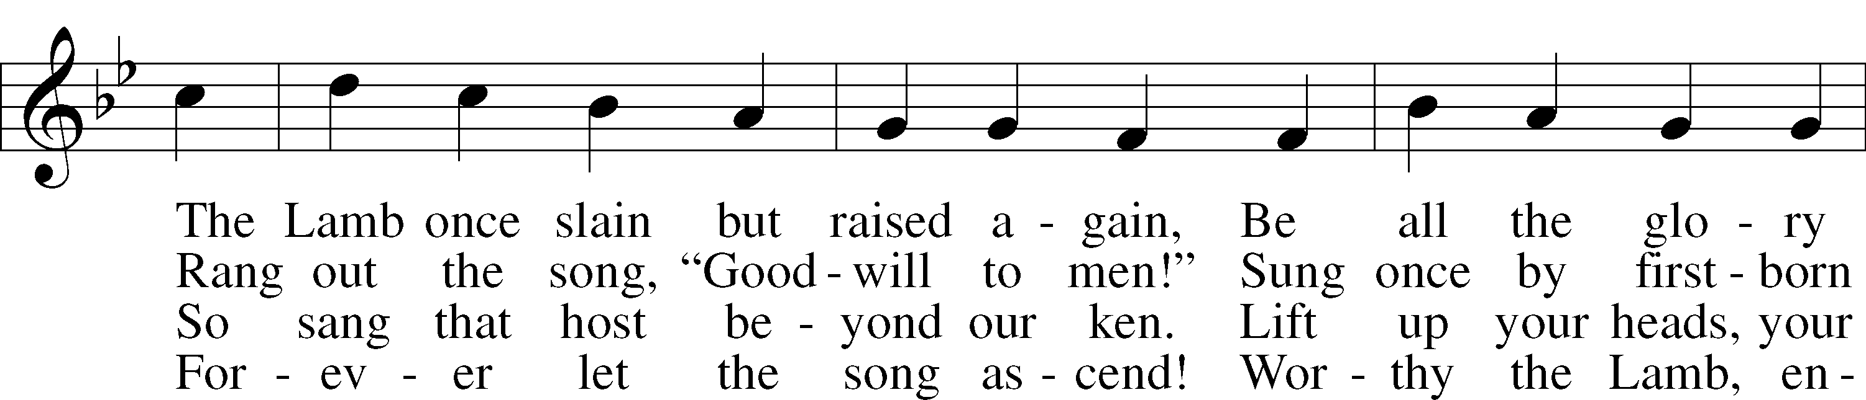
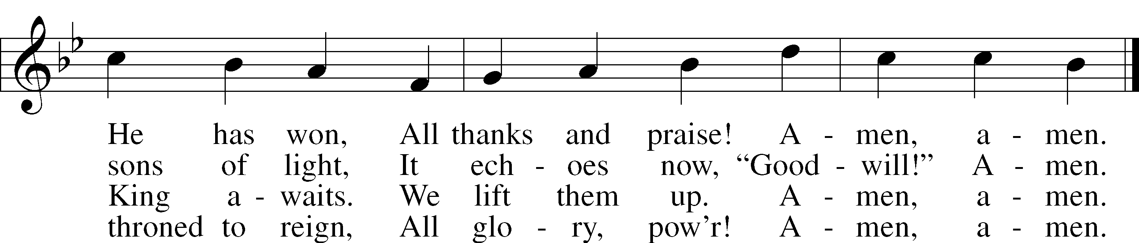

Text: John Julian, 1839–1913, alt.
Tune: Johann Störls . . . Schlag- Gesang- Und Noten-Buch, 1744, Stuttgart
Text and tune: Public domain

THE WEEK OF PRAYER FOR CHRISTIAN UNITY ENDS TODAY.
A suggested prayer: God our Father, your Son Jesus prayed that his followers might be one. Make all Christians one with him, as he is one with you, so that in peace and unity we may carry your message of love to the world; through Jesus Christ our Lord.

HAPPY BIRTHDAY THIS WEEK TO:
Diana Berry 1/28
Wally Mankewicz 1/28

Coming up: Feb 1—congregation meeting
Feb 15—Transfiguration Sunday (burn palms)
--chili cookoff!!

THIS WEEK IN THE CHURCH CALENDAR
1/25: The Conversion of St. Paul
The observance of this festival, commemorating a momentous event in the life of the early Church, began in Gaul in the sixth century. It spread throughout the Western church and achieved such popularity that both the Anglican and Lutheran reformers retained the day on their calendars. The day has never been observed in the Eastern church. Prayer: Lord God, you taught the whole world through the preaching of your apostle, Paul. We celebrate his conversion and pray that we may follow his example and be witnesses to your truth in this world; through Jesus Christ our Lord. Read: Acts 2:1-22; Galatians1:11-24. THIS DAY MARKS THE END OF THE WEEK OF PRAYER FOR CHRISTIAN UNITY.
1/26: Timothy, Titus, and Silas, companions of Paul
TIMOTHY accompanied Paul on his 2nd missionary journey and became the intimate friend to whom Paul entrusted the mission at Thessalonica (1 Thess. 3:2) and Corinth (1 Cor. 4:17). He was with Paul at Rome and, according to Eusebius, became the first Bishop of Ephesus. A 4th century account of his acts tells of his martyrdom on January 22, 97. TITUS joined Paul on the journey to the apostolic council at Jerusalem Gal. 2:1). He was later sent on a difficult mission to Corinth (2 Cor. 8:6ff), and also worked in Crete and Dalmatia. According to Eusebius, Titus was the first Bishop of Crete. SILAS was a companion of Paul on his first visit to Macedonia and Corinth. An uncompromising preacher, Silas was commended by Paul for his faithfulness and steadfastness. Tradition says that he died in Macedonia.
1/27: Lydia, Dorcas, and Phoebe, witnesses to the faith
On this day the Church remembers three women who were companions in Paul’s ministry. LYDIA was Paul’s first convert at Philippi. She was a merchant of purple-dyed goods, and because purple dye was extremely expensive, it is likely that she was a woman of some wealth. Lydia and her household were baptized by Paul and for a time her home was a base for Paul’s missionary work. DORCAS is remembered for her charitable works, particularly making clothing for needy widows. PHOEBE was a diakonos, a deaconess in the church at Cenchreae, near Corinth. Paul praises her as one who, through her service, looked after many people.

