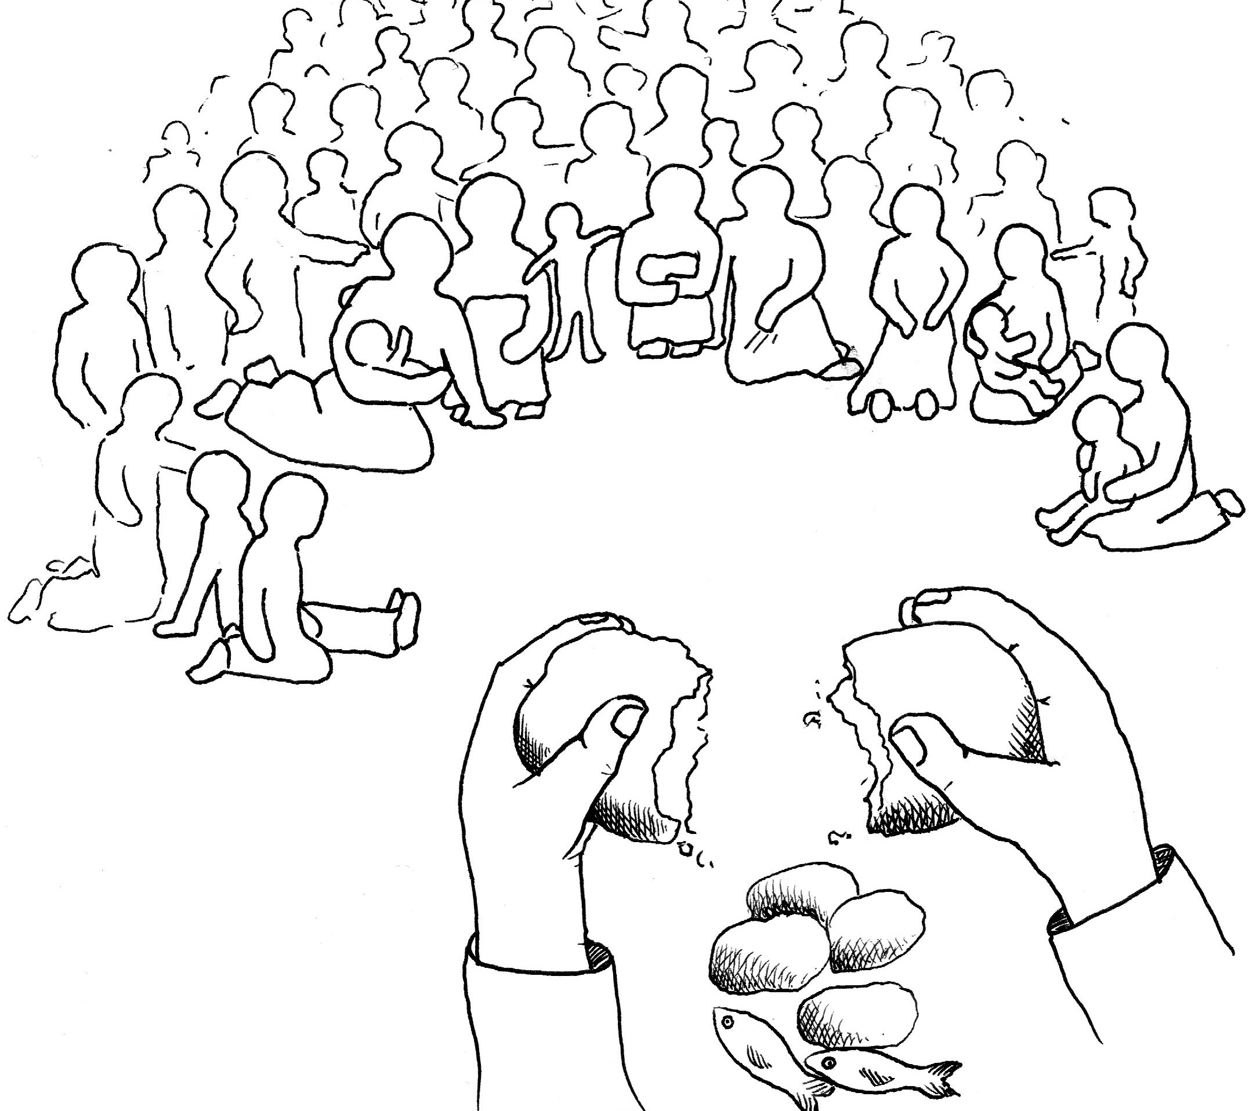

In today’s first reading God invites all who are hungry or thirsty to receive food and drink without cost. Jesus feeds the hungry multitude and reveals the abundance of God. At the eucharistic table we remember all who are hungry or poor in our world today, As we share the bread of life, we are sent forth to give ourselves away as bread for the hungry.

The Tenth Sunday after Pentecost Proper 13 2 August 2026
Markham Lutheran Church, 3518 W. 160th St., Markham, Illinois 60428
E-mail: markhamlutheranchurch@gmail.com Tel: 708-331-4885
Website: http://www.Markhamlutheranchurch.org/
Pastor Larry Schneekloth
Service of the Word

642 O Living Bread from Heaven
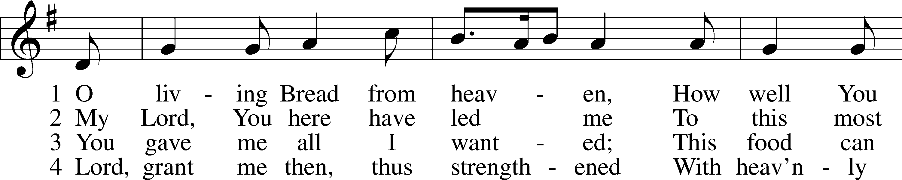
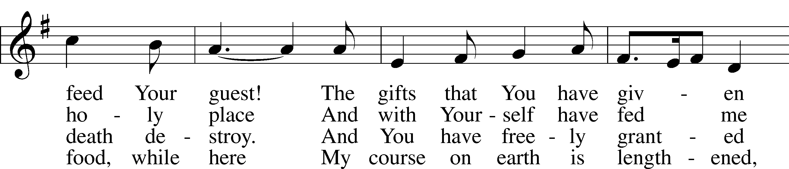
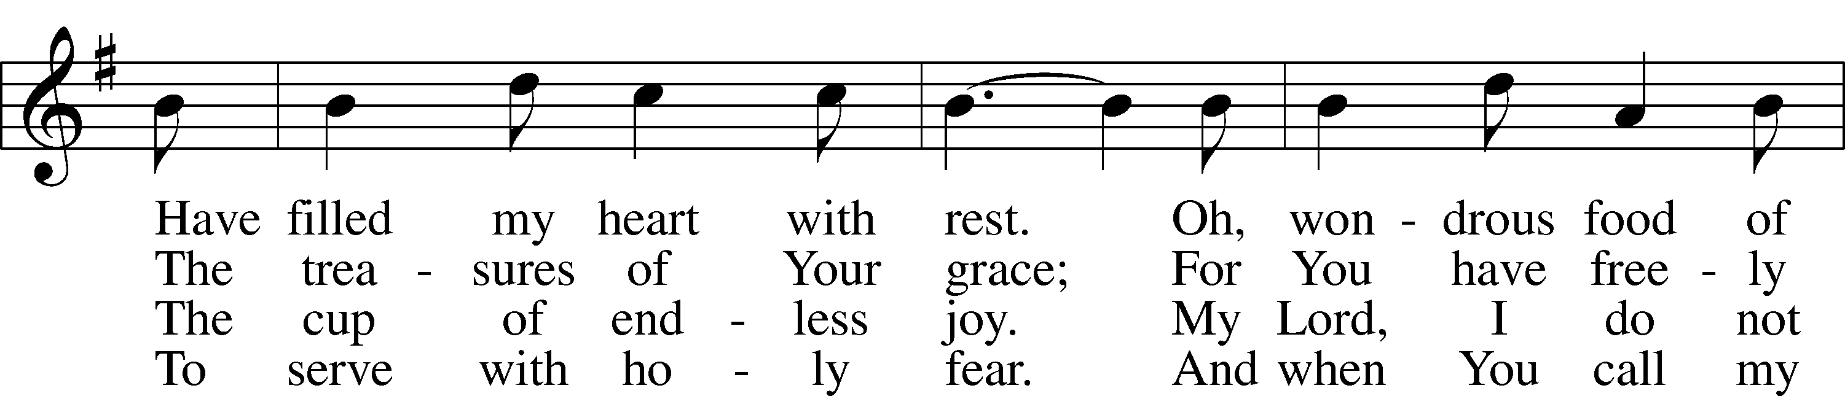
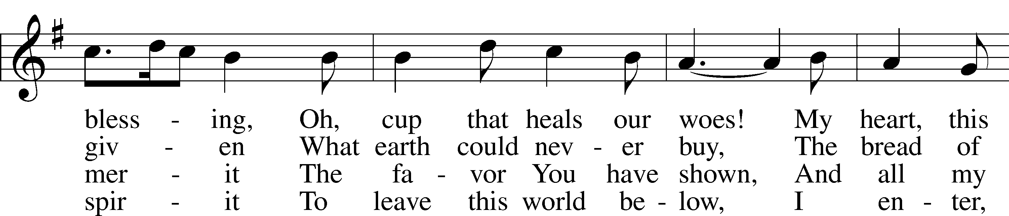
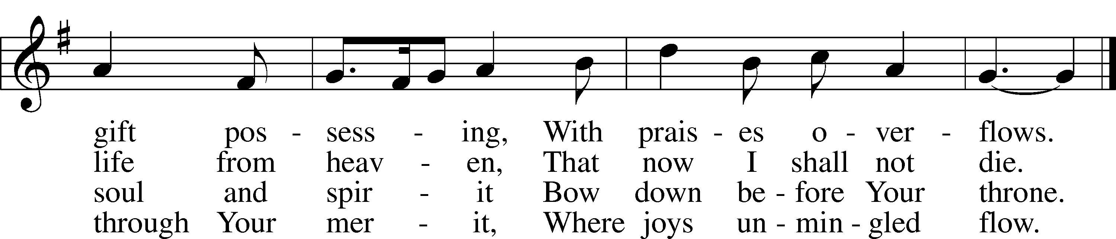

Text: Johann Rist, 1607–67; tr. Catherine Winkworth, 1827–78, alt.
Tune: Musae Sioniae, 1609, vol. 7, Wolfenbüttel, ed. Michael Praetorius
Text and tune: Public domain
P In the name of the Father and of the T Son and of the Holy Spirit.
C Amen.

P Almighty God, our heavenly Father, has had mercy on us and has given his only Son to die for us, and for his sake forgives us all our sins. To those who believe on his name he gives power to become the children of God, and has promised them his Holy Spirit. The one who believes and is baptized shall be saved. Grant this, Lord, unto us all,.
C Amen

Kyrie LSB 186
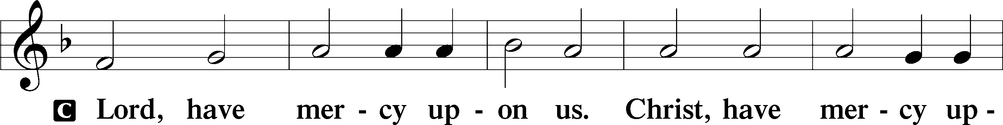
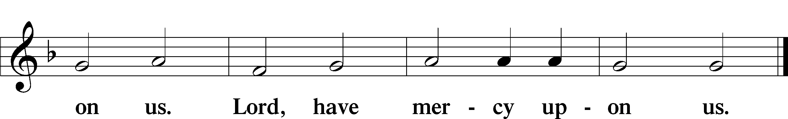

Gloria in Excelsis LSB 187
P Glory be to God on high:
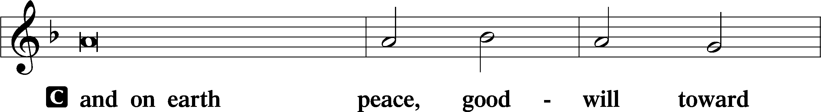
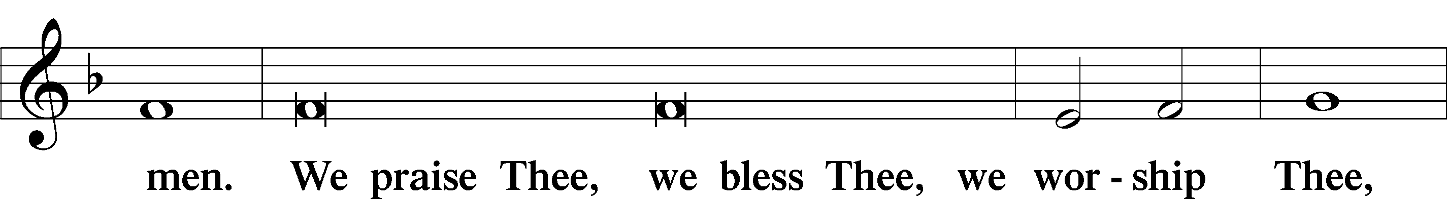
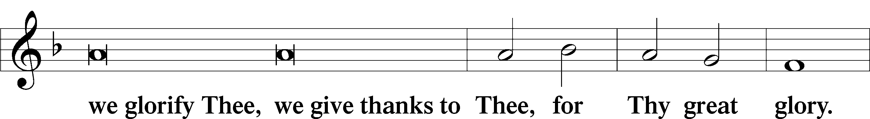
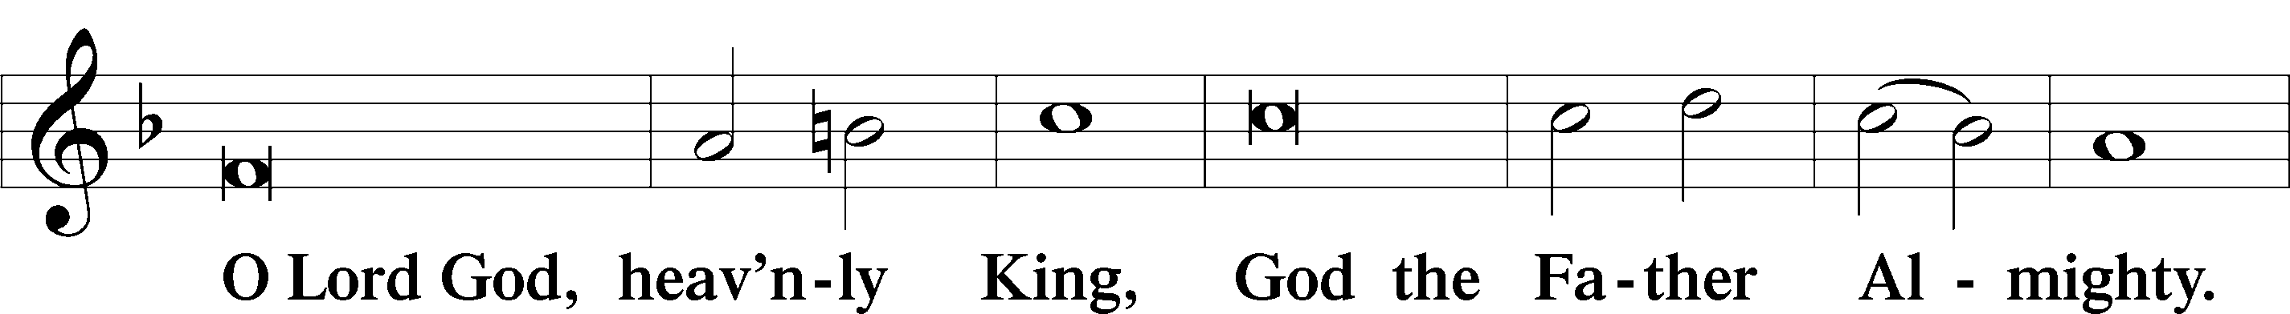
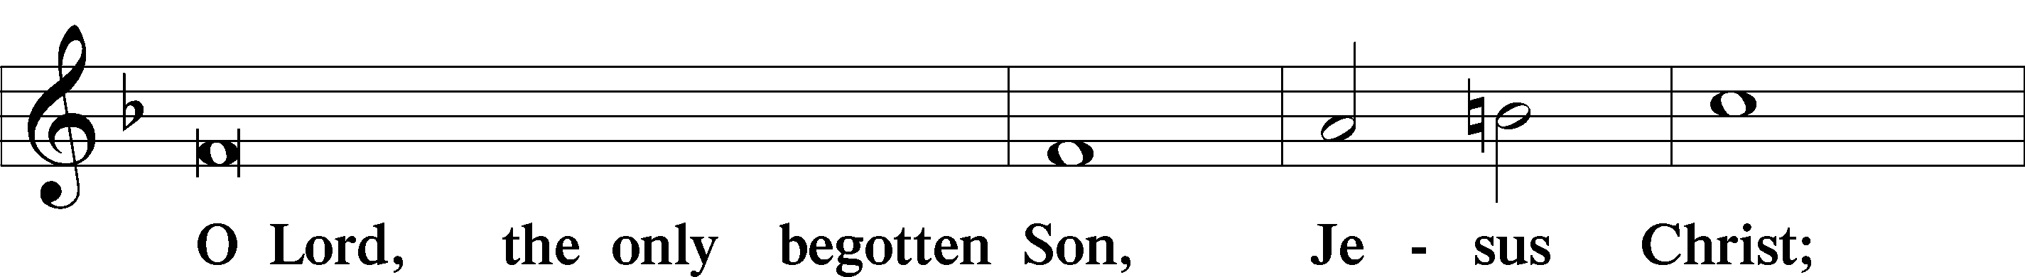
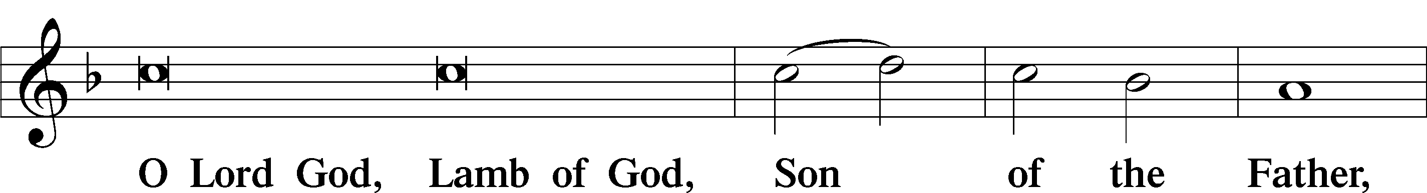
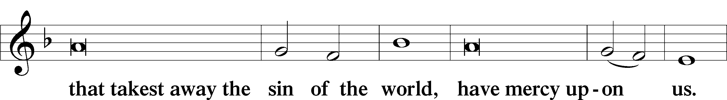
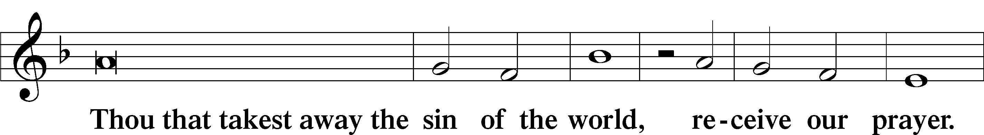
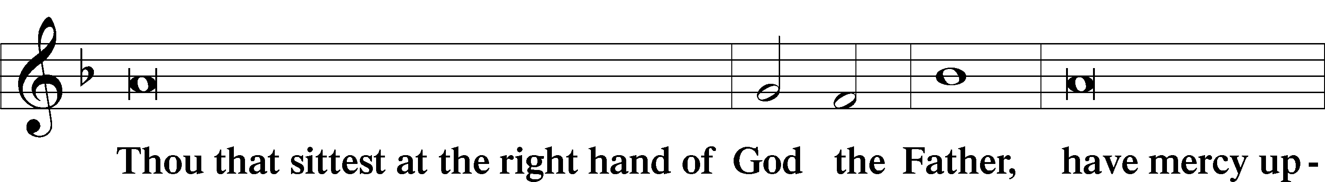
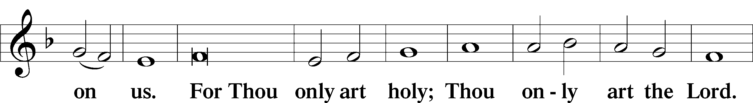
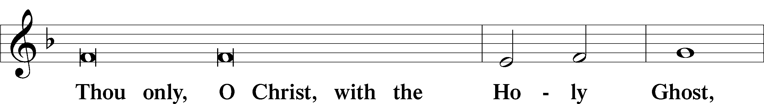
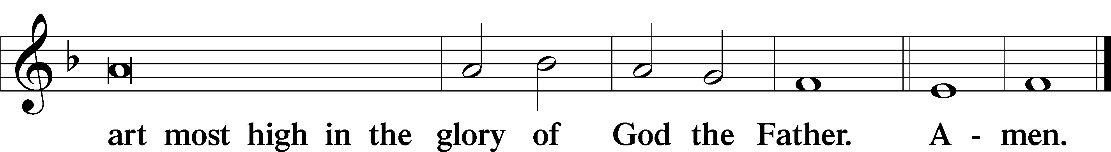

Collect of the Day

P Heavenly Father, though we do not deserve Your goodness, still You provide for all our needs of body and soul. Grant us Your Holy Spirit that we may acknowledge Your gifts, give thanks for all Your benefits, and serve You in willing obedience; through Jesus Christ, Your Son, our Lord, who lives and reigns with You and the Holy Spirit, one God, now and forever.

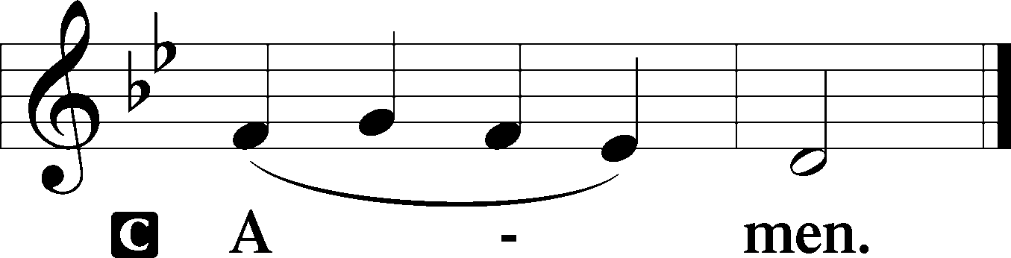

Old Testament Reading Isaiah 55:1–5

God invites Israel to a great feast at which both food and drink are free. God also promises to make an everlasting covenant with all peoples, with promises that previously had been limited to Israel. As David was a witness to the nations, these nations shall now acknowledge the ways in which God has glorified Israel.

Hear, everyone who thirsts; come to the waters; and you who have no money, come, buy and eat! Come, buy wine and milk without money and without price. ² Why do you spend your money for that which is not bread and your earnings for that which does not satisfy? Listen carefully to me, and eat what is good, and delight yourselves in rich food. ³ Incline your ear, and come to me; listen, so that you may live. I will make with you an everlasting covenant, my steadfast, sure love for David. ⁴ See, I made him a witness to the peoples, a leader and commander for the peoples. ⁵ Now you shall call nations that you do not know, and nations that do not know you shall run to you, because of the Lord your God, the Holy One of Israel, for he has glorified you.
A This is the Word of the Lord.
C Thanks be to God.

Psalm Psalm 136:1–9
1Give thanks to the Lord, for | he is good,*
for his steadfast love endures for- | ever.
2GIVE THANKS TO THE | GOD OF GODS,*
FOR HIS STEADFAST LOVE ENDURES FOR- | EVER.
3Give thanks to the | Lord of lords,*
for his steadfast love endures for- | ever;
4TO HIM WHO ALONE DOES GREAT | WONDERS,*
FOR HIS STEADFAST LOVE ENDURES FOR- | EVER;
5to him who by understanding made the | heavens,*
for his steadfast love endures for- | ever;
6TO HIM WHO SPREAD OUT THE EARTH ABOVE THE | WATERS,*
FOR HIS STEADFAST LOVE ENDURES FOR- | EVER;
7to him who made the | great lights,*
for his steadfast love endures for- | ever;
8THE SUN TO RULE O- | VER THE DAY,*
FOR HIS STEADFAST LOVE ENDURES FOR- | EVER;
9the moon and stars to rule o- | ver the night,*
FOR HIS STEADFAST LOVE ENDURES FOR- | EVER;

Epistle Romans 9:1–5

This begins a new section of Paul’s letter in which he will deal with the place of Israel in God’s saving plan. He opens by highlighting how Israel’s heritage and legacy include being God’s children, having God’s covenants, being given God’s law, participating in worship of God, and receiving divine promises.

9 I am speaking the truth in Christ—I am not lying; my conscience confirms it by the Holy Spirit— ² I have great sorrow and unceasing anguish in my heart. ³ For I could wish that I myself were accursed and cut off from Christ for the sake of my own brothers and sisters, my own flesh and blood. ⁴ They
are Israelites, and to them belong the adoption, the glory, the covenants, the giving of the law, the worship, and the promises; ⁵ to them belong the patriarchs, and from them, according to the flesh, comes the Christ, who is over all, God blessed forever. Amen.
A This is the Word of the Lord.
C Thanks be to God.

Holy Gospel Matthew 14:13–21
P The Holy Gospel according to St. Matthew.
C Glory to you, O Lord.

¹³ Now when Jesus heard this, he withdrew from there in a boat to a deserted place by himself. But when the crowds heard it, they followed him on foot from the towns. ¹⁴ When he went ashore, he saw a great crowd, and he had compassion for them and cured their sick. ¹⁵ When it was evening, the disciples came to him and said, “This is a deserted place, and the hour is now late; send the crowds away so that they may go into the villages and buy food for themselves.” ¹⁶ Jesus said to them, “They need not go away; you give them something to eat.” ¹⁷ They replied, “We have nothing here but five loaves and two fish.” ¹⁸ And he said, “Bring them here to me.” ¹⁹ Then he ordered the crowds to sit down on the grass. Taking the five loaves and the two fish, he looked up to heaven and blessed and broke the loaves and gave them to the disciples, and the disciples gave them to the crowds. ²⁰ And all ate and were filled, and they took up what was left over of the broken pieces, twelve baskets full. ²¹ And those who ate were about five thousand men, besides women and children.
P This is the Gospel of the Lord.
C Praise to you, Lord Jesus Christ.

The Homily

625 Lord Jesus Christ, Life-Giving Bread
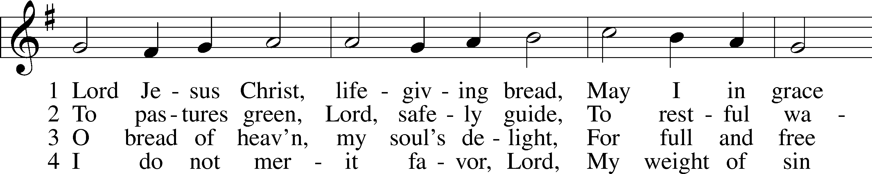
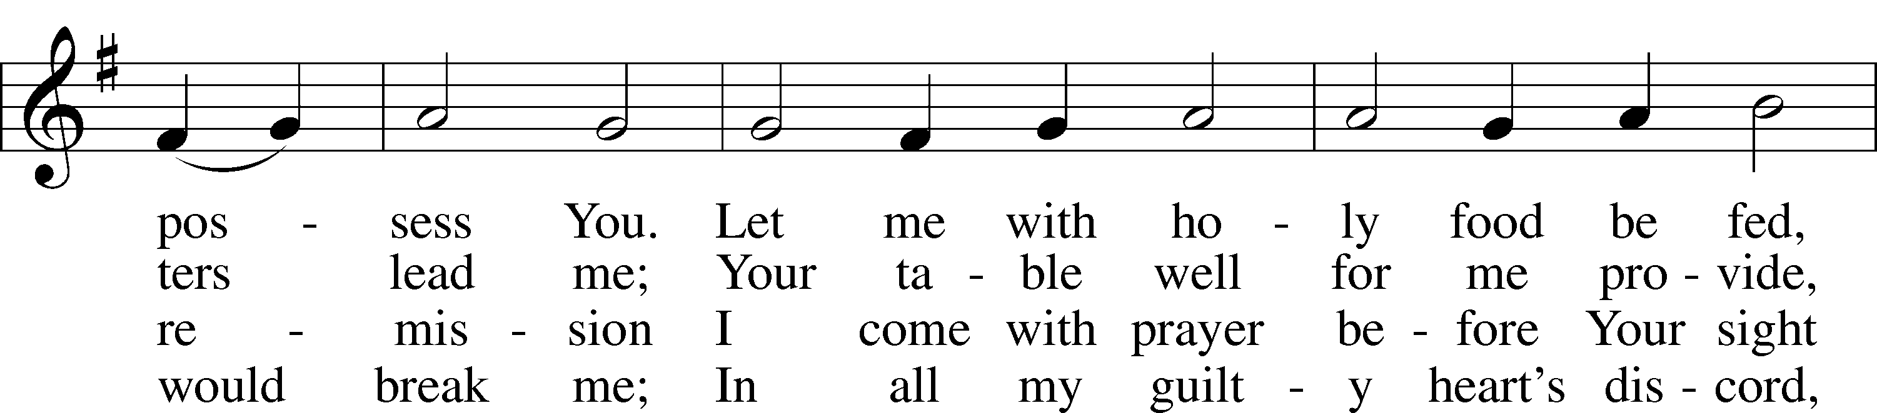
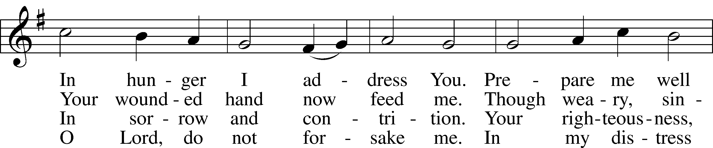
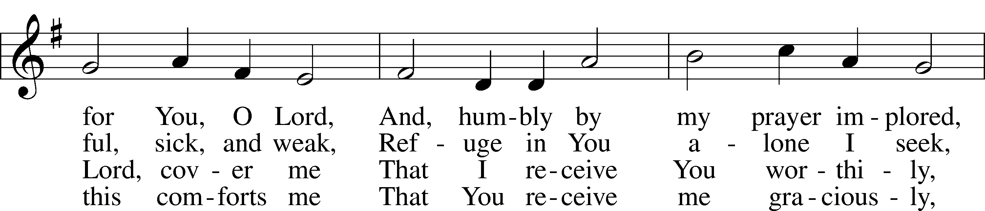
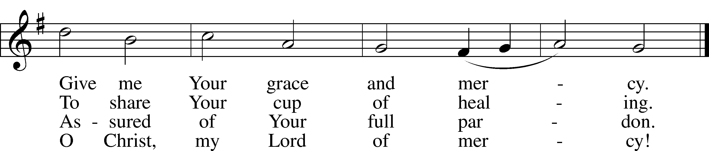
Text: Johann Rist, 1607–67; tr. Arthur T. Russell, 1806–74, alt.
Tune: Theütsch kirchen ampt, 1525, Strassburg
Text and tune: Public domain

Nicene Creed

We believe in one God, the Father, the Almighty, maker of heaven and earth, of all that is, seen and unseen.

We believe in one Lord, Jesus Christ, the only Son of God, eternally begotten of the Father, God from God, Light from Light, true God from true God, begotten, not made, of one Being with the Father; through him all things were made. For us and for our salvation he came down from heaven, was incarnate of the Holy Spirit and the Virgin Mary and became truly human. For our sake he was crucified under Pontius Pilate; he suffered death and was buried. On the third day he rose again in accordance with the Scriptures; he ascended into heaven and is seated at the right hand of the Father. He will come again in glory to judge the living and the dead, and his kingdom will have no end.

We believe in the Holy Spirit, the Lord, the giver of life, who proceeds from the Father and the Son, who with the Father and the Son is worshiped and glorified, who has spoken through the prophets. We believe in one holy catholic and apostolic Church. We acknowledge one baptism for the forgiveness of sins. We look for the resurrection of the dead, and the ₍₊₎ life of the world to come. Amen.

The Prayer of the Church
...Lord, in your mercy,
HEAR OUR PRAYER.

(Last petition:) Into your hands we commend ourselves, and all for whom we pray, trusting in your mercy, through Jesus Christ our Lord.
AMEN.

789 Praise and Thanksgiving
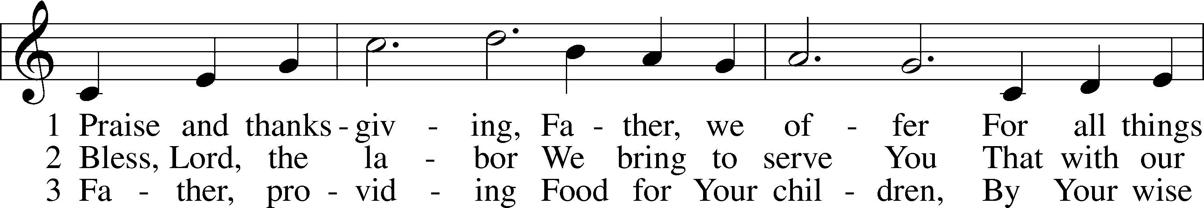
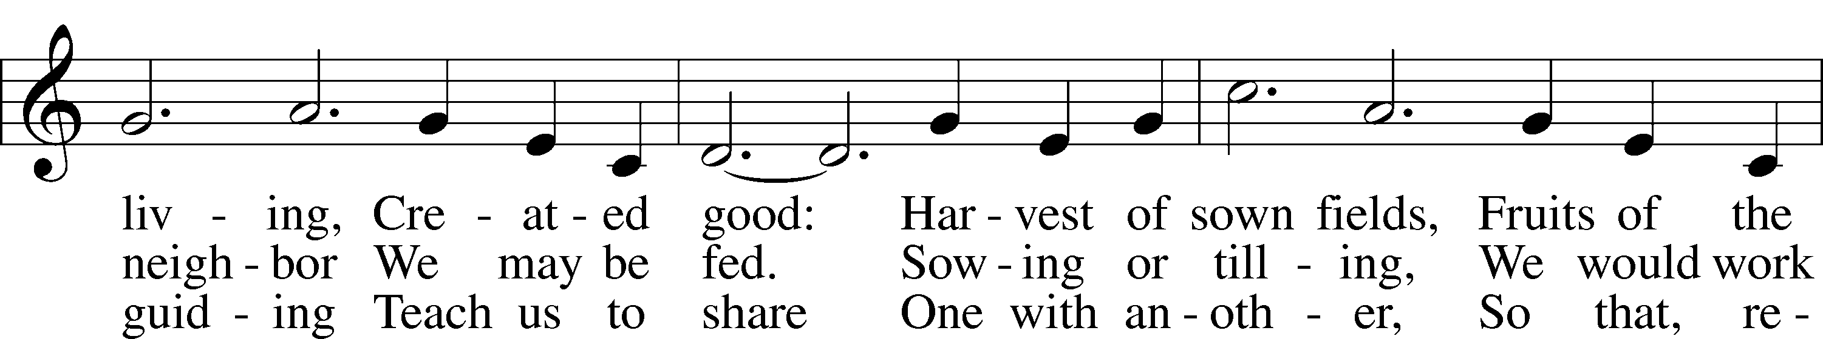
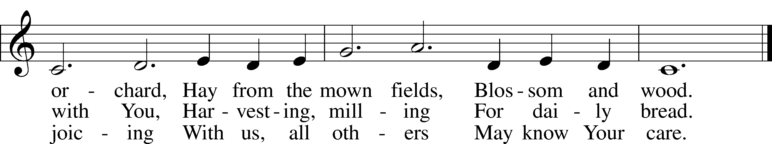
Text: Albert F. Bayly, 1901–84
Tune: Gaelic, 19th cent.
Text: © 1987 Oxford University Press. Used by permission: LSB Hymn License no. 110001341
Tune: Public domain

Service of the Sacrament
Lord be with you.
AND ALSO WITH YOU.
Lift up your hearts.
WE LIFT THEM TO THE LORD.
Let us give thanks to the Lord our God.
IT IS RIGHT TO GIVE GOD THANKS AND PRAISE.

It is indeed right and salutary that we should at all times and in all places offer thanks and praise to you, O Lord, holy Father, through Christ our Lord; who on this first day of the week overcame death and the grave, and by his glorious resurrection opened to us the way of everlasting life. And so, with the church on earth and the hosts of heaven, we praise your name, and join their unending hymn:

Sanctus LSB 195
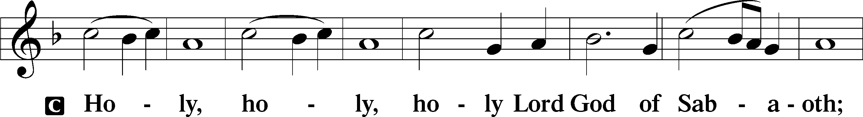
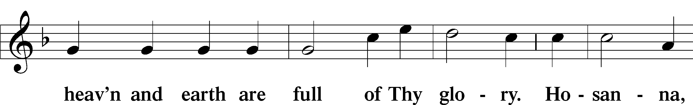
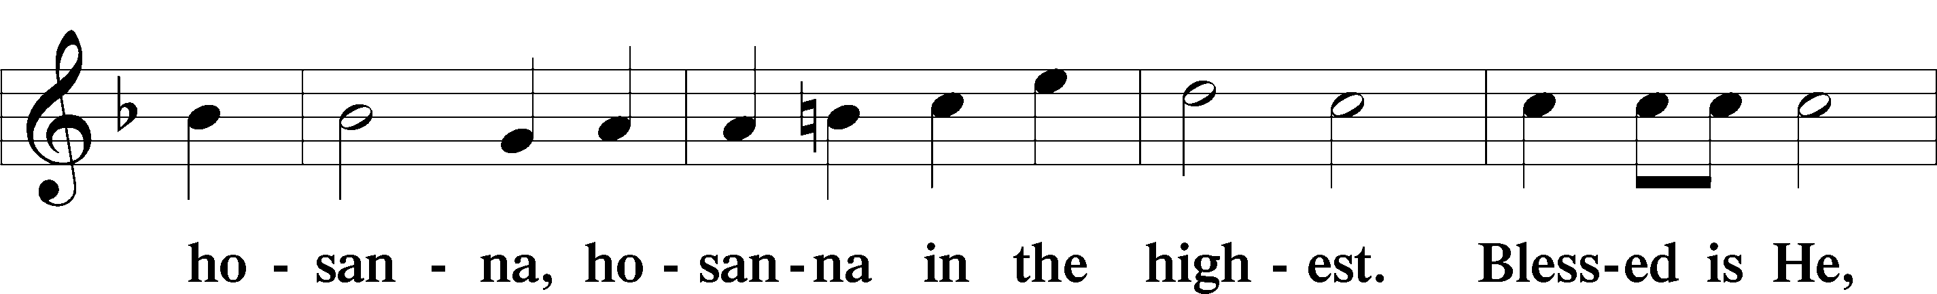
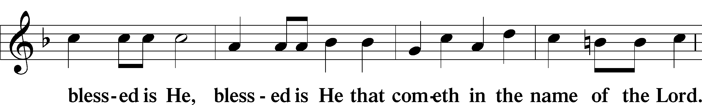
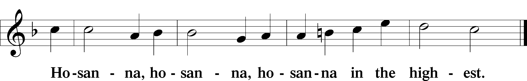

Our Lord Jesus Christ…

As often as we eat this bread, and drink from his cup, we proclaim the Lord’s death until he comes.
CHRIST HAS DIED. CHRIST IS RISEN. CHRIST WILL COME AGAIN.

Remember us in your kingdom and teach us to pray: OUR FATHER....

THE HOLY COMMUNION

The Thanksgiving and Dismissal
O give thanks to the Lord, for he is good.
AND HIS MERCY ENDURES FOREVER.

We give you thanks, O Father, for the food with which you have fed us this day: Your holy word, the remembrance of our Baptism, and the Bread and Wine of the Holy Communion. We ask that you continue to strengthen us in our faith in you, and in our fervent love for one another; through Christ our Lord.
AMEN.

Almighty God bless you, the Father, the Son, and the Holy Spirit.
AMEN.

774 Feed Thy Children, God Most Holy
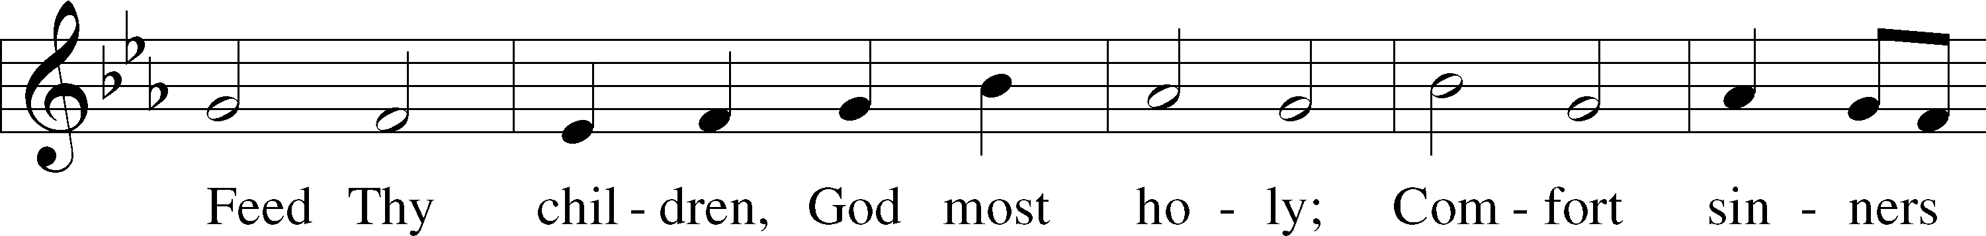
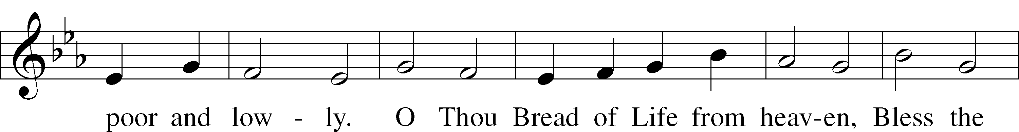
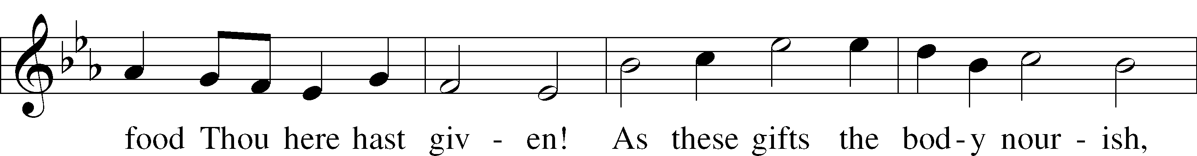
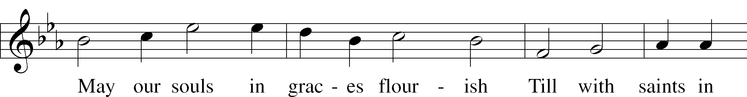
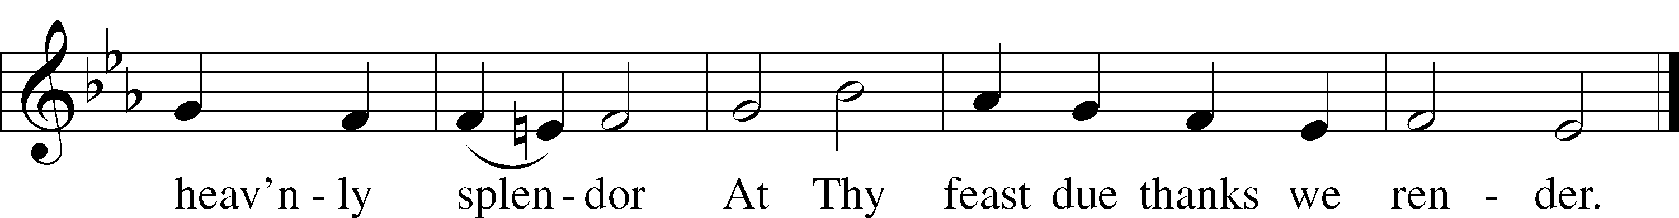

Acknowledgments
Divine Service, Setting Three from Lutheran Service Book
Created by Lutheran Service Builder © 2026 Concordia Publishing House.

THIS WEEK IN THE CHURCH CALENDAR
8/6: John Mason Neale, hymnwriter, 1866
Neale was born in London, January 24, 1818. He studied classics at Cambridge and was associated there with the movement for church renewal. Ill health prevented him from being rector of a parish and so his life was spent as warden of Sackville College in East Grinstead. He was the founder of the Sisterhood of St. Margaret's. He is remembered today for his translations of the great hymns of Christian antiquity, making them available to English-speaking churches. He died on the Feast of the Transfiguration, August 6, 1866.

Happy birthday this week to:
Brenda Guinn 8/5 Sharon Hart 8/5

