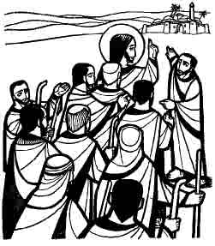
Jesus points ahead to the events of Holy Week—He is going “up to Jerusalem” and to the cross. He asks the disciples, “Are you able to drink the cup that I am to drink?” He points out the difficult paths into which discipleship can lead. To be his disciples, we follow him wherever he leads us, even through suffering and sacrifices for God and for the world. Have, therefore, the mind of Christ, and do not count the cost.

The Fourth Sunday in Lent 15 March 2026
Markham Lutheran Church, 3518 W. 160th St., Markham, Illinois 60428
E-mail: markhamlutheranchurch@gmail.com; Tel: 708-331-4885
Website: http://www.Markhamlutheranchurch.org/
Pastor Larry Schneekloth
Confession and Absolution

761 Rock of Ages, Cleft for Me
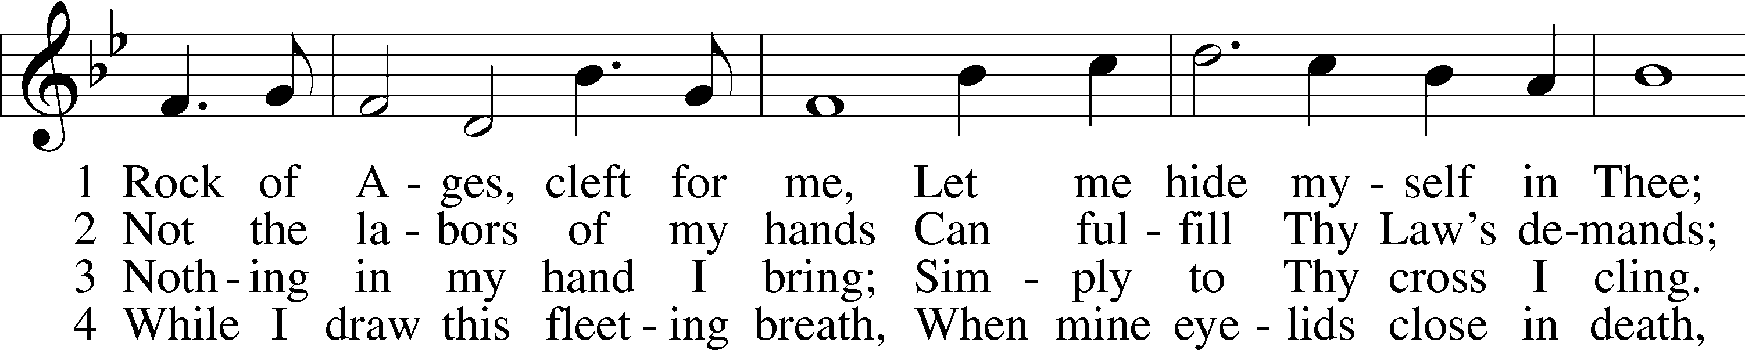
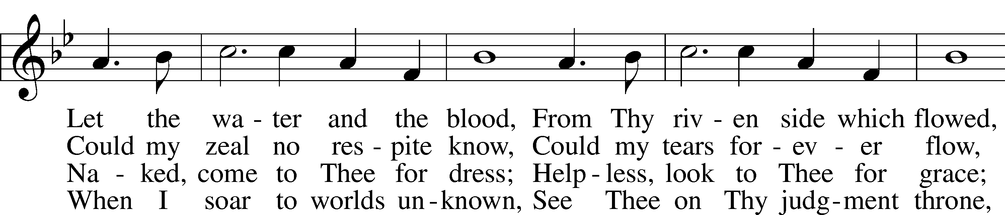
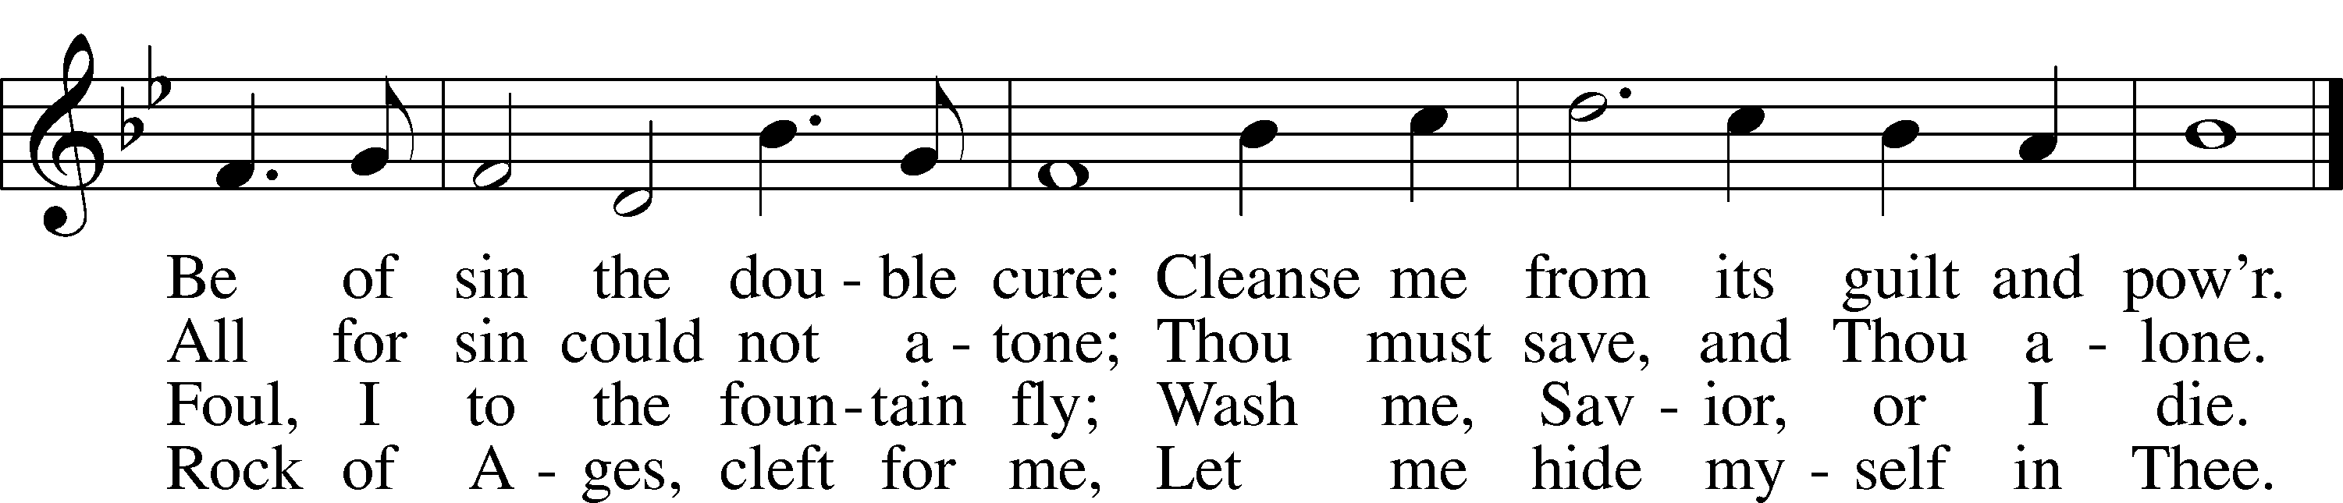
Text: Augustus M. Toplady, 1740–78
Tune: Thomas Hastings, 1784–1872
Text and tune: Public domain

P In the name of the Father and of the T Son and of the Holy Spirit.
C Amen.

P Beloved in the Lord! Let us draw near with a true heart and confess our sins unto God our Father, beseeching Him in the name of our Lord Jesus Christ to grant us forgiveness.

P Our help is in the name of the Lord,
C who made heaven and earth.
P I said, I will confess my transgressions unto the Lord,
C and You forgave the iniquity of my sin.

Silence for reflection on God’s Word and for self-examination.

P O almighty God, merciful Father,
C I, a poor, miserable sinner, confess unto You all my sins and iniquities with which I have ever offended You and justly deserved Your temporal and eternal punishment. But I am heartily sorry for them and sincerely repent of them, and I pray You of Your boundless mercy and for the sake of the holy, innocent, bitter sufferings and death of Your beloved Son, Jesus Christ, to be gracious and merciful to me, a poor, sinful being.

P Upon this your confession, I, by virtue of my office, as a called and ordained servant of the Word, announce the grace of God unto all of you, and in the stead and by the command of my Lord Jesus Christ I announce the forgiveness of all your sins in the name of the Father and of the T Son and of the Holy Spirit.
C Amen.

Service of the Word

Collect of the Day

P Let us pray.
O God our Father, you have entrusted us with a priceless inheritance. Give us each day the courage to risk defeat; and if we fail, by your grace receive us when we return to you; through Jesus Christ, Your Son, our Lord, who lives and reigns with You and the Holy Spirit, one God, now and forever.
C Amen.

Sit

Old Testament Reading Hosea 5:15-6:2

I will return again to my place until they acknowledge their guilt and seek my face. In their distress they will beg my favor: 6 “Come, let us return to the Lord, for it is he who has torn, and he will heal us; he has struck down, and he will bind us up. ² After two days he will revive us; on the third day he will raise us up, that we may live before him.”
A This is the Word of the Lord.
C Thanks be to God.

Psalm 43

¹ Vindicate me, O God, and defend my cause against an ungodly people;
from those who are deceitful and unjust, deliver me!
² FOR YOU ARE THE GOD IN WHOM I TAKE REFUGE; WHY HAVE YOU CAST ME OFF? WHY MUST I WALK ABOUT MOURNFULLY BECAUSE OF THE OPPRESSION OF THE ENEMY?
³ O send out your light and your truth; let them lead me; let them bring me to your holy hill and to your dwelling.
⁴ THEN I WILL GO TO THE ALTAR OF GOD, TO GOD MY EXCEEDING JOY, AND I WILL PRAISE YOU WITH THE HARP,
O GOD, MY GOD.
⁵ Why are you cast down, O my soul, and why are you disquieted within me?
HOPE IN GOD, FOR I SHALL AGAIN PRAISE HIM,
MY HELP AND MY GOD.

Epistle Romans 8:1-10
Therefore there is now no condemnation for those who are in Christ Jesus. ² For the law of the Spirit of life in Christ Jesus has set you free from the law of sin and of death. ³ For God has done what the law, weakened by the flesh, could not do: by sending his own Son in the likeness of sinful flesh and to deal with sin, he condemned sin in the flesh, ⁴ so that the just requirement of the law might be fulfilled in us, who walk not according to the flesh but according to the Spirit. ⁵ For those who live according to the flesh set their minds on the things of the flesh, but those who live according to the Spirit set their minds on the things of the Spirit. ⁶ To set the mind on the flesh is death, but to set the mind on the Spirit is life and peace. ⁷ For this reason the mind that is set on the flesh is hostile to God; it does not submit to God’s law—indeed, it cannot, ⁸ and those who are in the flesh cannot please God. ⁹ But you are not in the flesh; you are in the Spirit, since the Spirit of God dwells in you. Anyone who does not have the Spirit of Christ does not belong to him. ¹⁰ But if Christ is in you, then the body is dead because of sin, but the Spirit is life because of righteousness.
A This is the Word of the Lord.
C Thanks be to God.

Holy Gospel Matthew 20:17-28
P The Holy Gospel according to St. Matthew.
C Glory to you, O Lord.

¹⁷ While Jesus was going up to Jerusalem, he took the twelve disciples aside by themselves and said to them on the way, ¹⁸ “Look, we are going up to Jerusalem, and the Son of Man will be handed over to the chief priests and scribes, and they will condemn him to death; ¹⁹ then they will hand him over to the gentiles to be mocked and flogged and crucified, and on the third day he will be raised.”
²⁰ Then the mother of the sons of Zebedee came to him with her sons, and kneeling before him, she asked a favor of him. ²¹ And he said to her, “What do you want?” She said to him, “Declare that these two sons of mine will sit, one at your right hand and one at your left, in your kingdom.” ²² But Jesus answered, “You do not know what you are asking. Are you able to drink the cup that I am about to drink?” They said to him, “We are able.” ²³ He said to them, “You will indeed drink my cup, but to sit at my right hand and at my left, this is not mine to grant, but it is for those for whom it has been prepared by my Father.”
²⁴ When the ten heard it, they were angry with the two brothers. ²⁵ But Jesus called them to him and said, “You know that the rulers of the gentiles lord it over them, and their great ones are tyrants over them. ²⁶ It will not be so among you, but whoever wishes to be great among you must be your servant, ²⁷ and whoever wishes to be first among you must be your slave, ²⁸ just as the Son of Man came not to be served but to serve and to give his life a ransom for many.”
P This is the Gospel of the Lord.
C Praise to you, Lord Jesus Christ.

The Homily

851 Lord of Glory, You Have Bought Us
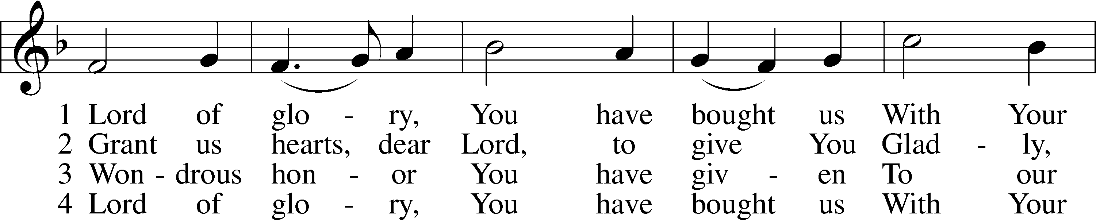
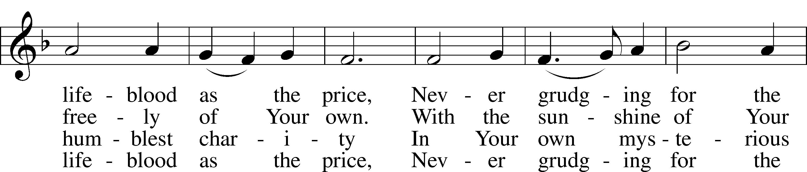
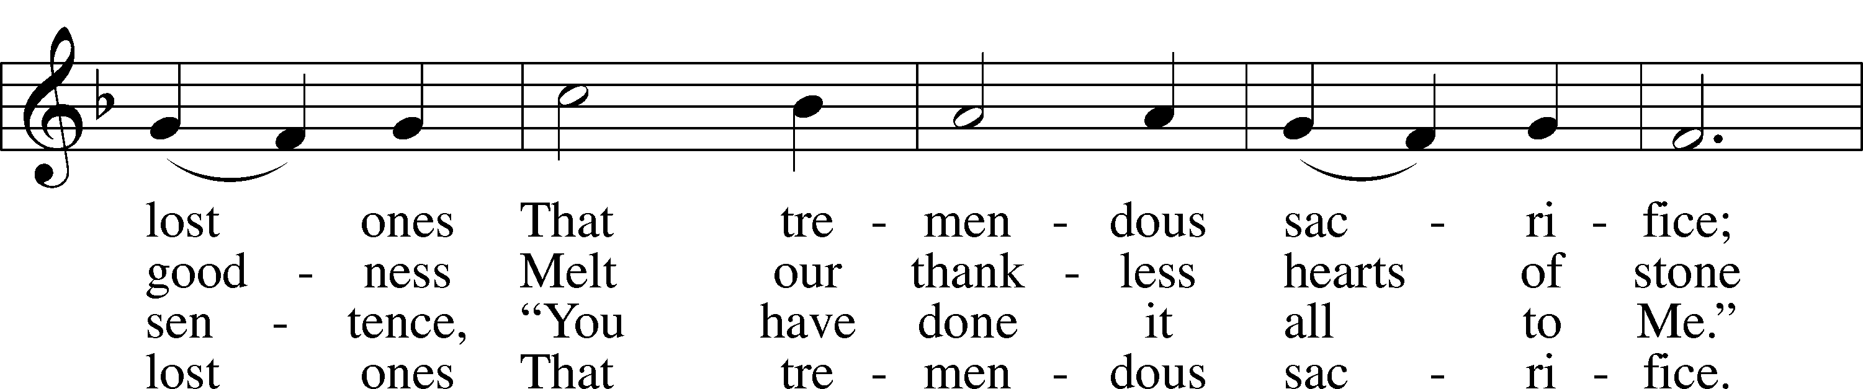
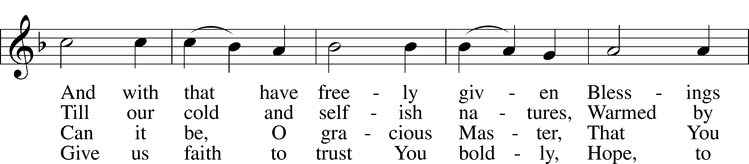
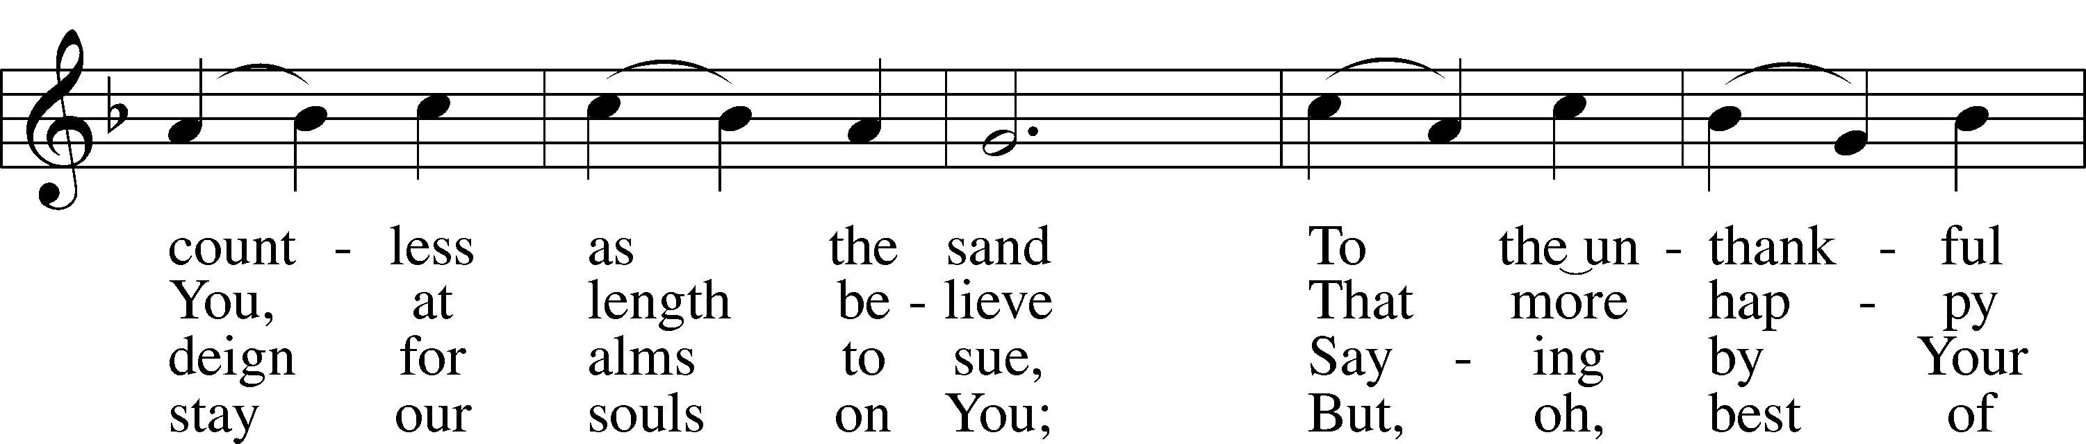
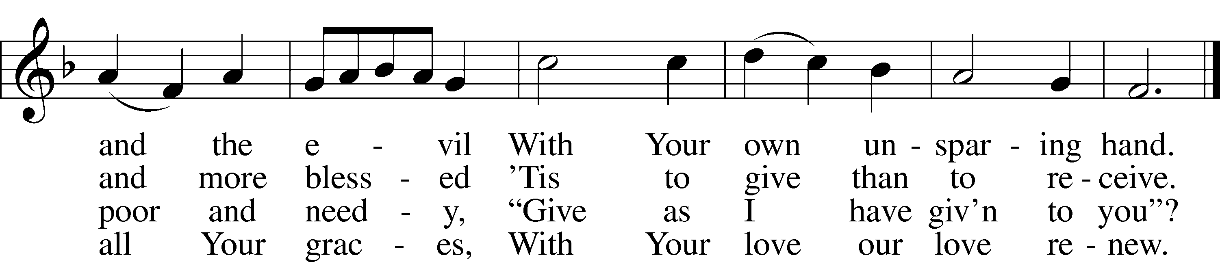
Text: Eliza S. Alderson, 1818–89, alt.
Tune: Rowland H. Prichard, 1811–87
Text and tune: Public domain

Nicene Creed
We believe in one God, the Father, the Almighty, maker of heaven and earth, of all that is, seen and unseen.
We believe in one Lord, Jesus Christ, the only Son of God, eternally begotten of the Father, God from God, Light from Light, true God from true God, begotten, not made, of one Being with the Father; through him all things were made. For us and for our salvation he came down from heaven, was incarnate of the Holy Spirit and the Virgin Mary and became truly human. For our sake he was crucified under Pontius Pilate; he suffered death and was buried. On the third day he rose again in accordance with the Scriptures; he ascended into heaven and is seated at the right hand of the Father. He will come again in glory to judge the living and the dead, and his kingdom will have no end.
We believe in the Holy Spirit, the Lord, the giver of life, who proceeds from the Father and the Son, who with the Father and the Son is worshiped and glorified, who has spoken through the prophets. We believe in one holy catholic and apostolic Church. We acknowledge one baptism for the forgiveness of sins. We look for the resurrection of the dead, and the ₍₊₎ life of the world to come. Amen
The Prayer of the Church
...Lord, in your mercy,
HEAR OUR PRAYER.

(Last petition:) Into your hands we commend ourselves, and all for whom we pray, trusting in your mercy, through Christ our Lord.
AMEN.
435 Come to Calvary’s Holy Mountain
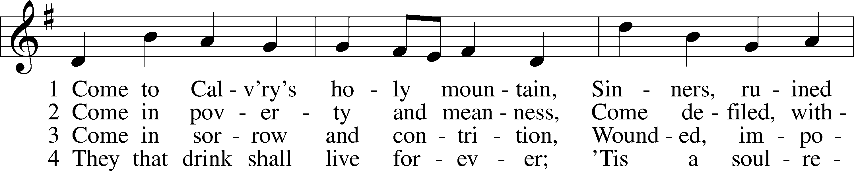
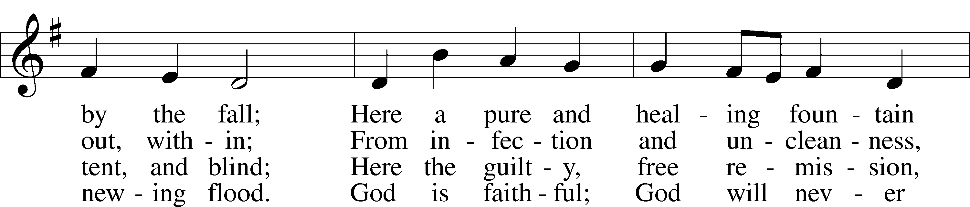
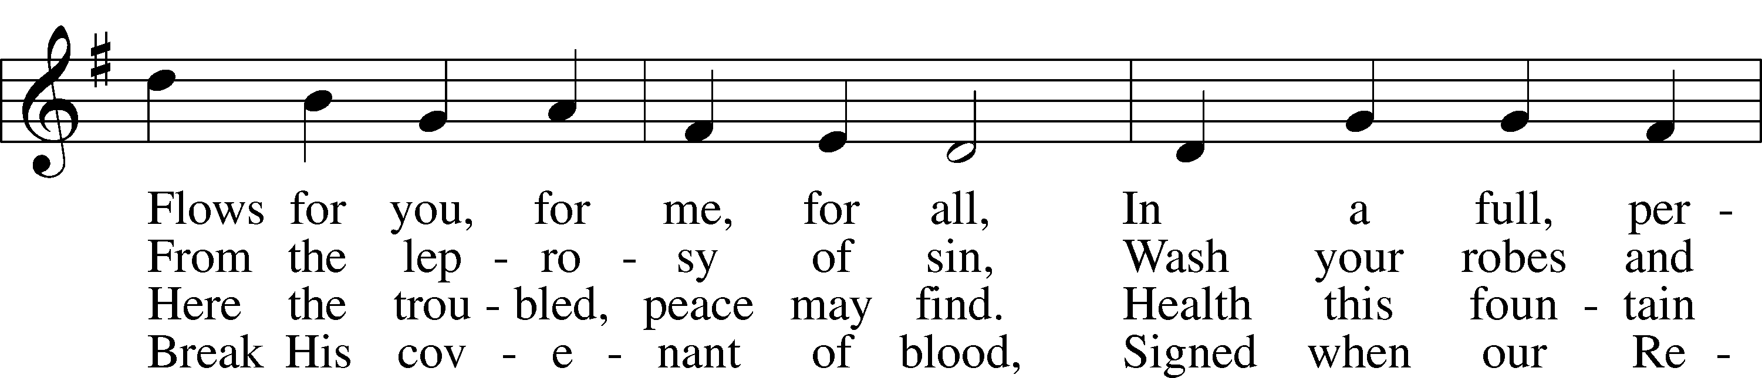
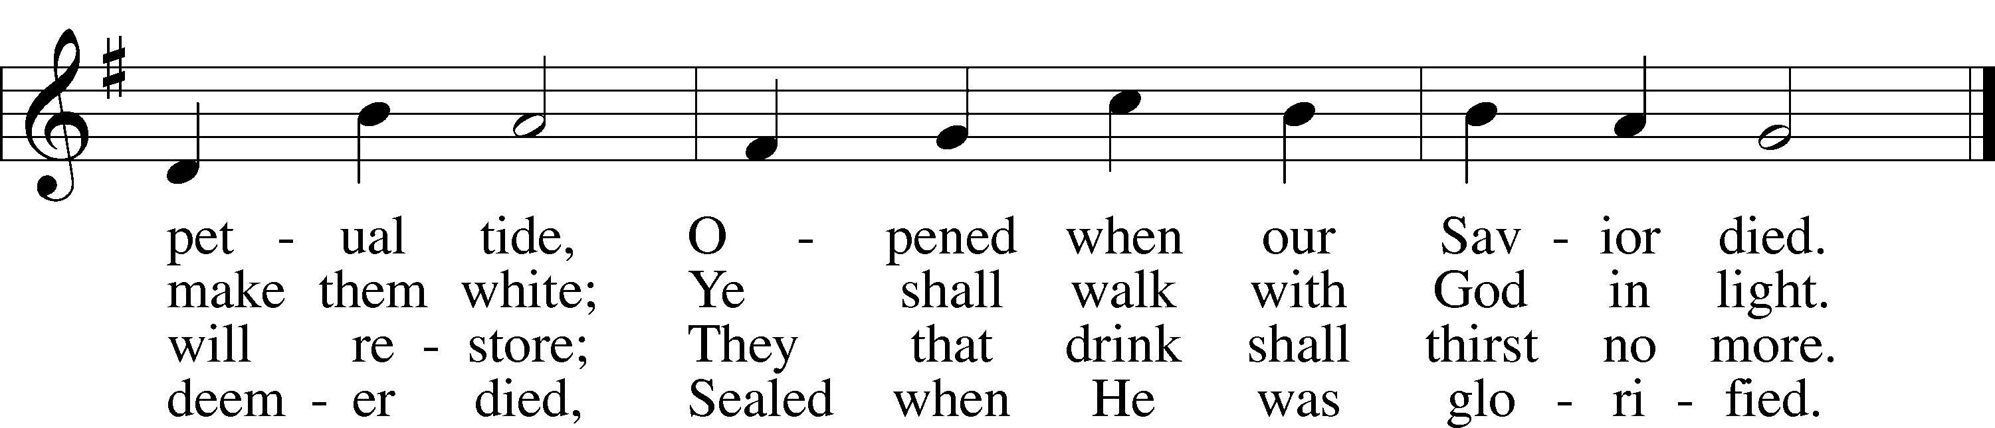

Text: James Montgomery, 1771–1854, alt.Tune: Ludvig M. Lindeman, 1812–87
Text and tune: Public domain

Service of the Sacrament

The Lord be with you.
AND ALSO WITH YOU.
Lift up your hearts.
WE LIFT THEM TO THE LORD.
Let us give thanks to the Lord our God.
IT IS RIGHT TO GIVE GOD THANKS AND PRAISE.

It is indeed right and salutary that we should at all times and in all places offer thanks and praise to you, O Lord, holy Father, through Christ our Lord, who on the tree of the cross has given salvation to all of us; that the devil, who by a tree was once victorious, might by the tree of the cross be overcome. And so, with the Church on earth and the hosts of heaven, we praise your name, and join their unending hymn:

HOLY, HOLY, HOLY, LORD GOD OF HOSTS:
HEAVEN AND EARTH ARE FULL OF YOUR GLORY.
HOSANNA IN THE HIGHEST.
BLESSED IS HE (+) THAT COMES IN THE NAME OF THE LORD.
HOSANNA IN THE HIGHEST.

Our Lord Jesus Christ…we proclaim the Lord's death until he comes.
CHRIST HAS DIED. CHRIST IS RISEN. CHRIST WILL COME AGAIN.

Bless us, O Lord, through this holy Bread and Cup, and bring us to life everlasting, through Jesus Christ our Lord.
THROUGH HIM, WITH HIM, IN HIM, IN THE UNITY OF THE HOLY SPIRIT, ALL HONOR AND GLORY IS YOURS, ALMIGHTY FATHER, NOW AND FOREVER. AMEN.

In the words of our Lord we pray: OUR FATHER...

The Holy Communion

The Thanksgiving and Dismissal
O give thanks to the Lord, for he is good.
AND HIS MERCY ENDURES FOREVER.

We give you thanks, O Father, for the food with which you have fed us this day: Your holy word, the remembrance of our Baptism, and the Bread and Wine of the Holy Communion.
MAY THE WORDS, AND THE MEAL WE HAVE SHARED BE OUR NOURISHMENT IN THE DAYS AHEAD; THROUGH JESUS CHRIST OUR LORD. AMEN.

Almighty God bless you, the Father, the Son, and the Holy Spirit.
AMEN.

422 On My Heart Imprint Your Image
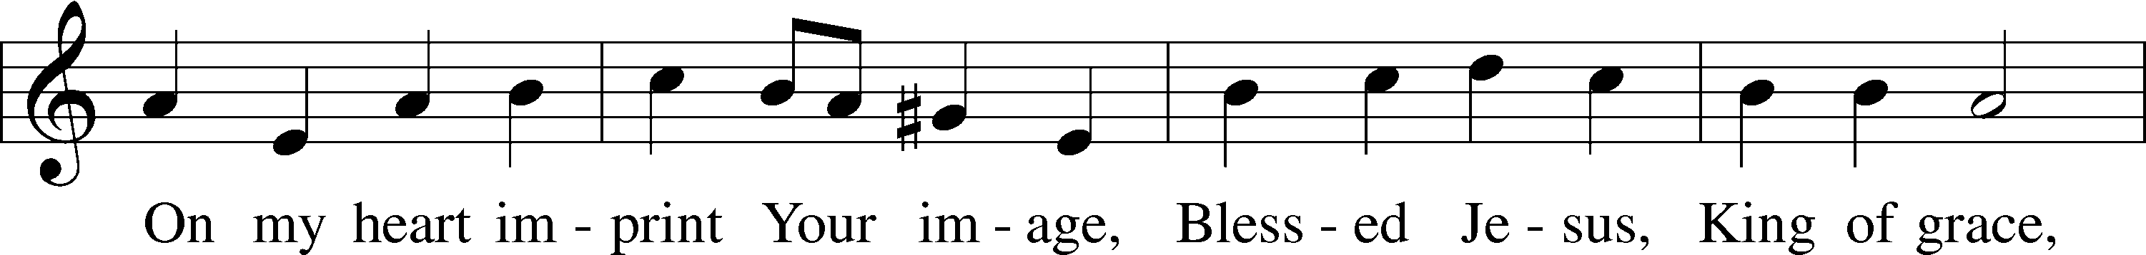
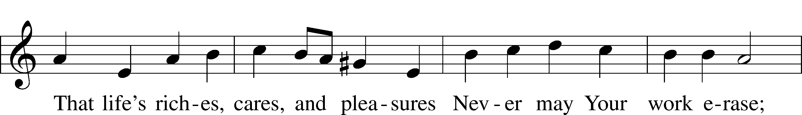
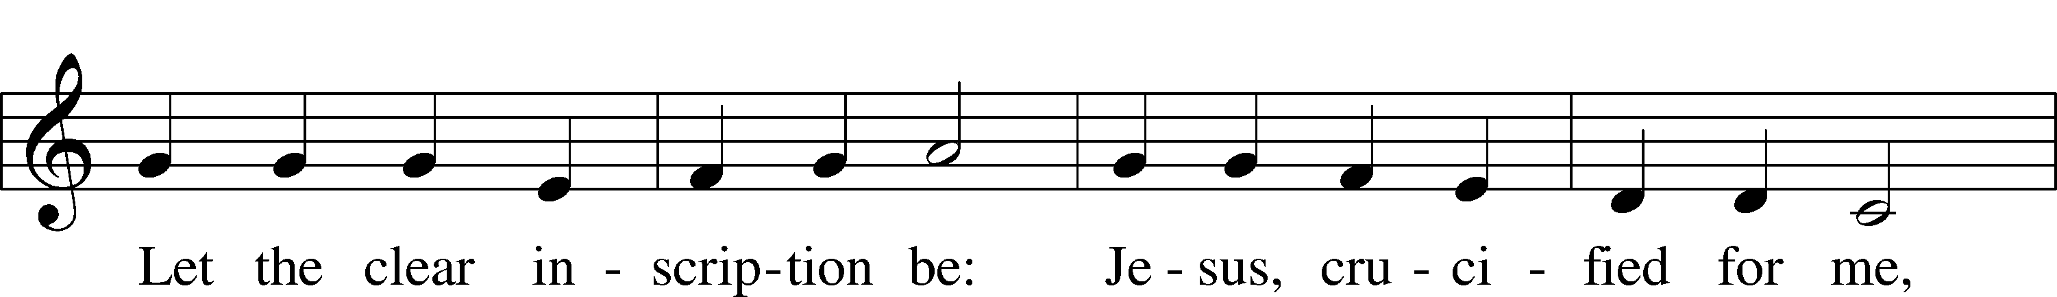
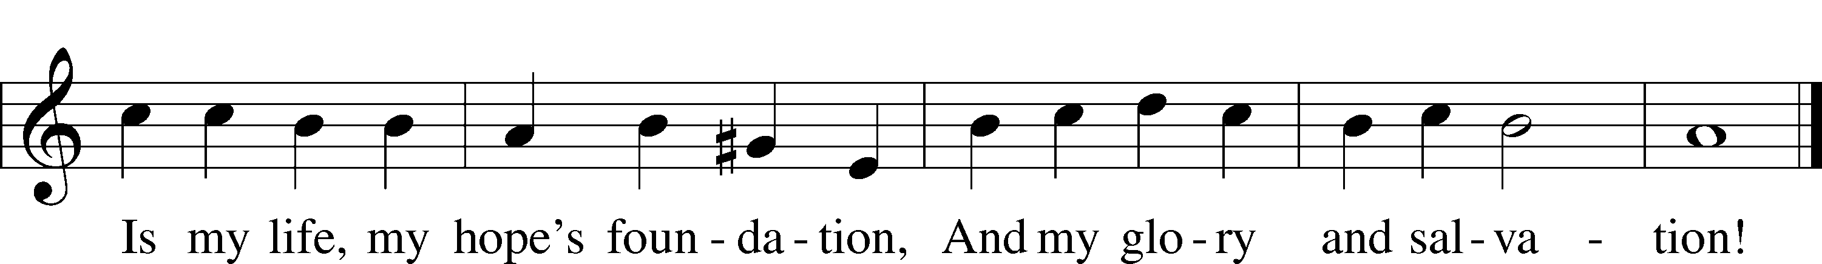

Text: Thomas Hansen Kingo, 1634–1703; tr. Peer O. Strömme, 1856–1921, alt.
Tune: Johann Balthasar König, 1691–1758
Text and tune: Public domain

Acknowledgments
Divine Service, from Lutheran Service Book
Created by Lutheran Service Builder © 2023 Concordia Publishing House.

THIS WEEK IN THE CHURCH CALENDAR
3/19: Joseph, earthly father and guardian of our Lord
The husband of the Virgin Mary was a carpenter who is portrayed in Scripture as a devout and honest man, concerned for his wife and Child. It seems that he was no longer living when Jesus began his ministry. The special remembrance of Joseph appears to have begun in the East and developed comparatively late in the West, the earliest commemoration being held in the ninth century. The major emphasis on his commemoration was during the 15th century.
3/24: Oscar Arnulfo Romero, Bishop of El Salvador, martyr, died 1980
Romero is remembered for his advocacy on behalf of the poor in El Salvador, though it was not a characteristic of his early priesthood. After being appointed as archbishop of San Salvador, he preached against the political repression in his country. He and other priests and church workers were considered traitors for their bold stand for justice, especially defending the rights of the poor. After several years of threats to his life, Bishop Romero was assassinated while presiding at the Eucharist. During the 1980s thousands died in El Salvador during political unrest.
3/25: The Annunciation of our Lord
The angelic announcement to Mary of the birth of Jesus was observed in the East in the fifth century. By the eighth century the observance had become general in the West. The date is determined by Christmas, being exactly nine months before the Feast of the Nativity. Read: Luke 1:26-38. Prayer: Almighty God, you announce your will for us in mysterious and troubling ways. We pray that, as Mary once heard and accepted the angel's message of your will, we too may hear your call and respond with full faith and willing-ness to serve; through your Son, Jesus Christ our Lord.

