The Program:
Confirmation class meets weekly for an hour (sometimes on Zoom; masks are not required for in person sessions but are always appreciated by immune compromised Pastor). If students have not already made their First Communion, the first several sessions will be about Holy Communion (Eucharist). Remember, a person becomes a member of the Body of Christ at their baptism and can and should receive Holy Communion well before the confirmation program - it is not confirmation that makes you a member of the church and 'worthy' of receiving Holy Communion. If for some reason a confirmand has not been baptized, they will receive additional instruction to prepare for that Sacrament.
​​The course of study will be the Bible, Luther's Small Catechism, Lutheran Living (a deeper exploration of important teachings such as Grace, the Cross, Law and Gospel, etc.). Let us know if your child requires these materials in a format other than the printed word.
​Confirmands will become familiar with the Creeds (Apostles and Nicene) and the Lord's Prayer (if they are able to memorize easily, that's always a nice thing; understanding is far more important). They will continue learning and thinking about how Scripture relates to and impacts their modern lives.
​​Confirmands will be given other reading and writing assignments throughout the three year confirmation period. (If there are ways for a confirmand to access and share their understanding of the material that are better suited to their learning and communication style, Pastor is on board with that.)
​If a student must miss a class session for a legitimate reason (illness, death in the family), Pastor would appreciate receiving advance notice, if at all possible, and ideally the session should be made-up before the next class.
Requirements: *
​Confirmands are expected to attend Sunday School when it is in session and church regularly, as well as other scheduled services. Depending on your circumstances, especially with the on-going pandemic, attending via Zoom, when offered, and Livestream counts. If you are ill or think/know you've been exposed to COVID-19, you are encouraged to attend church via Facebook Live. At home or worshiping in person, confirmands will be expected to fully participate in worship as they are able (making the sign of the cross, praying, singing, or at least paying attention to the hymns, and making the appropriate responses, etc.).
​Confirmands will have the opportunity to serve as acolytes throughout the year, including summer, assisting the pastor as needed during worship services.

Confirmands are encouraged to take part in other events and activities sponsored by the congregation as they are able, such as helping with fund raisers and workdays, decorating the church for Advent, Christmas and Easter, etc.
​During their final year of Confirmation, a confirmand will choose their Bible verse and prepare their statement of faith. The latter is usually a written statement, but if another option better suits the confirmand, let Pastor know. The statement/expression of faith will be shared with the congregation at the Confirmation service in a way that's comfortable for them.
​It is up to the parents/guardians and confirmands to fulfill the requirements of the Confirmation program. Pastor and other teachers will encourage and help you as far as they are able with your cooperation and will try their best to make any accommodations and adjustments to the program and the way classes are structured/conducted that you need to succeed. They will not nag or chase you down.
​Confirmands are strongly encouraged to choose a ministry, if they aren't already involved: There are many options. There are even vital "behind the scenes" roles if being front and center isn't your style.
​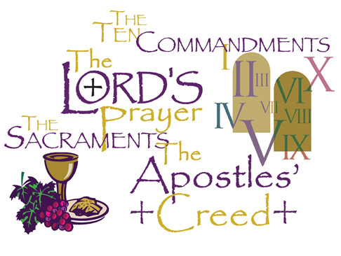

* We will tailor the requirements to the confirmand as best we can. We want each one to feel comfortable, confident, and successful! We are each an important part of the body of Christ and vital to the mission and ministry of Markham Lutheran!

