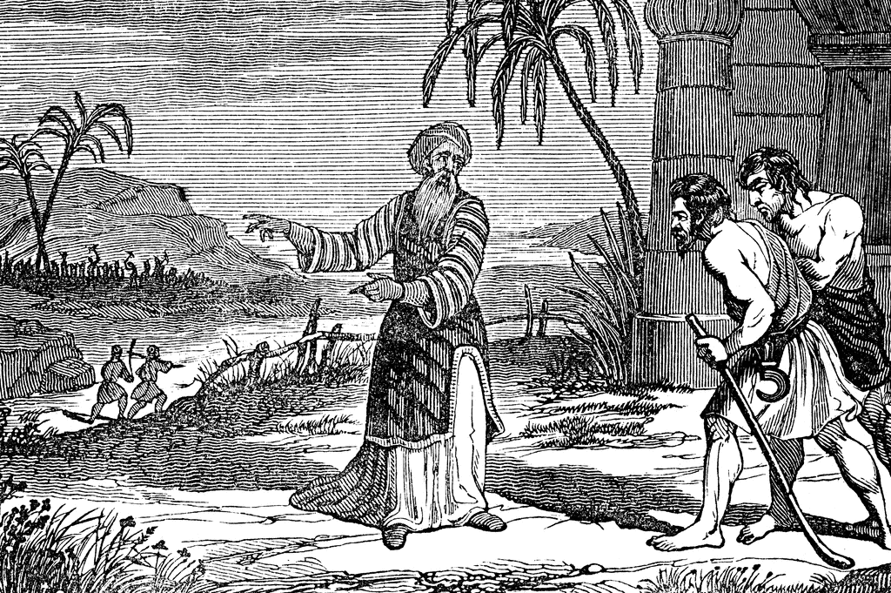
Hired workers in the vineyard

Matthew narrates Jesus’ parable in which Jesus says that the reign of God is like that of a landowner who pays his workers the same wage no matter what time of day they began to work. God is gracious and merciful, abounding in steadfast love. In baptism we are given the grace of God that is freely given to all. Through our efforts to live in response to God’s great goodness, to live the Gospel, “to work in the vineyard,” we give glory to our loving Lord.
The 17th Sunday after Pentecost Proper 20 20 September 2026
Markham Lutheran Church, 3518 W. 160th St., Markham, Illinois 60428
E-mail:markhamlutheranchurch@gmail.com; Tel: 708-331-4885
Website: http://www.Markhamlutheranchurch.org/
Pastor Larry Schneekloth
Service of the Word

738 Lord of All Hopefulness
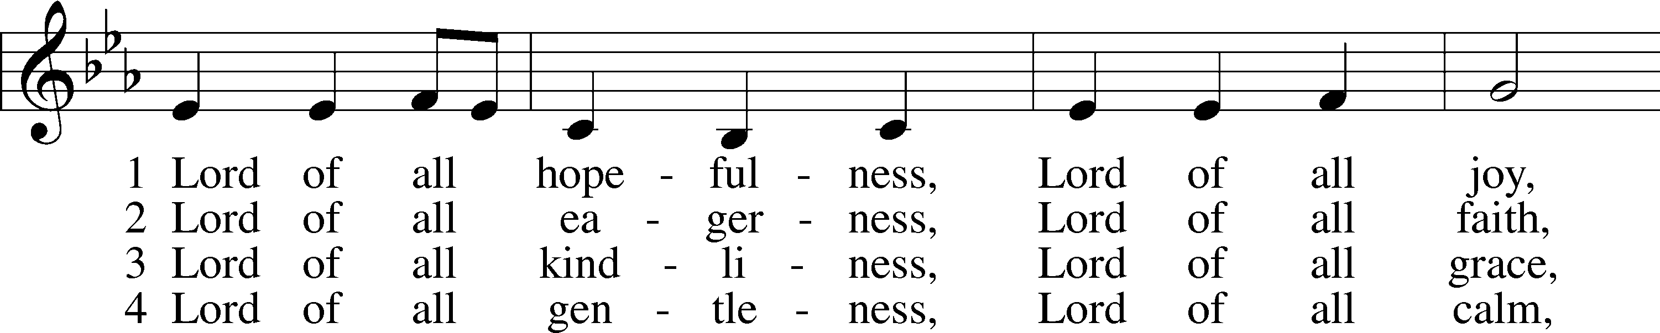
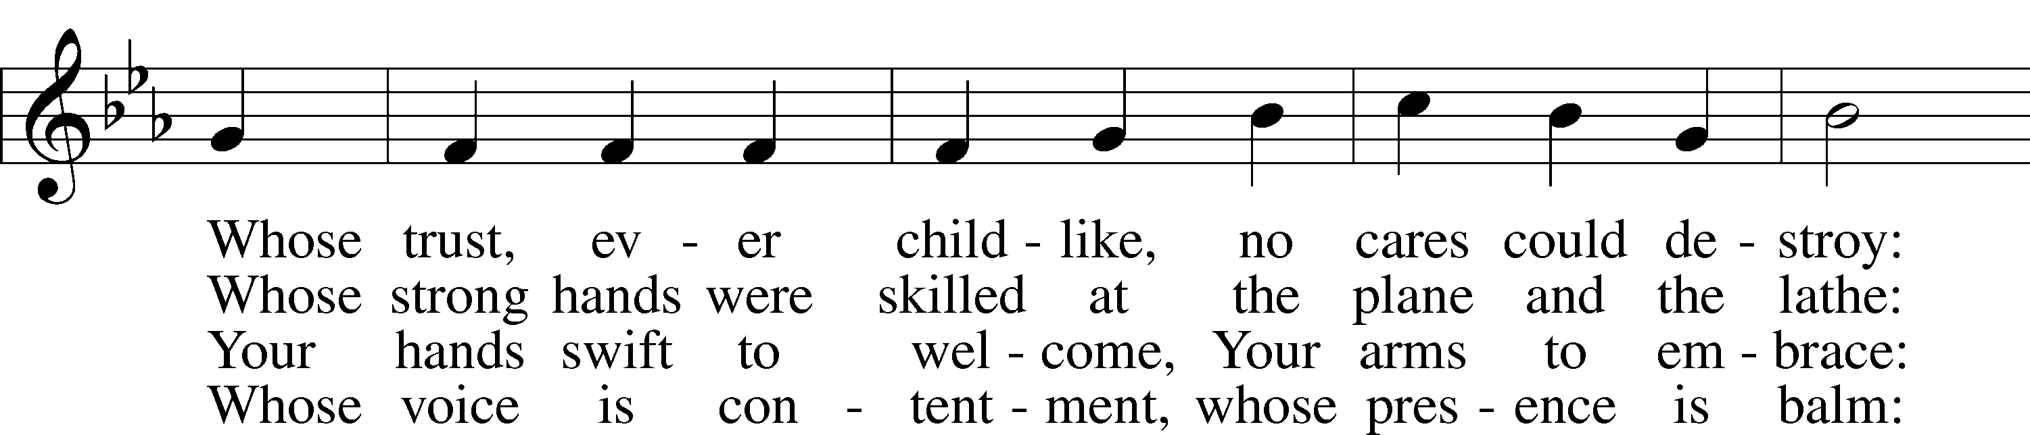
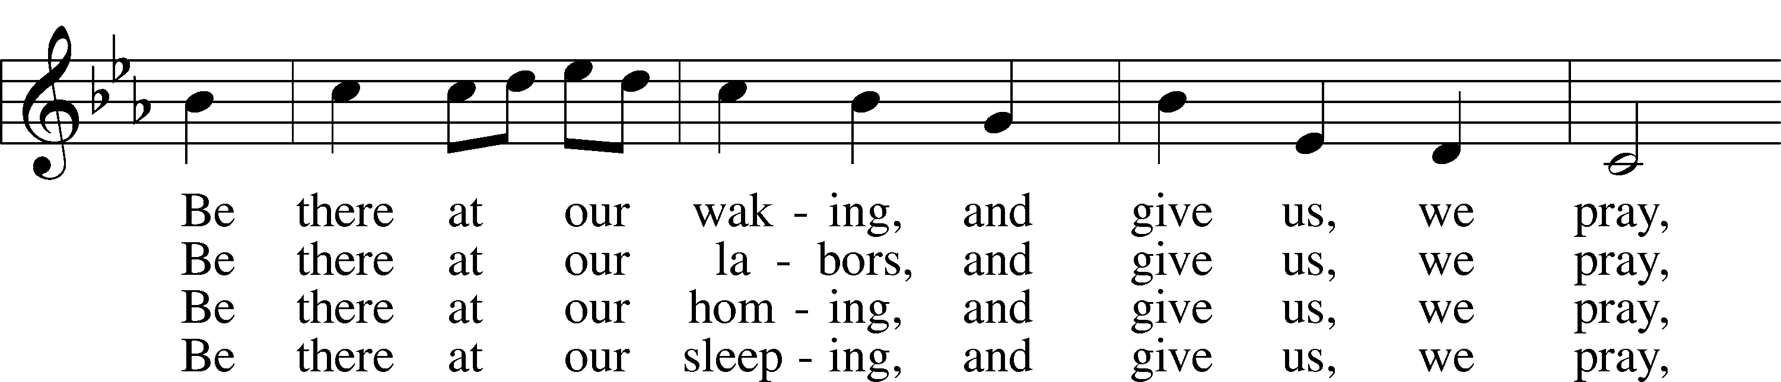
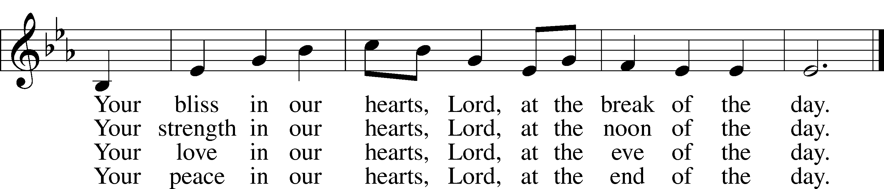

Text: Jan Struther, 1901–53
Tune: Irish
Text: © Oxford University Press. Used by permission: LSB Hymn License no. 110001341
Tune: Public domain

P In the name of the Father and of the T Son and of the Holy Spirit.
C Amen.
Kyrie LSB 168



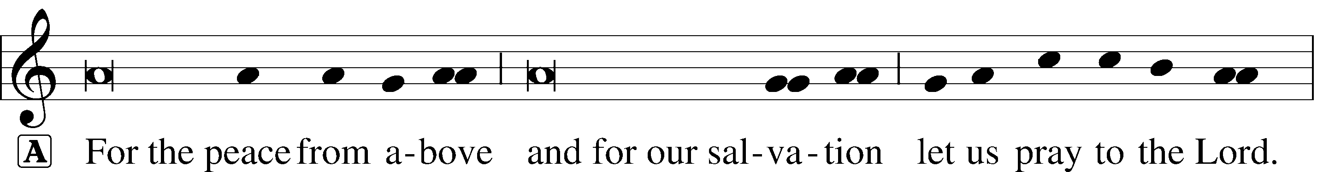


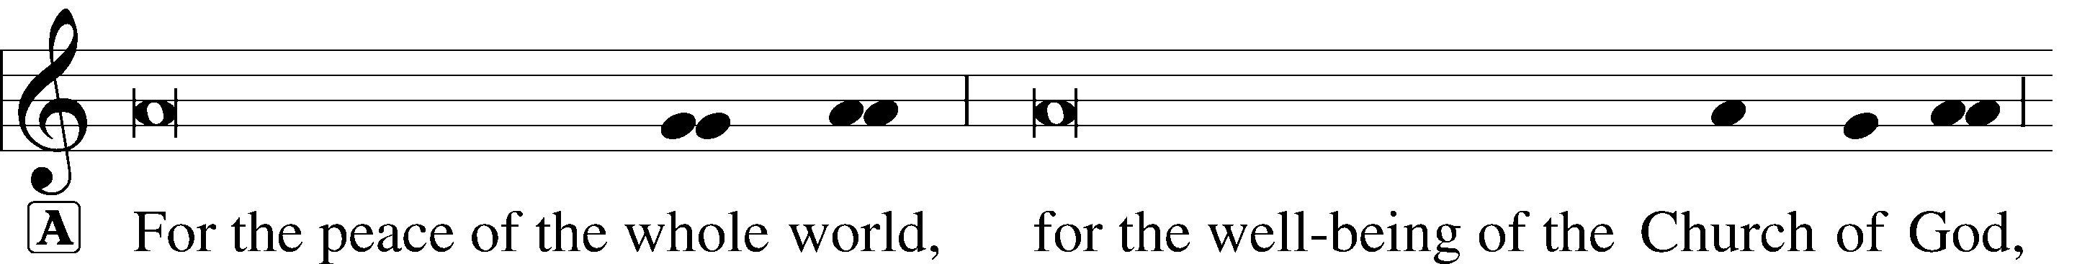



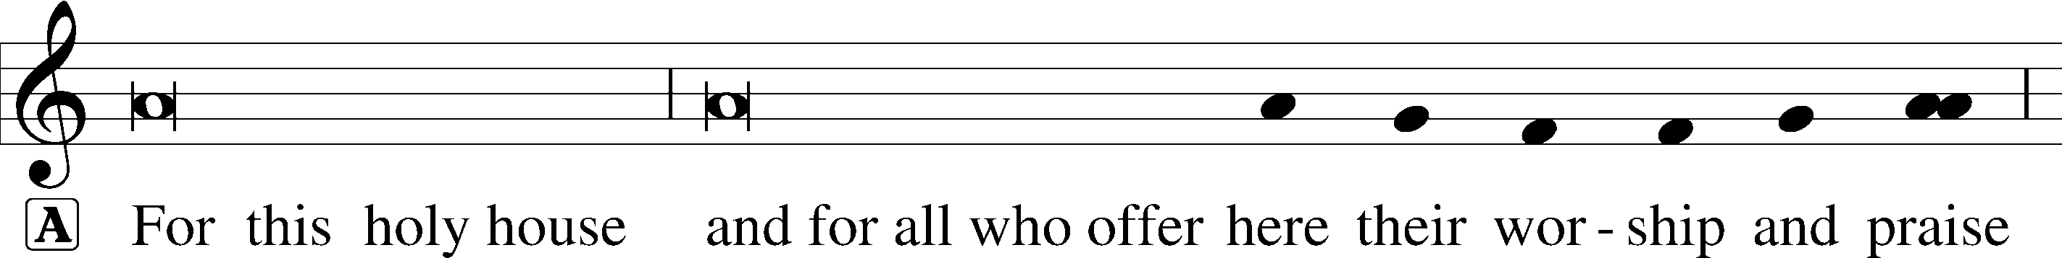






This Is the Feast LSB 171
A This is the feast of victory for our God. Alleluia.
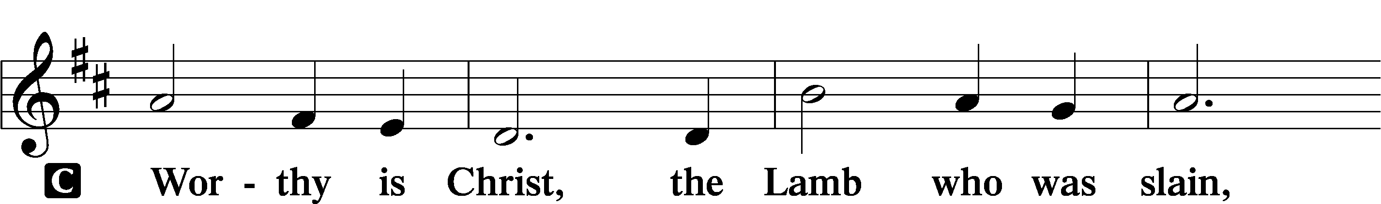
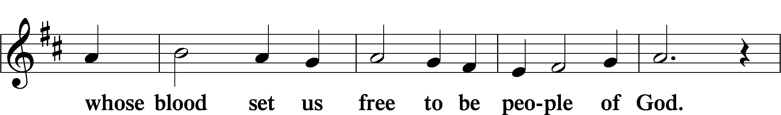
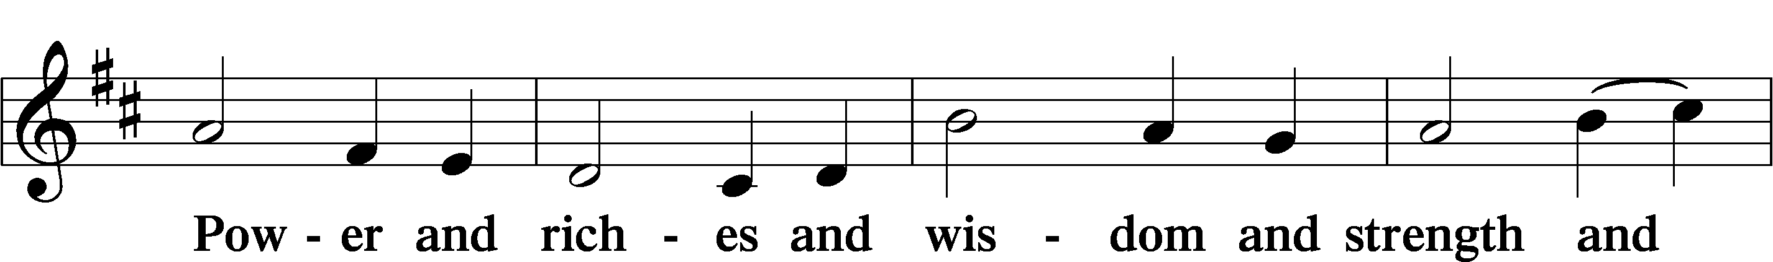
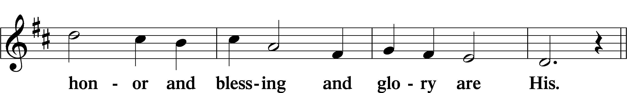
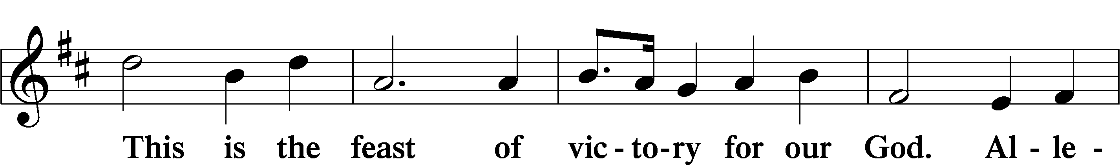
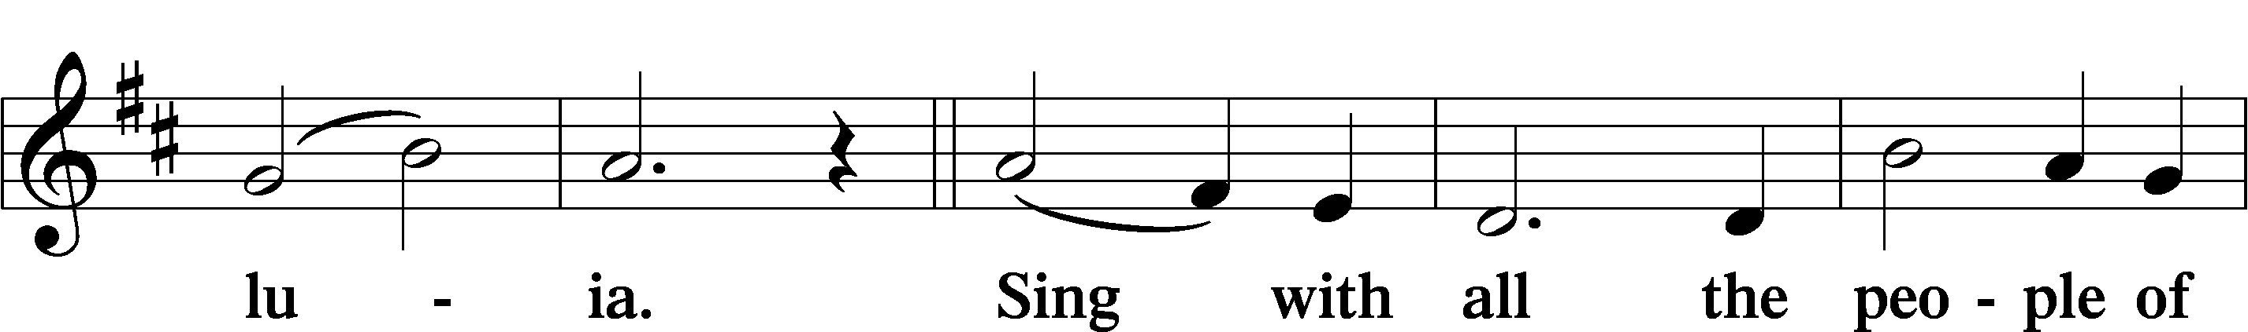
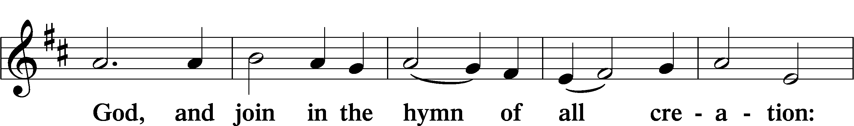
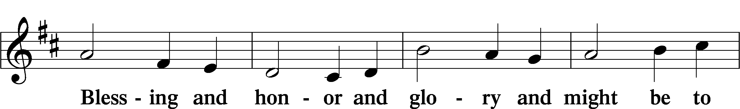
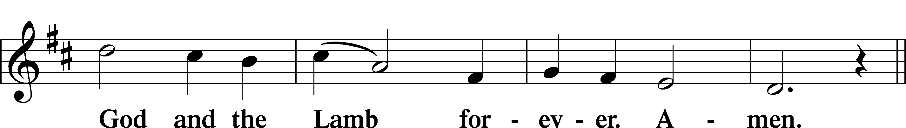
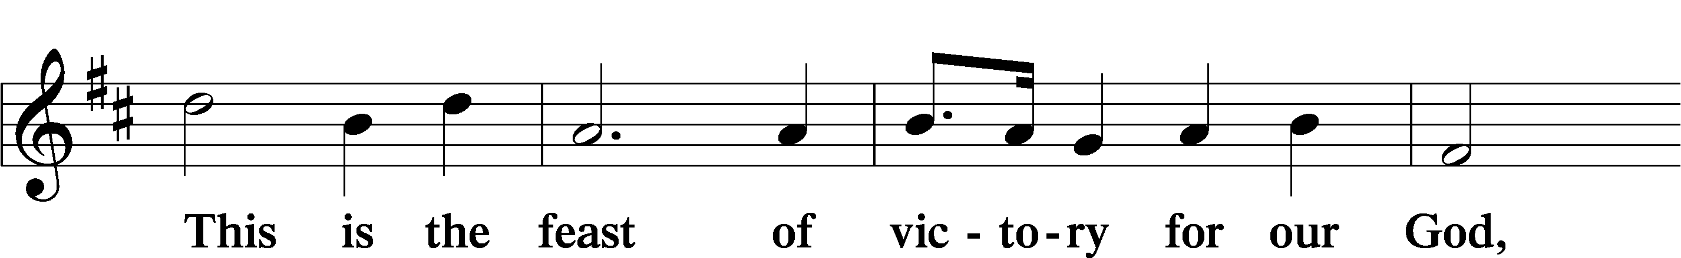
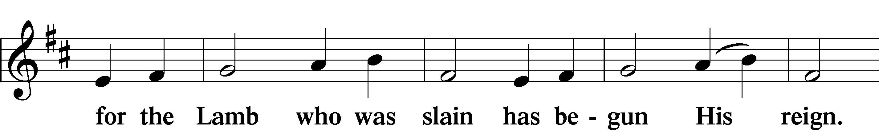
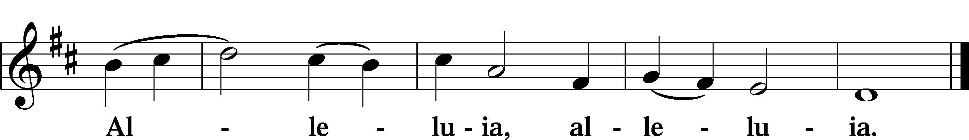

Collect of the Day
P Let us pray. Lord God, heavenly Father, since we cannot stand before You relying on anything we have done, help us trust in Your abiding grace and live according to Your Word; through Jesus Christ, Your Son, our Lord, who lives and reigns with You and the Holy Spirit, one God, now and forever.

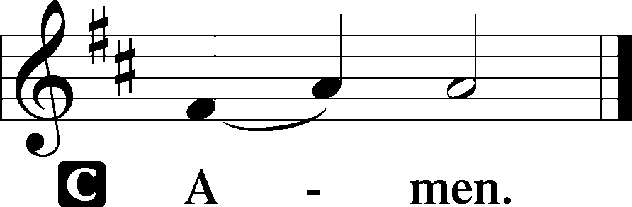

Old Testament Reading Isaiah 55:6–9

Isaiah declares that now is the time for God’s people to repent and return to the Lord. Why? Because God wants to pardon those who return. God’s ways are the ways of mercy and forgiveness.

Seek the Lord while he may be found; call upon him while he is near; ⁷ let the wicked forsake their way and the unrighteous their thoughts; let them return to the Lord, that he may have mercy on them, and to our God, for he will abundantly pardon. ⁸ For my thoughts are not your thoughts, nor are your ways my ways, says the Lord. ⁹ For as the heavens are higher than the earth, so are my ways higher than your ways and my thoughts than your thoughts.
A This is the Word of the Lord.
C Thanks be to God.

Epistle Philippians 1:12–14, 19–30

Paul writes to the Philippians from prison. Though he is uncertain about the outcome of his imprisonment, he is committed to the ministry of the gospel and calls on the Philippians to live lives that reflect and enhance the gospel mission.

¹² I want you to know, brothers and sisters, that what has happened to me has actually resulted in the progress of the gospel, ¹³ so that it has become known throughout the whole imperial guard^{[g]} and to everyone else that my imprisonment is for Christ, ¹⁴ and most of the brothers and sisters, having been made confident in the Lord by my imprisonment, dare to speak the word with greater boldness and without fear…. ¹⁹ for I know that through your prayers and the help of the Spirit of Jesus Christ this will turn out for my salvation. ²⁰ It is my eager expectation and hope that I will not be put to shame in any way but that by my speaking with all boldness Christ will be exalted now as always in my body, whether by life or by death. ²¹ For to me, living is Christ and dying is gain. ²² If I am to live in the flesh, that means fruitful labor for me, yet I cannot say which I will choose. ²³ I am hard pressed between the two: my desire is to depart and be with Christ, for that is far better, ²⁴ but to remain in the flesh is more necessary for you. ²⁵ Since I am convinced of this, I know that I will remain and continue with all of you for your progress and joy in faith, ²⁶ so that, by my presence again with you, your boast might abound in Christ Jesus because of me. ²⁷ Only, live your life in a manner worthy of the gospel of Christ, so that, whether I come and see you or am absent and hear about you, I will know that you are standing firm in one spirit, striving side by side with one mind for the faith of the gospel ²⁸ and in no way frightened by those opposing you. For them, this is evidence of their destruction but of your salvation. And this is God’s doing. ²⁹ For he has graciously granted you the privilege not only of believing in Christ but of suffering for him as well, ³⁰ since you are having the same struggle that you saw I had and now hear that I still have.
A This is the Word of the Lord.
C Thanks be to God.

Holy Gospel Matthew 20:1–16
P The Holy Gospel according to St. Matthew.
C Glory to You, O Lord.
20 “For the kingdom of heaven is like a landowner who went out early in the morning to hire laborers for his vineyard. ² After agreeing with the laborers for a denarius for the day, he sent them into his vineyard. ³ When he went out about nine o’clock, he saw others standing idle in the marketplace, ⁴ and he said to them, ‘You also go into the vineyard, and I will pay you whatever is right.’ So they went. ⁵ When he went out again about noon and about three o’clock, he did the same. ⁶ And about five o’clock he went out and found others standing around, and he said to them, ‘Why are you standing here idle all day?’ ⁷ They said to him, ‘Because no one has hired us.’ He said to them, ‘You also go into the vineyard.’ ⁸ When evening came, the owner of the vineyard said to his manager, ‘Call the laborers and give them their pay, beginning with the last and then going to the first.’ ⁹ When those hired about five o’clock came, each of them received a denarius. ¹⁰ Now when the first came, they thought they would receive more; but each of them also received a denarius. ¹¹ And when they received it, they grumbled against the landowner, ¹² saying, ‘These last worked only one hour, and you have made them equal to us who have borne the burden of the day and the scorching heat.’ ¹³ But he replied to one of them, ‘Friend, I am doing you no wrong; did you not agree with me for a denarius? ¹⁴ Take what belongs to you and go; I choose to give to this last the same as I give to you. ¹⁵ Am I not allowed to do what I choose with what belongs to me? Or are you envious because I am generous? ¹⁶ So the last will be first, and the first will be last.”
P This is the Gospel of the Lord.
C Praise to You, Lord Jesus Christ.

Sermon

555 Hymn of the Day Salvation unto Us Has Come

1 Salvation unto us has come By God’s free grace and favor;
Good works cannot avert our doom, They help and save us never.
Faith looks to Jesus Christ alone, Who did for all the world atone;
He is our one Redeemer.

6 Since Christ has full atonement made And brought to us salvation,
Each Christian therefore may be glad And build on this foundation.
Your grace alone, dear Lord, I plead, Your death is now my life indeed,
For You have paid my ransom.

9 Faith clings to Jesus’ cross alone And rests in Him unceasing;
And by its fruits true faith is known, With love and hope increasing.
For faith alone can justify; Works serve our neighbor and supply
The proof that faith is living.

D 10 All blessing, honor, thanks, and praise To Father, Son, and Spirit,
The God who saved us by His grace; All glory to His merit.
O triune God in heav’n above, You have revealed Your saving love;
Your blessèd name we hallow.

Nicene Creed

We believe in one God, the Father, the Almighty, maker of heaven and earth, of all that is, seen and unseen.

We believe in one Lord, Jesus Christ, the only Son of God, eternally begotten of the Father, God from God, Light from Light, true God from true God, begotten, not made, of one Being with the Father; through him all things were made. For us and for our salvation he came down from heaven, was incarnate of the Holy Spirit and the Virgin Mary and became truly human. For our sake he was crucified under Pontius Pilate; he suffered death and was buried. On the third day he rose again in accordance with the Scriptures; he ascended into heaven and is seated at the right hand of the Father. He will come again in glory to judge the living and the dead, and his kingdom will have no end.

We believe in the Holy Spirit, the Lord, the giver of life, who proceeds from the Father and the Son, who with the Father and the Son is worshiped and glorified, who has spoken through the prophets. We believe in one holy catholic and apostolic Church. We acknowledge one baptism for the forgiveness of sins. We look for the resurrection of the dead, and the T life of the world to come. Amen.

The Prayer of the Church
...Lord, in your mercy,
HEAR OUR PRAYER.

(Last petition:) Into your hands we commend ourselves, and all for whom we pray, trusting in your mercy, through Jesus Christ our Lord.
AMEN.
827 Hark, the Voice of Jesus Calling
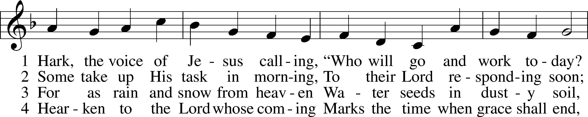
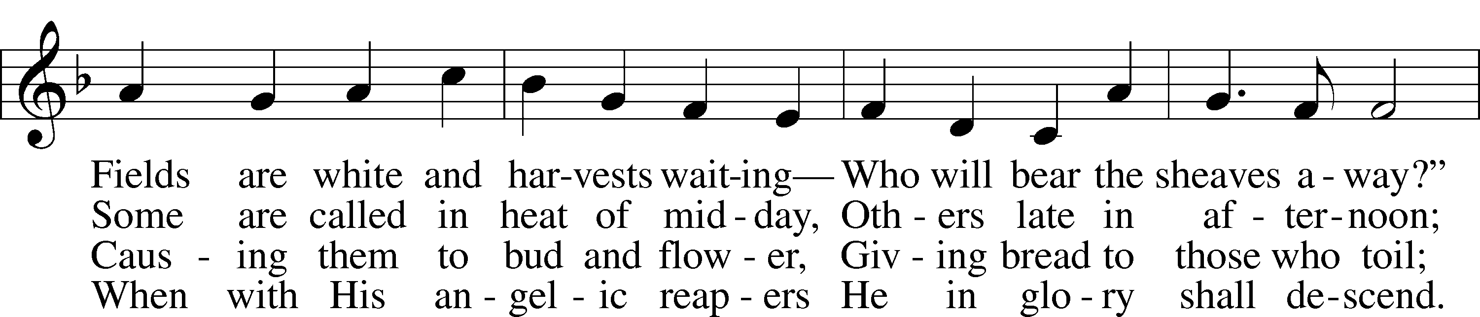
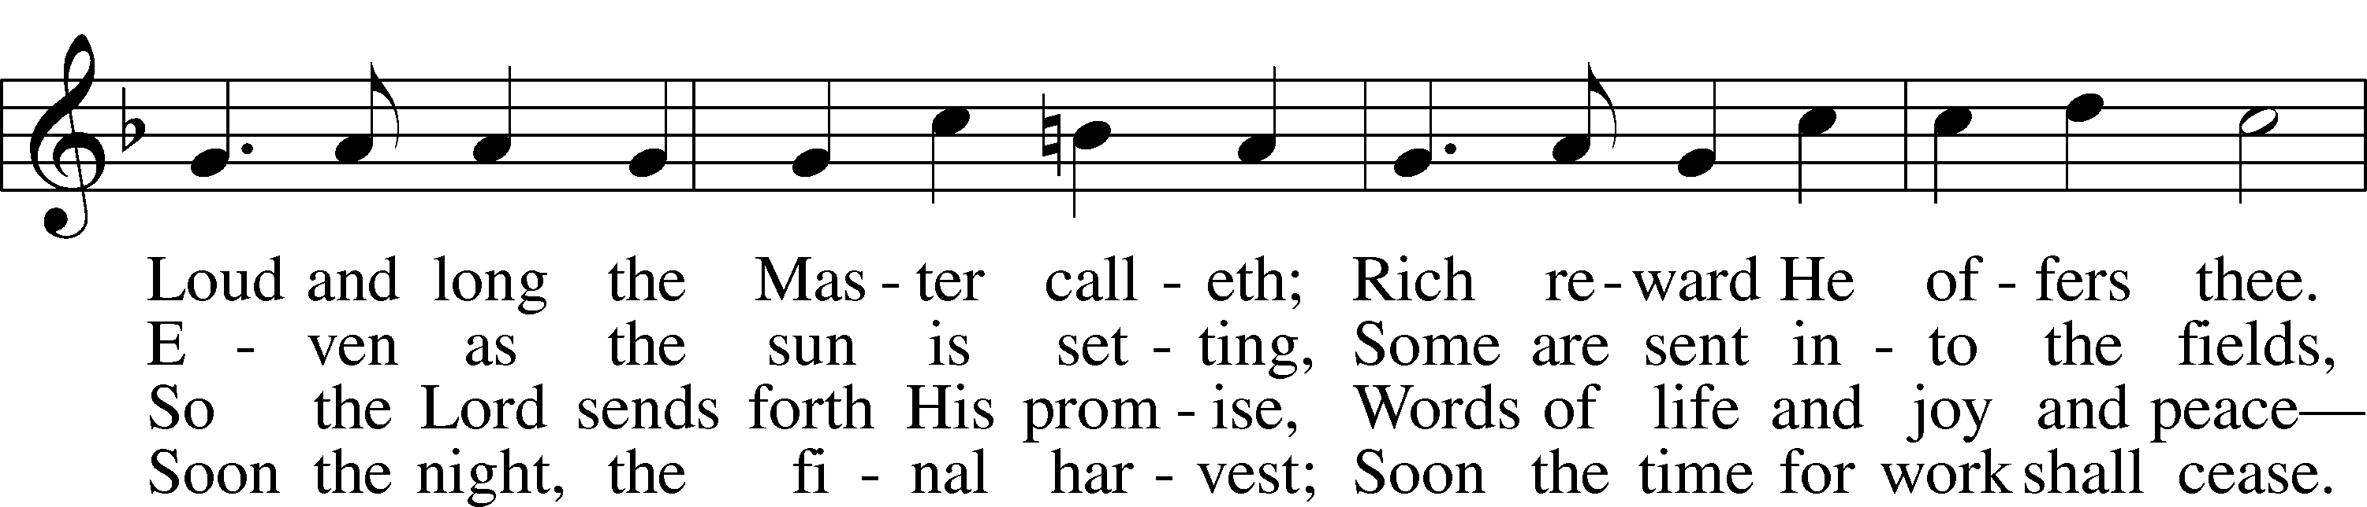
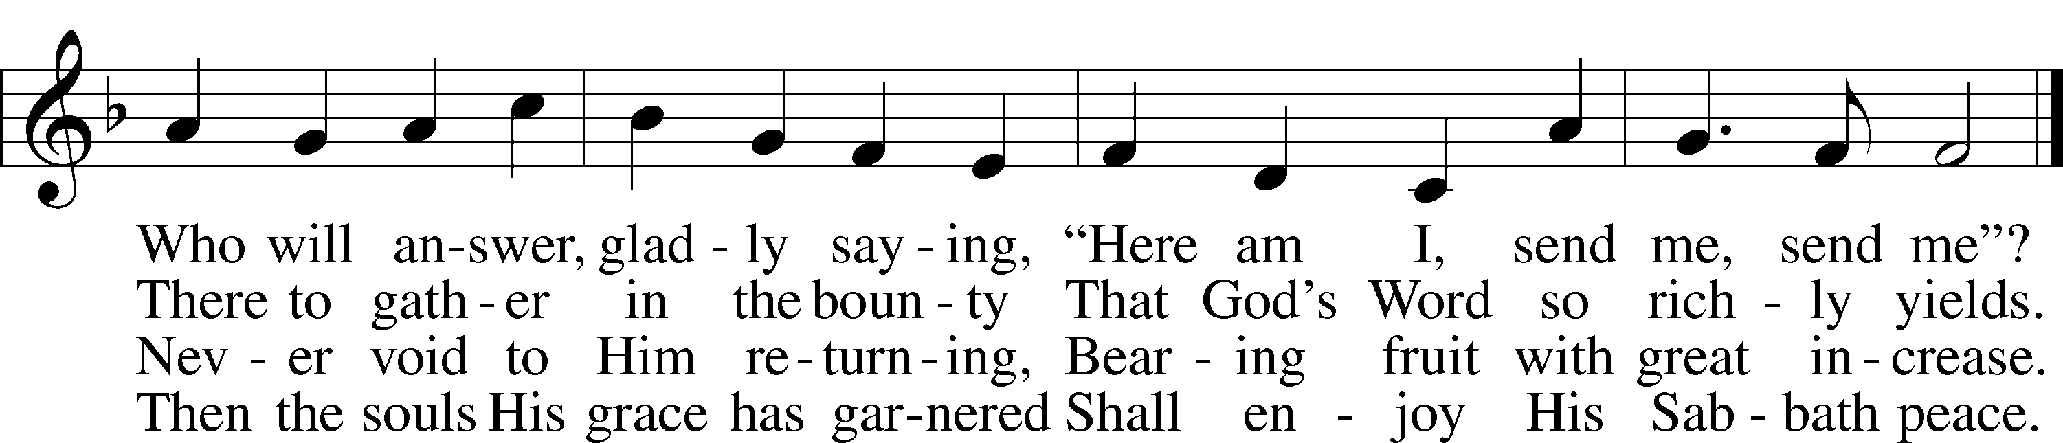

Text (st. 1): Daniel March, 1816–1909, alt.; (sts. 2–4): Stephen P. Starke, 1955 Tune: Joseph Barnby, 1838–96
Text (sts. 2–4): © 2001 Stephen P. Starke, admin. Concordia Publishing House. Used by permission: LSB Hymn License no. 110001341
Text (st. 1) and tune: Public domain

Service of the Sacrament
The Lord be with you. AND ALSO WITH YOU.
Lift up your hearts. WE LIFT THEM TO THE LORD.
Let us give thanks to the Lord our God.
IT IS RIGHT TO GIVE GOD THANKS AND PRAISE.

It is indeed right and salutary that we should at all times and in all places offer thanks and praise to you, O Lord, holy Father, through Christ our Lord; who on this first day of the week overcame death and the grave, and by his glorious resurrection opened to us the way of everlasting life. And so, with the church on earth and the hosts of heaven, we praise your name, and join their unending hymn:

Sanctus LSB 178
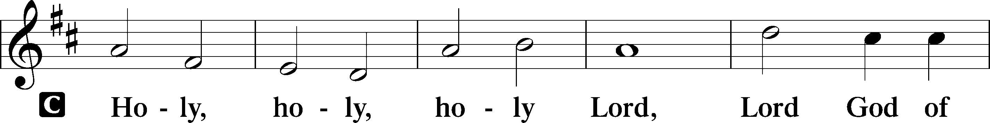
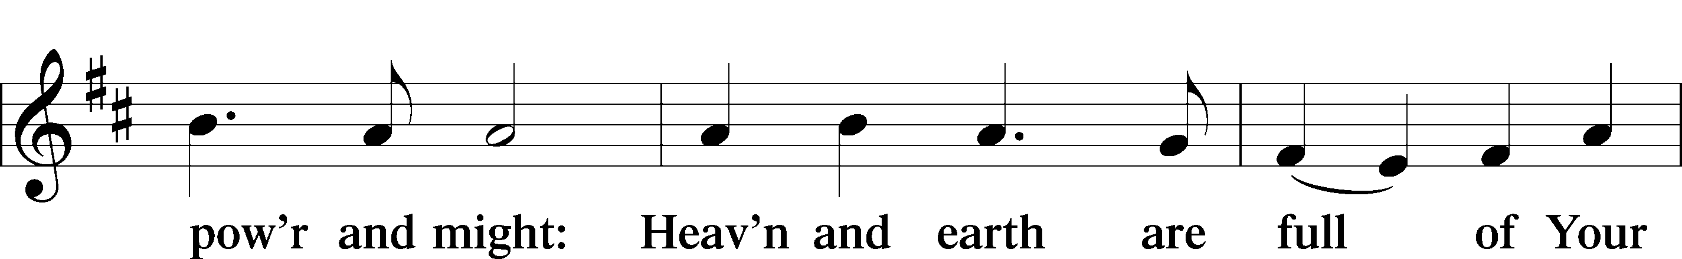
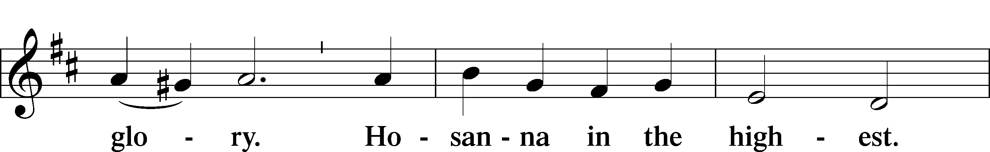
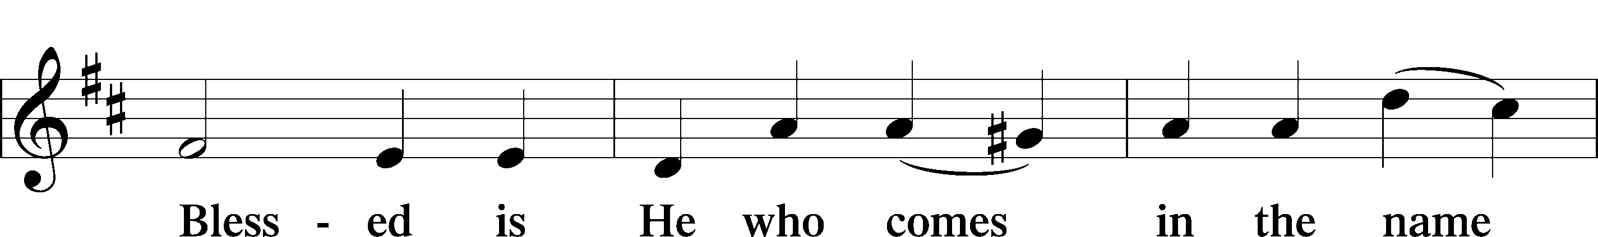
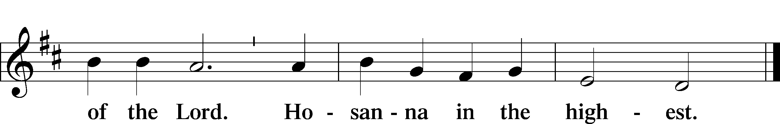

Our Lord Jesus Christ… As often as we eat this bread, and drink from his cup, we proclaim the Lord’s death until he comes.
CHRIST HAS DIED. CHRIST IS RISEN. CHRIST WILL COME AGAIN.

Remember us in your kingdom and teach us to pray: OUR FATHER....

THE HOLY COMMUNION

The Thanksgiving and Dismissal
O give thanks to the Lord, for he is good.
AND HIS MERCY ENDURES FOREVER.

We give you thanks, O Father, for the food with which you have fed us this day: Your holy word, the remembrance of our Baptism, and the Bread Wine of the Holy Communion. We ask that you continue to strengthen us in our faith in you, and in our fervent love for one another; through Jesus Christ our Lord.
AMEN.

Almighty God bless you, the Father, the T Son, and the Holy Spirit.
AMEN.

"There's A Wideness In God's Mercy"
(tune: Nettleton LSB 686 “Come Thou Fount of Every Blessing”)

- There's a wideness in God's mercy like the wideness of the sea.
There's a kindness in his justice which is more than liberty.
There is welcome for the sinner and more graces for the good.
There is mercy with the Savior; there is healing in his blood.

- For the love of God is broader than the measure of our mind.
And the heart of the Eternal is most wonderfully kind.
If our love were but more simple we should take him at his word,
And our lives would be all sunshine in the sweetness of our Lord.

THIS WEEK IN THE CHURCH CALENDAR
9/21: St. Matthew, Evangelist
Matthew (the son of Alphaeus, according to Mark) was a tax collector for the Roman government in Capernaum. He is called Levi in the accounts of his call to discipleship, although in the lists of the Twelve he is always called Matthew. It is a traditional belief that Levi was his original name and Matthew (Hebrew, "gift from God") was given to him after he became a disciple. Since the second century the authorship of the first gospel has been attributed to Matthew. He is usually represented in art by a winged man (suggested by Ezekiel 1:1-10 and 10:8-14). His feast day in the East is November 16.
/25: Sergius of Radonezh, Abbot, 1392
Sergius, the most beloved of all Russian saints, was born at Rostov, Russia, c.1314. Driven from his home by civil war at the age of twenty, Sergius, with his brother Stephen, took up the life of a hermit and was, in time, joined by others. He was noted for his respectful attitude toward nature and his use of his influence to preserve peace among quarreling princes. Offered the metropolitan See of Moscow in 1378, Sergius refused it. He died at Holy Trinity Monastery, Moscow, in 1392.

