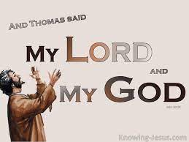

In spite of all we have heard and all we have seen, it is often hard to believe. Because it is hard to believe, we will invest ourselves in he Easter mystery for fifty days (a week of weeks). Because it is hard to believe, John the evangelist will provide sign after sign celebrating Jesus’ victory over death. Because it is hard to believe, the risen Jesus will return to us again and again in the mystery of holy communion, inviting us to touch and taste his presence, and offering us his peace.

The 2nd Sunday of Easter 27 April 2025
Markham Lutheran Church, 3518 W. 160th St., Markham, Illinois 60428
E-mail: markhamlutheranchurch@gmail.com; Tel: 708-331-4885
Website: http://www.Markhamlutheranchurch.org/
Pastor Larry Schneekloth
470 O Sons and Daughters of the King

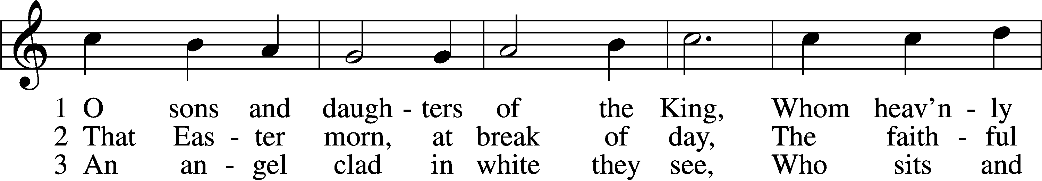
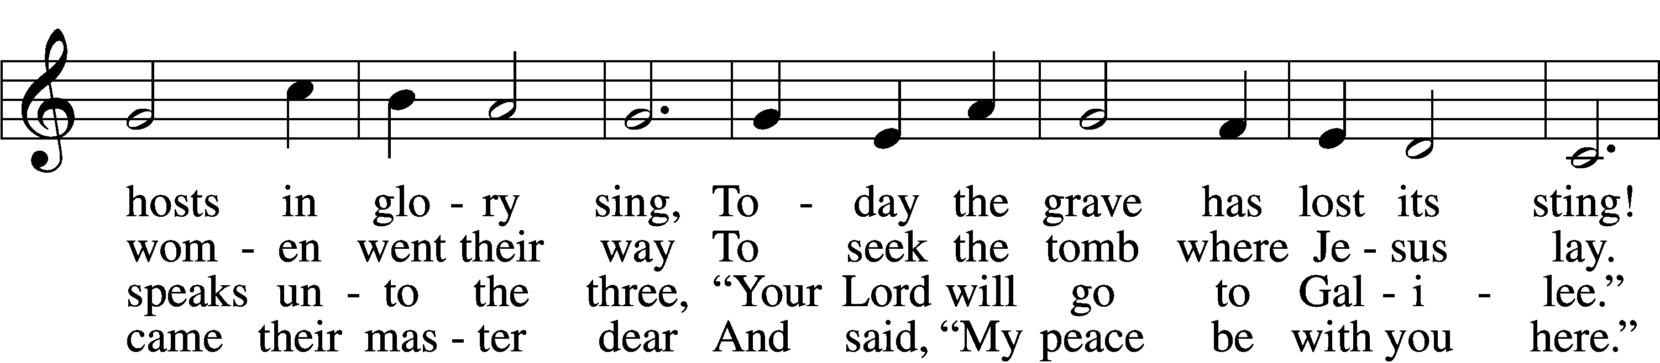
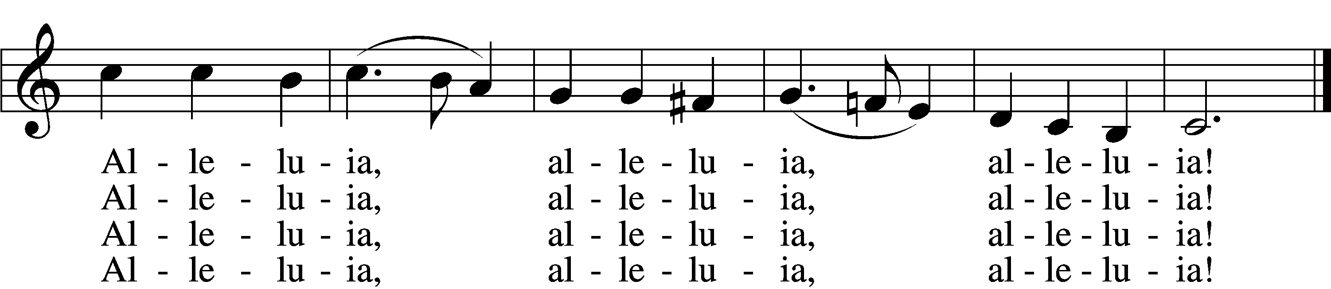

P In the name of the Father and of the T Son and of the Holy Spirit.
C Amen.

Kyrie
A Lord Jesus, you are the Lord of all who trust in you.
C Lord, have mercy.
A Lord Jesus, you reveal to us the Father’s infinite love.
C Christ, have mercy.
A Lord Jesus, you come in word and sacrament to strengthen our faith
C Lord, have mercy.

This Is the Feast LSB 171
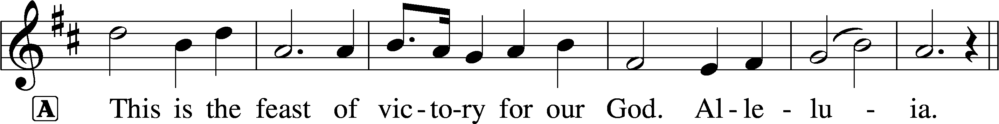
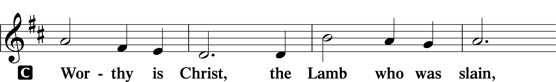
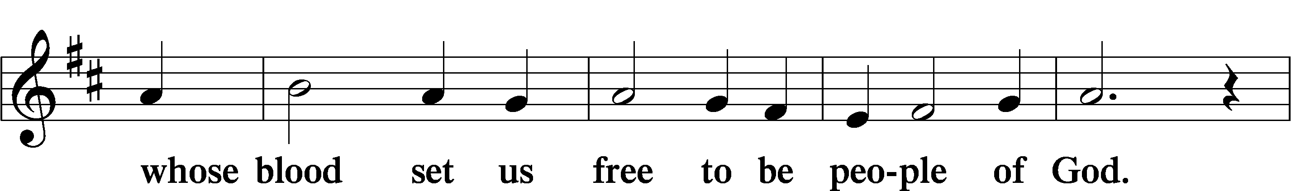
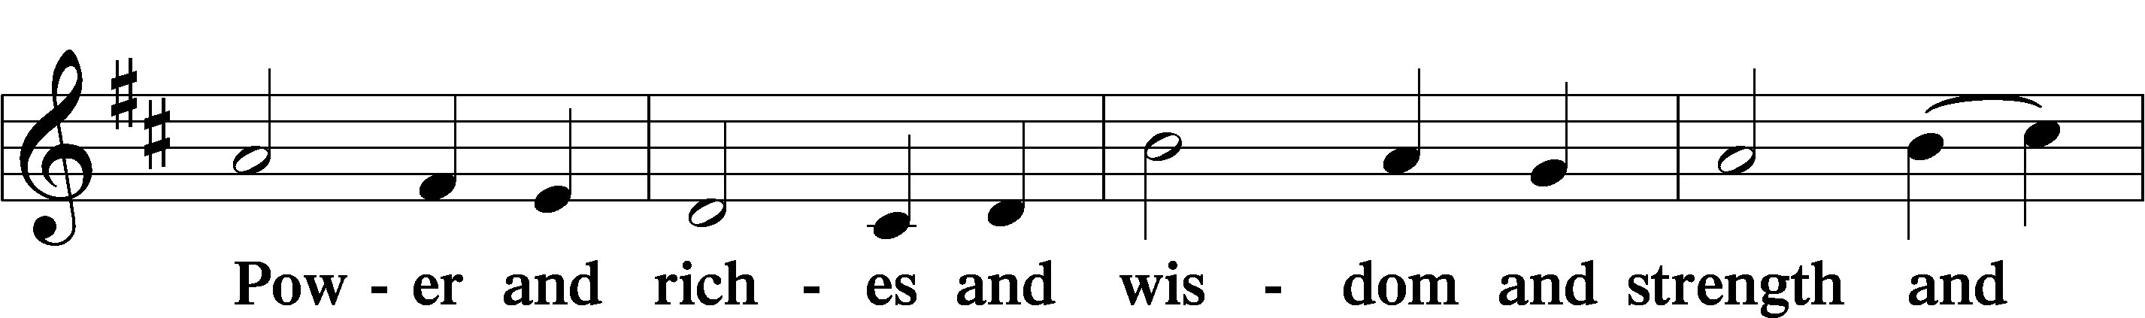
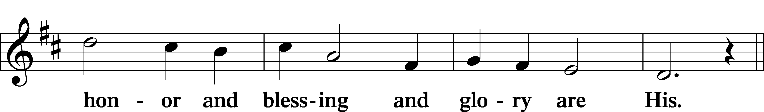
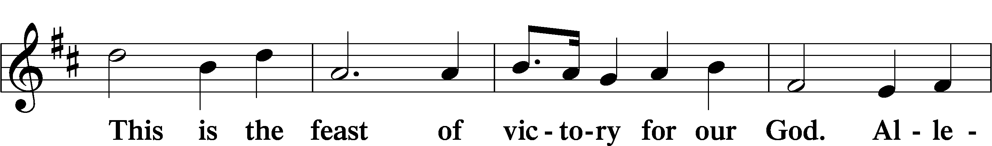
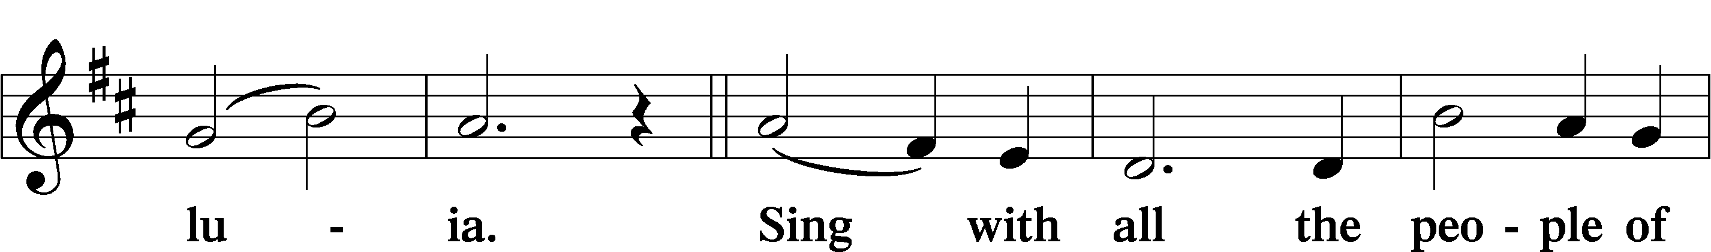
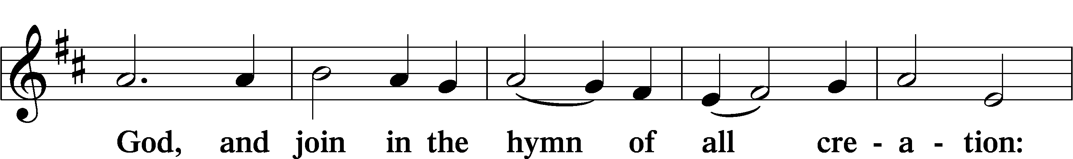
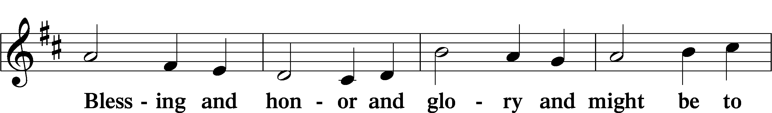
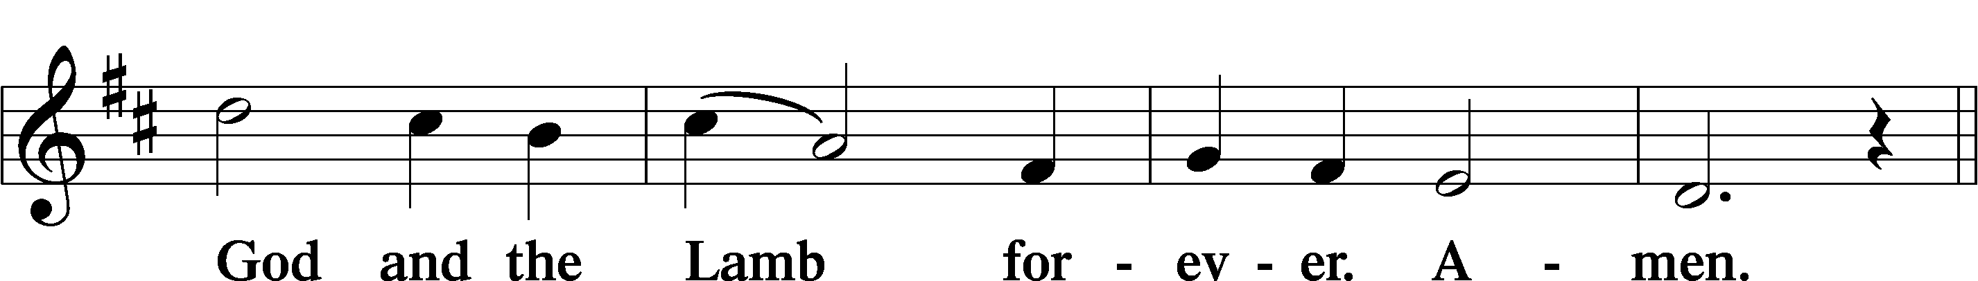
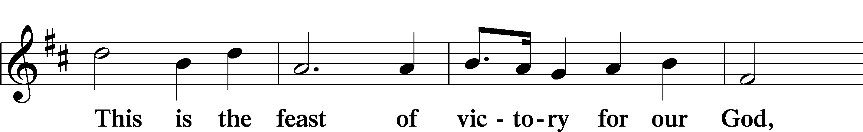
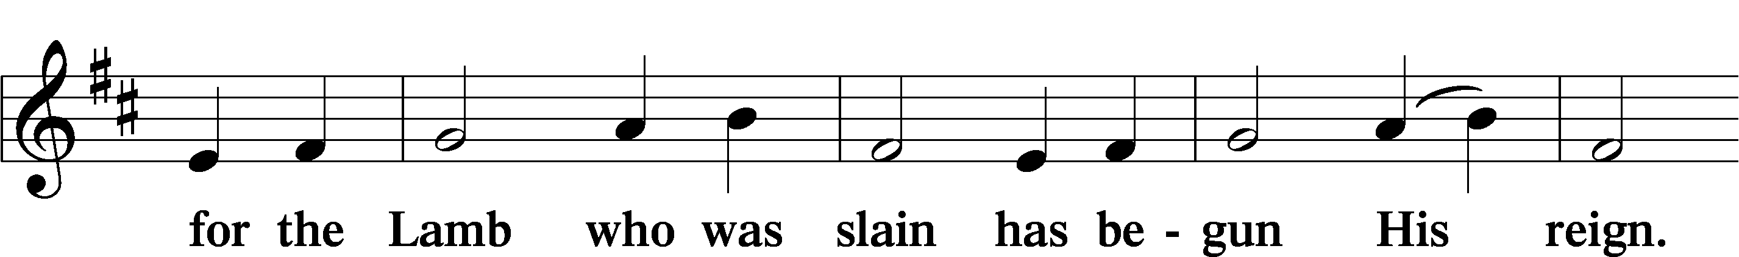
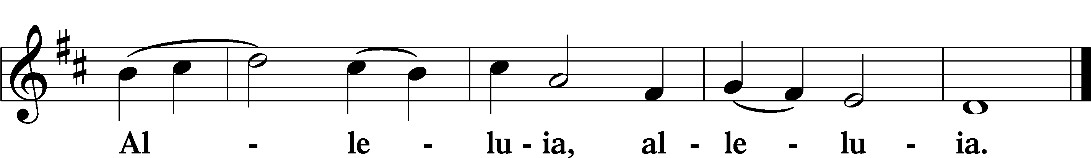

Salutation and Collect of the Day
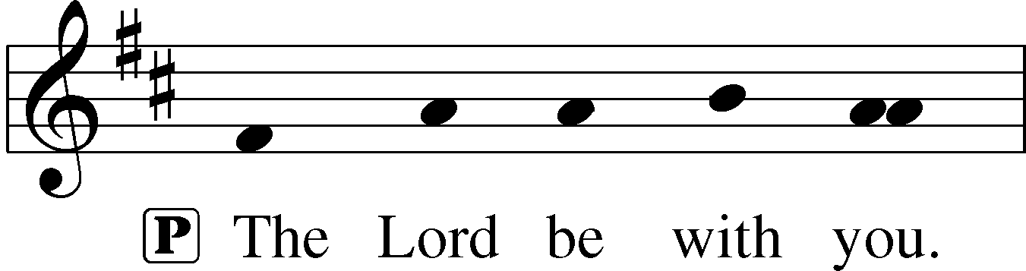
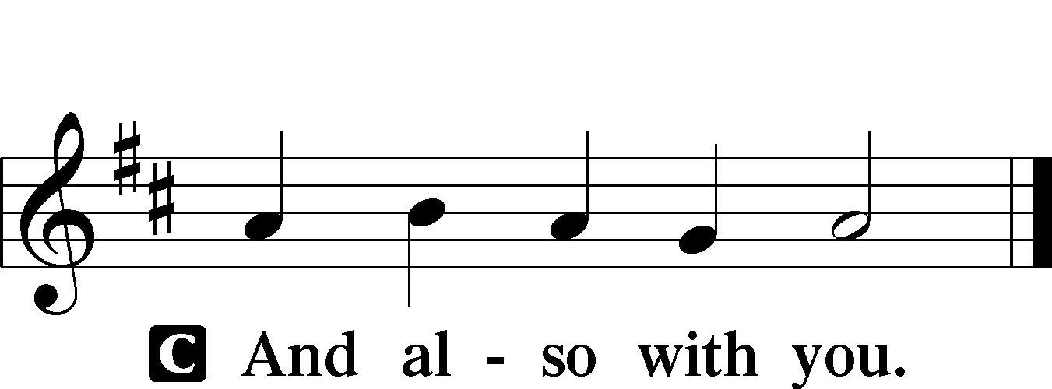

P Let us pray. Almighty God, grant that we who have celebrated the Lord’s resurrection may by your grace confess in our life and conversation that Jesus is Lord and God; through the same Jesus Christ, your Son, who lives and reigns with You and the Holy Spirit, one God, now and forever.

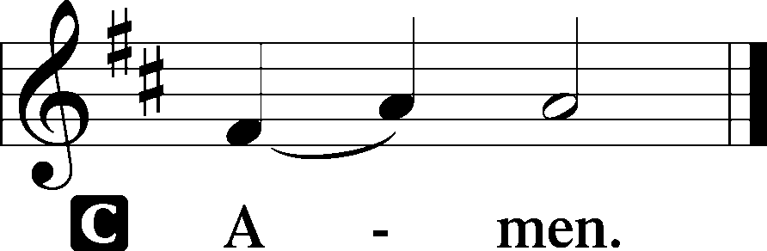
First Reading Acts 5:12, 17–32
¹² Now many signs and wonders were done among the people through the apostles… ¹⁷ Then the high priest took action; he and all who were with him (that is, the sect of the Sadducees), being filled with jealousy, ¹⁸ arrested the apostles and put them in the public prison. ¹⁹ But during the night an angel of the Lord opened the prison doors, brought them out, and said, ²⁰ “Go, stand in the temple and tell the people the whole message about this life.” ²¹ When they heard this, they entered the temple at daybreak and went on with their teaching. When the high priest and those with him arrived, they called together the council and the whole body of the elders of Israel, and sent to the prison to have them brought. ²² But when the temple police went there, they did not find them in the prison; so they returned and reported, ²³ “We found the prison securely locked and the guards standing at the doors, but when we opened them, we found no one inside.” ²⁴ Now when the captain of the temple and the chief priests heard these words, they were perplexed about them, wondering what might be going on. ²⁵ Then someone arrived and announced, “Look, the men whom you put in prison are standing in the temple and teaching the people!” ²⁶ Then the captain went with the temple police and brought them, but without violence, for they were afraid of being stoned by the people. ²⁷ When they had brought them, they had them stand before the council. The high priest questioned them, ²⁸ saying, “We gave you strict orders not to teach in this name, yet here you have filled Jerusalem with your teaching and you are determined to bring this man’s blood on us.” ²⁹ But Peter and the apostles answered, “We must obey God rather than any human authority. ³⁰ The God of our ancestors raised up Jesus, whom you had killed by hanging him on a tree. ³¹ God exalted him at his right hand as Leader and Savior that he might give repentance to Israel and forgiveness of sins. ³² And we are witnesses to these things, and so is the Holy Spirit whom God has given to those who obey him.”
A This is the Word of the Lord.
C Thanks be to God.

Psalm Psalm 148
1Praise the Lord! Praise the Lord from the | heavens;* praise him | in the heights!
2PRAISE HIM, ALL HIS | ANGELS;* PRAISE HIM, | ALL HIS HOSTS!
3Praise him, | sun and moon,* praise him, all you | shining stars!
4PRAISE HIM, YOU HIGHEST | HEAVENS,*
AND YOU WATERS ABOVE THE | HEAVENS!
5Let them praise the name | of the Lord!*
For he commanded and they were cre- | ated.
6AND HE ESTABLISHED THEM FOREVER AND | EVER;*
HE GAVE A DECREE, AND IT SHALL NOT | PASS AWAY.
7Praise the Lord | from the earth,* you great sea creatures and | all deeps,
8FIRE AND HAIL, | SNOW AND MIST,*
STORMY WIND FULFILL- | ING HIS WORD!
9Mountains and | all hills,* fruit trees and all | cedars!
10BEASTS AND ALL | LIVESTOCK,*
CREEPING THINGS AND | FLYING BIRDS!
11Kings of the earth and all | peoples,* princes and all rulers | of the earth!
12YOUNG MEN AND MAIDENS TO- | GETHER,*
OLD MEN AND | CHILDREN!
13Let them praise the name of the Lord, for his name alone is ex- | alted;*
his majesty is above earth and | heaven.
14HE HAS RAISED UP A HORN FOR HIS PEOPLE, PRAISE FOR | ALL HIS SAINTS,* FOR THE PEOPLE OF ISRAEL WHO ARE NEAR TO HIM. | PRAISE THE LORD!

Epistle Revelation 1:4–8

⁴ John to the seven churches that are in Asia: Grace to you and peace from him who is and who was and who is to come, and from the seven spirits who are before his throne, ⁵ and from Jesus Christ, the faithful witness, the firstborn of the dead, and the ruler of the kings of the earth. To him who loves us and freed us from our sins by his blood, ⁶ and made us to be a kingdom, priests serving his God and Father, to him be glory and dominion forever and ever. Amen. ⁷ Look! He is coming with the clouds; every eye will see him, even those who pierced him; and on his account all the tribes of the earth will wail. So it is to be. Amen. ⁸ “I am the Alpha and the Omega,” says the Lord God, who is and who was and who is to come, the Almighty.
A This is the Word of the Lord. C Thanks be to God.

Stand

Holy Gospel John 20:19–31
P The Holy Gospel according to St. John.
C Glory to You, O Lord.
⁹ When it was evening on that day, the first day of the week, and the doors of the house where the disciples had met were locked for fear of the Jews, Jesus came and stood among them and said, “Peace be with you.” ²⁰ After he said this, he showed them his hands and his side. Then the disciples rejoiced when they saw the Lord. ²¹ Jesus said to them again, “Peace be with you. As the Father has sent me, so I send you.” ²² When he had said this, he breathed on them and said to them, “Receive the Holy Spirit. ²³ If you forgive the sins of any, they are forgiven them; if you retain the sins of any, they are retained.” ²⁴ But Thomas (who was called the Twin), one of the twelve, was not with them when Jesus came. ²⁵ So the other disciples told him, “We have seen the Lord.” But he said to them, “Unless I see the mark of the nails in his hands, and put my finger in the mark of the nails and my hand in his side, I will not believe.” ²⁶ A week later his disciples were again in the house, and Thomas was with them. Although the doors were shut, Jesus came and stood among them and said, “Peace be with you.” ²⁷ Then he said to Thomas, “Put your finger here and see my hands. Reach out your hand and put it in my side. Do not doubt but believe.” ²⁸ Thomas answered him, “My Lord and my God!” ²⁹ Jesus said to him, “Have you believed because you have seen me? Blessed are those who have not seen and yet have come to believe.”
³⁰ Now Jesus did many other signs in the presence of his disciples, which are not written in this book. ³¹ But these are written so that you may come to believe that Jesus is the Messiah, the Son of God, and that through believing you may have life in his name.
P This is the Gospel of the Lord.
C Praise to You, Lord Jesus Christ.

The Homily

Nicene Creed

We believe in one God, the Father, the Almighty, maker of heaven and earth, of all that is, seen and unseen.

We believe in one Lord, Jesus Christ, the only Son of God, eternally begotten of the Father, God from God, Light from Light, true God from true God, begotten, not made, of one Being with the Father; through him all things were made. For us and for our salvation he came down from heaven, was incarnate of the Holy Spirit and the Virgin Mary and became truly human. For our sake he was crucified under Pontius Pilate; he suffered death and was buried. On the third day he rose again in accordance with the Scriptures; he ascended into heaven and is seated at the right hand of the Father. He will come again in glory to judge the living and the dead, and his kingdom will have no end.

We believe in the Holy Spirit, the Lord, the giver of life, who proceeds from the Father and the Son, who with the Father and the Son is worshiped and glorified, who has spoken through the prophets. We believe in one holy catholic and apostolic Church. We acknowledge one baptism for the forgiveness of sins. We look for the resurrection of the dead, and the ₍₊₎ life of the world to come. Amen

The Prayer of the Church
.... Lord, in your mercy,
HEAR OUR PRAYR.

(After the last petition) O Christ, Redeemer of the world, we praise you and confess that you are the Lord, to the glory of God the Father.
AMEN.

Christ is risen! Alleluia!
HE IS RISEN INDEED! ALLELUIA!
470 O Sons and Daughters of the King

4 That night the apostles met in fear; Among them came their master dear
And said, “My peace be with you here.” Alleluia!

5 When Thomas first the tidings heard That they had seen the risen Lord,
He doubted the disciples’ word. Alleluia!

6 “My piercèd side, O Thomas, see, And look upon My hands, My feet;
Not faithless but believing be.” Alleluia!

7 No longer Thomas then denied; He saw the feet, the hands, the side;
“You are my Lord and God!” he cried. Alleluia!

8 How blest are they who have not seen And yet whose faith has constant been,
For they eternal life shall win. Alleluia!

9 On this most holy day of days Be laud and jubilee and praise:
To God your hearts and voices raise. Alleluia!

Text: attr. Jean Tisserand, d. 1494; tr. John Mason Neale, 1818–66, alt.
Text: Public domain

Service of the Sacrament
The Lord be with you.
AND ALSO WITH YOU.
Lift up your hearts.
WE LIFT THEM TO THE LORD.
Let us give thanks to the Lord our God.
IT IS RIGHT TO GIVE GOD THANKS AND PRAISE.

It is truly good, right, and salutary that we should at all times and in all places give thanks to you, holy Lord, almighty Father, everlasting God. And most especially are we bound to praise you on this day for the glorious resurrection of your Son, Jesus Christ, the very Paschal Lamb, who was sacrificed for us and bore the sins of the
world. By His dying he has destroyed death, and by his rising again he has restored to us everlasting life. Therefore with Mary Magdalene, Peter and John, and with all the witnesses of the resurrection, with angels and archangels, and with all the company of heaven we praise your name and join in their unending hymn:

Sanctus LSB 178
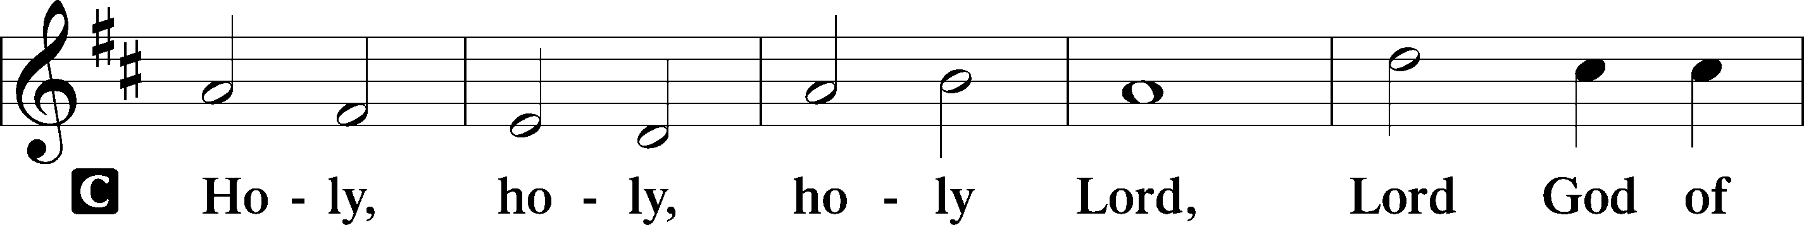
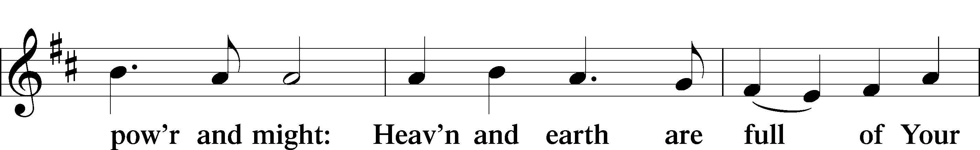
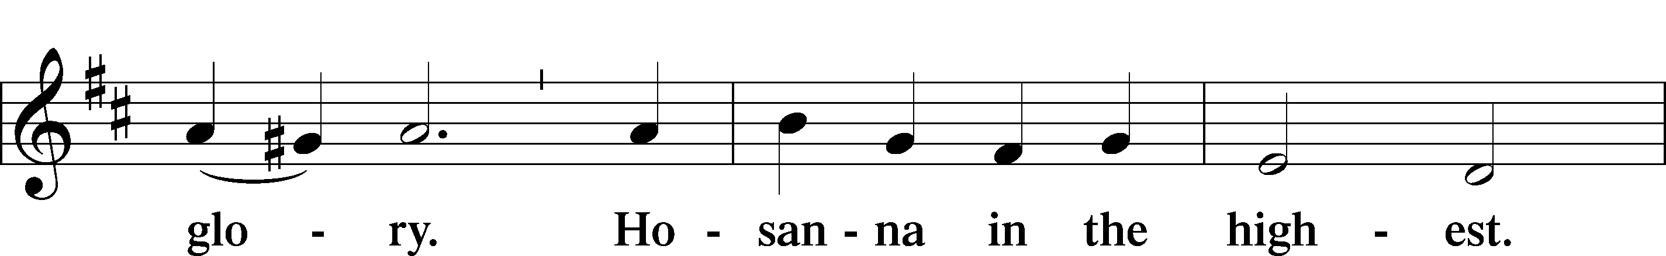
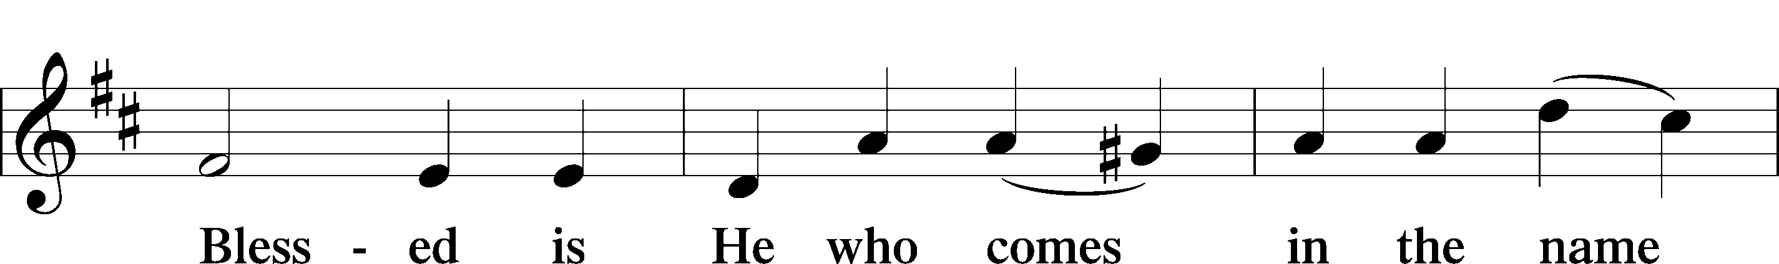
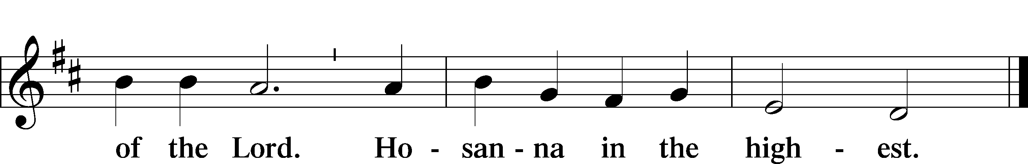

On the night he was betrayed…the Lord’s death until he comes.
CHRIST HAS DIED. CHRIST IS RISEN. CHRIST WILL COME AGAIN.

Join our prayers with those of your servants of every time and place, and unite them with the ceaseless petitions of Jesus Christ, our great High Priest, until he comes as victorious Lord of all.
THROUGH HIM, WITH HIM, IN HIM, IN THE UNITY OF THE HOLY SPIRIT, ALL HONOR AND GLORY IS YOURS, ALMIGHTY FATHER, NOW AND FOREVER. AMEN.

Remember us in your kingdom and teach us to pray:
OUR FATHER....

Agnus Dei
LSB 180
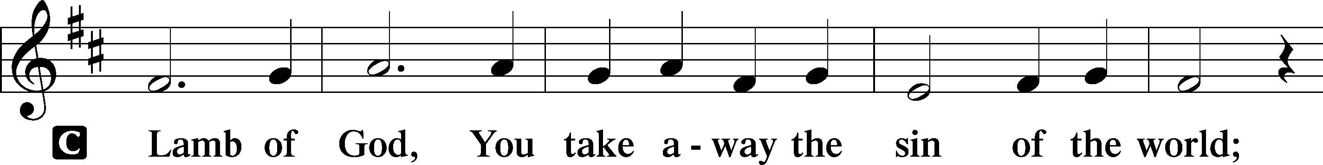
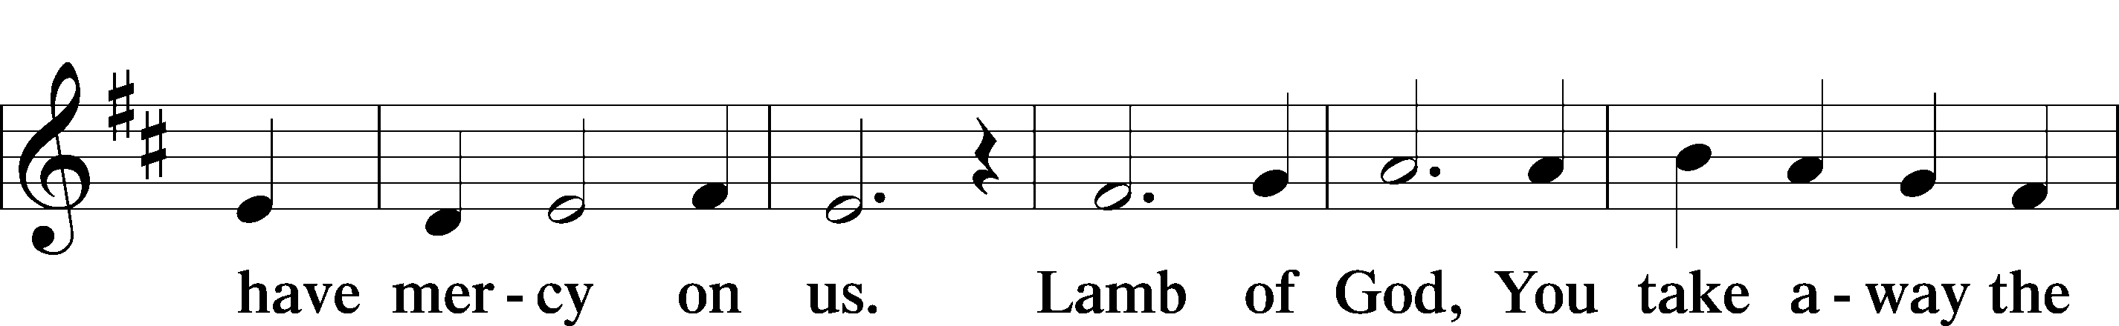
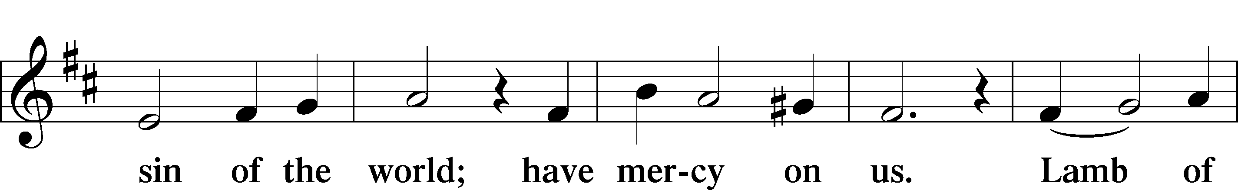
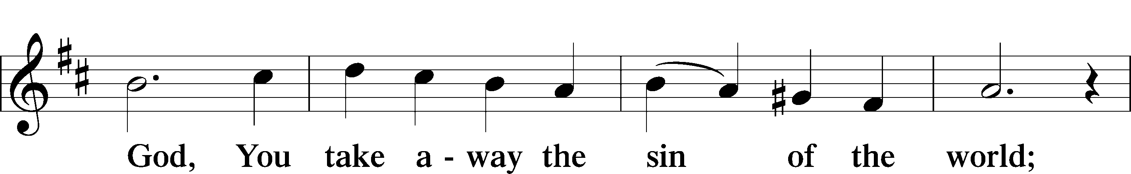
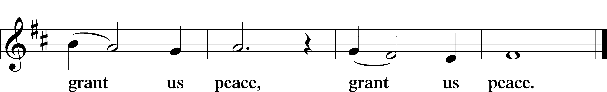

THE HOLY COMMUNION
The Thanksgiving and Closing

O give thanks to the Lord, for he is good,
AND HIS MERCY ENDURES FOREVER.

We give thanks to you, almighty God, that you have refreshed us through your holy Word, and your holy Meal. We ask that you use these gifts to your church to strengthen us; strengthen us in faith toward You and in fervent love toward one another; through Jesus Christ, your Son, our Lord, who lives and reigns with you and the Holy Spirit, one God, now and forever.
AMEN.

Almighty God bless you, the Father, the (+) Son, and the Holy Spirit.
AMEN.

469 Christ the Lord Is Risen Today
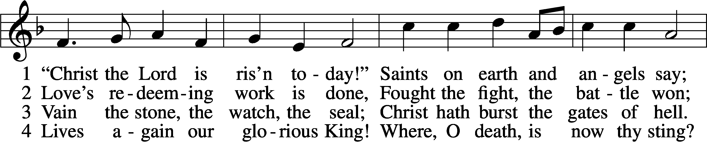
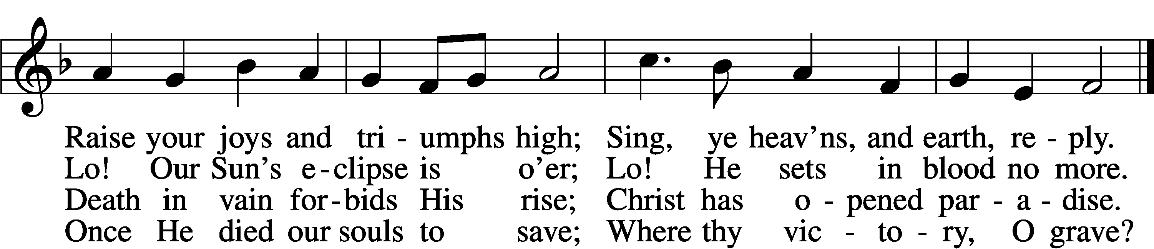

Belated Happy Birthday to Rhyan Bowie 4/25 Mitchell King 4/23

Easter Flowers are placed by Donna Schelonk and Diane Norcutt in loving memory of Diana Zwiener

JOIN US NEXT SUNDAY AS WE CONTINUE TO CELEBRATE THE RESURRECTION OF OUR LORD DURING THE GREAT FIFTY DAYS OF THE EASTER SEASON! CHRIST IS RISEN INDEED! ALLELUIA!

THIS WEEK IN THE CHURCH CALENDAR
4/29: Catherine of Siena, teacher, 1380
Catherine was born in Siena in 1346. At an early age she had visions of Christ and decided to devote her life to God. After living in a closed-off room in her family's house for three years, she emerged to involve herself in a life of doing good works. She carried on a voluminous correspondence with leaders of church and state, persuading Gregory XI to return from Avignon to Rome. She was a woman of boundless energy who dealt effectively with rulers, diplomats, and leaders of all kinds and was also loved by the common people. She died in Rome at the age of 33. Highly regarded in northern Europe, her name was retained on a number of Lutheran calendars. The Roman Catholic calendar observes her feast day on April 29, the day of her death.
5/1: St. Philip and St. James, Apostles
Philip, like Peter and Andrew, was born at Bethsaida and was one of the first disciples of Jesus. After he became an apostle, he brought Nathaniel to Jesus. Philip may have been of Greek ancestry (his name is Greek), for when "certain Greeks" wanted to see Jesus, they came to Philip. According to tradition, Philip was martyred in Phrygia. James, the son of Alphaeus, is traditionally called "the less" to distinguish him from James the brother of John, and from James the brother of the Lord. Philip and James are commemorated together because the supposed remains of the two saints were placed in the Church of the Apostles in Rome on this day in 561.
5/2: Athanasius, Bishop of Alexandria, 373
Athanasius was born in Alexandria, c. 295. At the Council of Nicaea in 325 while still a deacon, he defended the divinity of Christ, and from that time on championed Christian orthodoxy against Arianism. Consecrated Bishop of Alexandria in 328, his 45-year episcopate was one of turmoil caused by civil authorities, heretical churchmen and his own rigid temperament. By his tireless defense of the faith, he earned the title, Father of Orthodoxy. The Athanasian Creed is named for him.
5/2: Elisabeth Cecelia von Meseritz Cruciger (also spelled Kreuziger, Creutziger etc.), Poet and Hymnographer, 1535
Elisabeth von Meseritz Kreuziger or Cruciger was the first female poet and hymn writer of the Protestant Reformation. She was a friend of Martin and Katherina “Katie” Luther. Frau Cruciger was born into a noble family in Meseritz in Farther Pomerania, and while still a child entered Marienbusch Abbey, a Premonstratesian house (The Order of the Canons of Prémontré) in Treptow an der Rega. She and her family got to know the ideas of the Reformation through Johannes Bugenhagen, and converted to Lutheranism. During the persecutions of Lutherans in Poland, the family removed Elisabeth from the abbey and in 1522 moved to Wittenberg. They lived in Bugenhagen's household. In 1524 Elisabeth married the theologian Caspar Cruciger the Elder, a student and assistant of Luther. They had one daughter, Elisabeth Cruciger the Younger (who married rector Kegel and then, on his death, Luther's son Hans in Eisleben), and one son, Caspar Cruciger the Younger. She died in Wittenberg.

