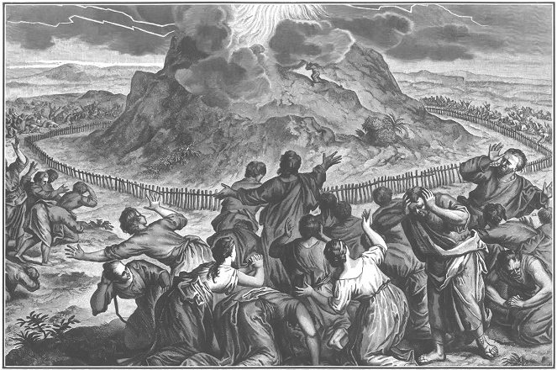
“…you are my possession…kingdom of priests…holy nation”
Moses tells the Israelites that they are called to be a priestly kingdom and a holy nation. Jesus sends out the disciples as laborers into the harvest. Jesus has made US God’s people, and sends us to tell the world the good news of God’s love in Christ.

The Third Sunday after Pentecost Proper 6 14 June 2026
Markham Lutheran Church, 3518 W. 160th St., Markham, Illinois 60428
E-mail: markhamlutheranchurch@gmail.com; Tel: 708-331-4885
Website: http://www.Markhamlutheranchurch.org/
Pastor Larry Schneekloth
Confession and Absolution

571 God Loved the World So That He Gave
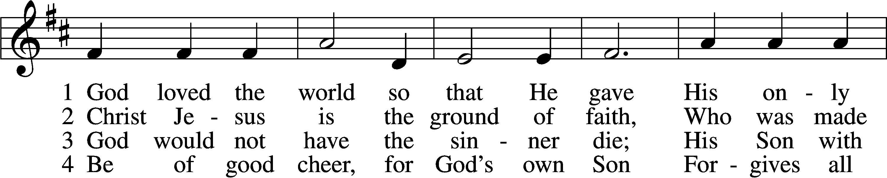
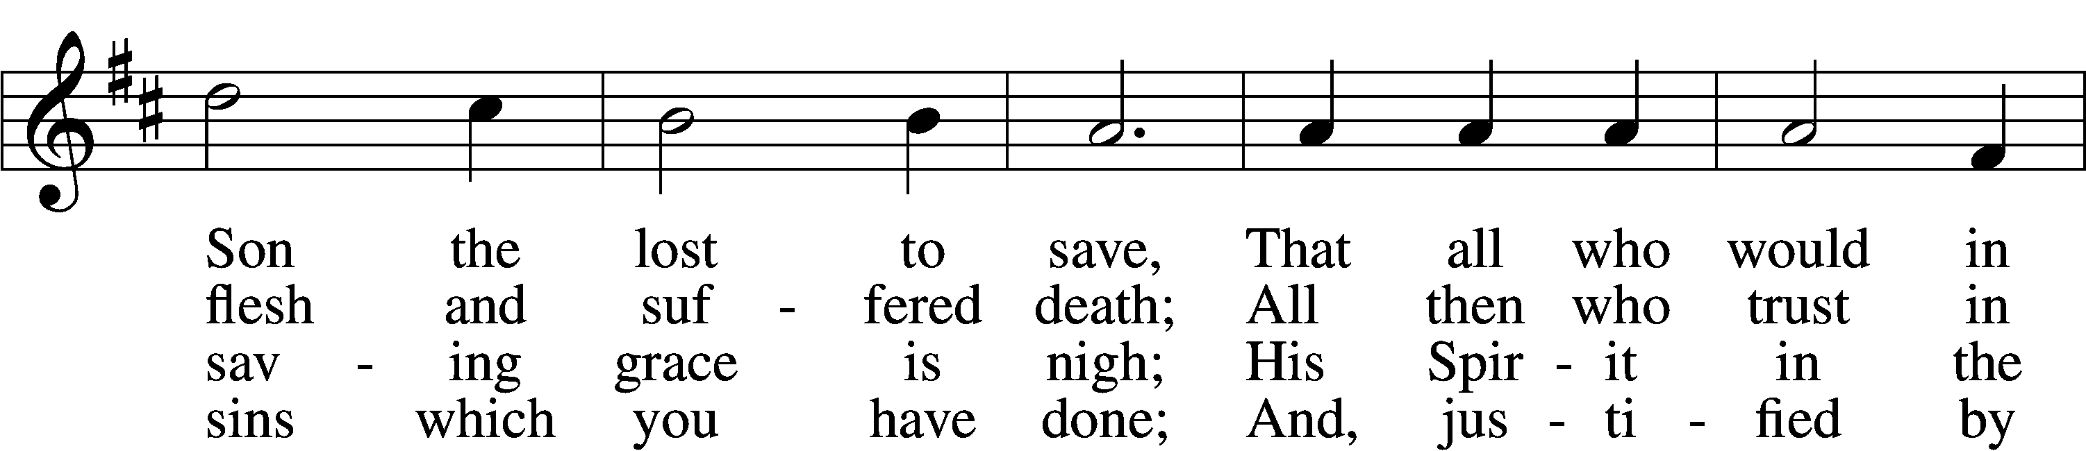
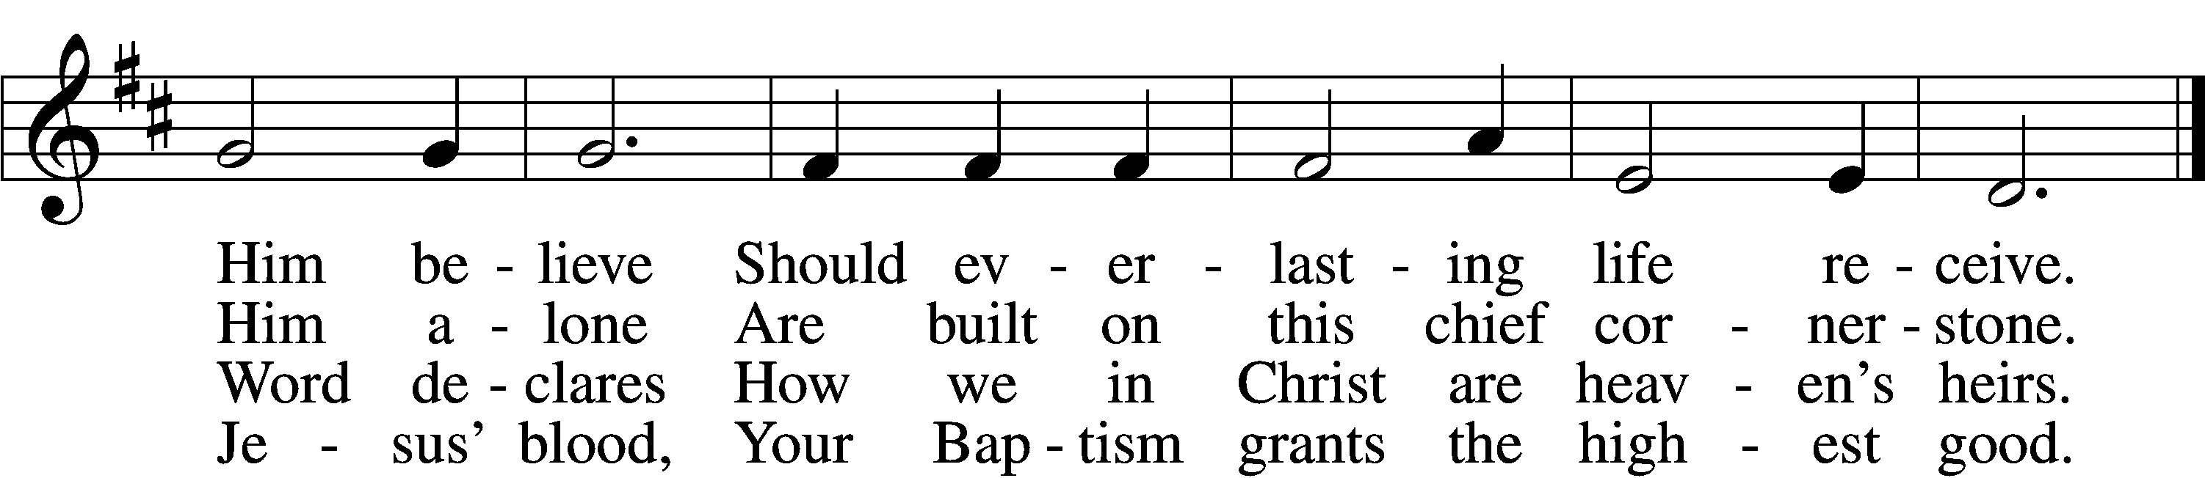

5 If you are sick, if death is near,
This truth your troubled heart can cheer:
Christ Jesus saves your soul from death;
That is the firmest ground of faith.

D 6 Glory to God the Father, Son,
And Holy Spirit, Three in One!
To You, O blessèd Trinity,
Be praise now and eternally!

Text: Heiliges Lippen- und Hertzens-Opffer, c. 1778, Stettin; tr. August Crull, 1845–1923, alt.
Tune: George J. Elvey, 1816–93
Text and tune: Public domain

The sign of the cross may be made by all in remembrance of their Baptism.

P In the name of the Father and of the T Son and of the Holy Spirit.
C Amen.

P Beloved in the Lord! Let us draw near with a true heart and confess our sins unto God our Father, beseeching Him in the name of our Lord Jesus Christ to grant us forgiveness.

P Our help is in the name of the Lord,
C who made heaven and earth.
P I said, I will confess my transgressions unto the Lord,
C and You forgave the iniquity of my sin.

Silence for reflection on God’s Word and for self-examination.

P O almighty God, merciful Father,
C I, a poor, miserable sinner, confess unto You all my sins and iniquities with which I have ever offended You and justly deserved Your temporal and eternal punishment. But I am heartily sorry for them and sincerely repent of them, and I pray You of Your boundless mercy and for the sake of the holy, innocent, bitter sufferings and death of Your beloved Son, Jesus Christ, to be gracious and merciful to me, a poor, sinful being.

P Upon this your confession, I, by virtue of my office, as a called and ordained servant of the Word, announce the grace of God unto all of you, and in the stead and by the command of my Lord Jesus Christ I declare the forgiveness of all your sins in the name of the Father and of the T Son and of the Holy Spirit.
C Amen.

Service of the Word
Kyrie LSB 186
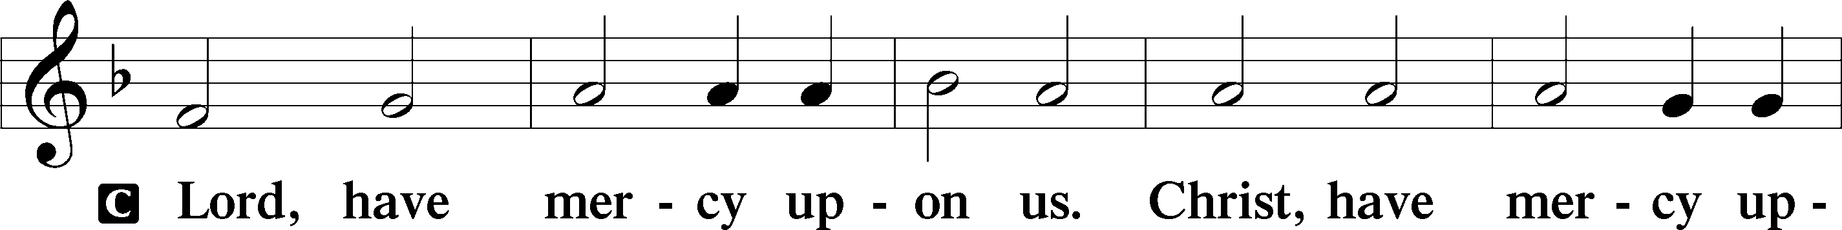
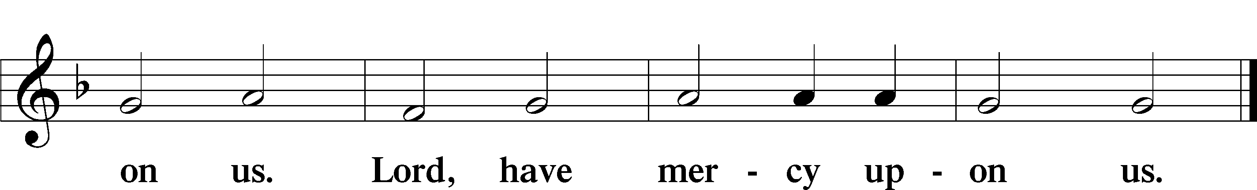

Salutation and Collect of the Day
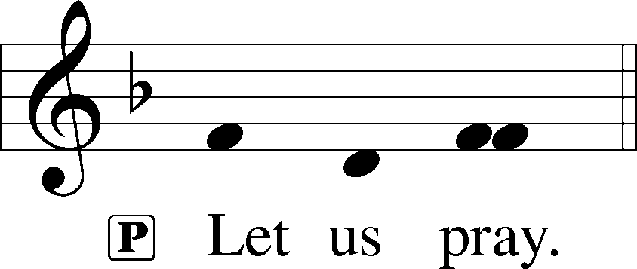

P Almighty, eternal God, in the Word of Your apostles and prophets You have proclaimed to us Your saving will. Grant us faith to believe Your promises that we may receive eternal salvation; through Jesus Christ, our Lord, who lives and reigns with You and the Holy Spirit, one God, now and forever.

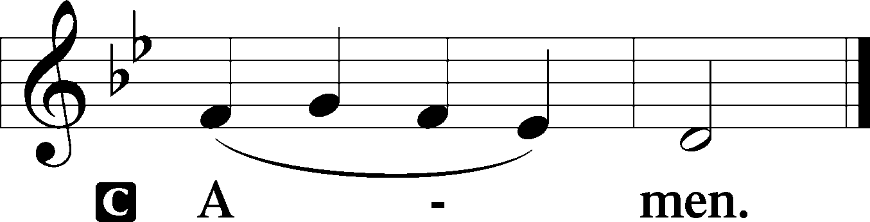

Sit

Old Testament Reading Exodus 19:2–8

At Sinai God assured Israel, “You shall be my treasured possession,” and commissioned them to serve as mediating priests for the nations. The people commit themselves completely to God’s will.

[The people of Israel] journeyed from Rephidim, entered the wilderness of Sinai, and camped in the wilderness; Israel camped there in front of the mountain. ³ Then Moses went up to God; the Lord called to him from the mountain, “Thus you shall say to the house of Jacob and tell the Israelites: ⁴ ‘You have seen what I did to the Egyptians and how I bore you on eagles’ wings and brought you to myself. ⁵ Now, therefore, if you obey my voice and keep my covenant, you shall be my treasured possession out of all the peoples. Indeed, the whole earth is mine, ⁶ but you shall be for me a priestly kingdom and a holy nation.’ These are the words that you shall speak to the Israelites.” ⁷ So Moses went, summoned the elders of the people, and set before them all these words that the Lord had commanded him. ⁸ The people all answered as one, “Everything that the Lord has spoken we will do.”
A This is the Word of the Lord.
C Thanks be to God.

Psalm 100
1Make a joyful noise to the Lord, | all the earth!*
2Serve the Lord with gladness! Come into his presence with | singing!
3KNOW THAT THE LORD, | HE IS GOD!*
IT IS HE WHO MADE US, AND WE ARE HIS; WE ARE HIS PEOPLE, AND THE SHEEP OF HIS | PASTURE.
4Enter his gates with thanksgiving, and his | courts with praise!*
Give thanks to him; | bless his name!
5FOR THE LORD IS GOOD; HIS STEADFAST LOVE ENDURES FOR- | EVER,*
AND HIS FAITHFULNESS TO ALL GENER- | ATIONS.

Epistle Romans 5:1-8

We are no longer God’s enemies but have peace with God because we were brought into a right relationship with God through Christ’s death.

Therefore, since we are justified by faith, we have peace with God through our Lord Jesus Christ, ² through whom we have obtained access to this grace in which we stand, and we boast in our hope of sharing the glory of God. ³ And not only that, but we also boast in our afflictions, knowing that affliction produces endurance, ⁴ and endurance produces character, and character produces hope, ⁵ and hope does not put us to shame, because God’s love has been poured into our hearts through the Holy Spirit that has been given to us. ⁶ For while we were still weak, at the right time Christ died for the ungodly. ⁷ Indeed, rarely will anyone die for a righteous person—though perhaps for a good person someone might actually dare to die. ⁸ But God proves his love for us in that while we still were sinners Christ died for us.
A This is the Word of the Lord.
C Thanks be to God.

Holy Gospel Matthew 9:35—10:8,16-22
P The Holy Gospel according to St. Matthew.
C Glory to you, O Lord.
Then Jesus went about all the cities and villages, teaching in their synagogues and proclaiming the good news of the kingdom and curing every disease and every sickness. ³⁶ When he saw the crowds, he had compassion for them because they were harassed and helpless, like sheep without a shepherd. ³⁷ Then he said to his disciples, “The harvest is plentiful, but the laborers are few; ³⁸ therefore ask the Lord of the harvest to send out laborers into his harvest.” 10 Then Jesus summoned his twelve disciples and gave them authority over unclean spirits, to cast them out, and to cure every disease and every sickness. ² These are the names of the twelve apostles: first, Simon, also known as Peter, and his brother Andrew; James son of Zebedee and his brother John; ³ Philip and Bartholomew; Thomas and Matthew the tax collector; James son of Alphaeus and Thaddaeus; ⁴ Simon the Cananaean and Judas Iscariot, the one who betrayed him. ⁵ These twelve Jesus sent out with the following instructions: “Do not take a road leading to gentiles, and do not enter a Samaritan town, ⁶ but go rather to the lost sheep of the house of Israel. ⁷ As you go, proclaim the good news, ‘The kingdom of heaven has come near.’ ⁸ Cure the sick; raise the dead; cleanse those with a skin disease; cast out demons.…¹⁶ “I am sending you out like sheep into the midst of
wolves, so be wise as serpents and innocent as doves. ¹⁷ Beware of them, for they will hand you over to councils and flog you in their synagogues, ¹⁸ and you will be dragged before governors and kings because of me, as a testimony to them and the gentiles. ¹⁹ When they hand you over, do not worry about how you are to speak or what you are to say, for what you are to say will be given to you at that time, ²⁰ for it is not you who speak, but the Spirit of your Father speaking through you. ²¹ Sibling will betray sibling to death and a father his child, and children will rise against parents and have them put to death, ²² and you will be hated by all because of my name. But the one who endures to the end will be saved.
P This is the Gospel of the Lord.
C Praise to you, Lord Jesus Christ.

The Homily

Nicene Creed

We believe in one God, the Father, the Almighty, maker of heaven and earth, of all that is, seen and unseen.

We believe in one Lord, Jesus Christ, the only Son of God, eternally begotten of the Father, God from God, Light from Light, true God from true God, begotten, not made, of one Being with the Father; through him all things were made. For us and for our salvation he came down from heaven, was incarnate of the Holy Spirit and the Virgin Mary and became truly human. For our sake he was crucified under Pontius Pilate; he suffered death and was buried. On the third day he rose again in accordance with the Scriptures; he ascended into heaven and is seated at the right hand of the Father. He will come again in glory to judge the living and the dead, and his kingdom will have no end.

We believe in the Holy Spirit, the Lord, the giver of life, who proceeds from the Father and the Son, who with the Father and the Son is worshiped and glorified, who has spoken through the prophets. We believe in one holy catholic and apostolic Church. We acknowledge one baptism for the forgiveness of sins. We look for the resurrection of the dead, and the ₍₊₎ life of the world to come. Amen.
The Prayer of the Church
...Lord, in your mercy,
HEAR OUR PRAYER.

(Last petition:) Into your hands we commend ourselves, and all for whom we pray, trusting in your mercy, through Jesus Christ our Lord.
AMEN.

646 Church of God, Elect and Glorious
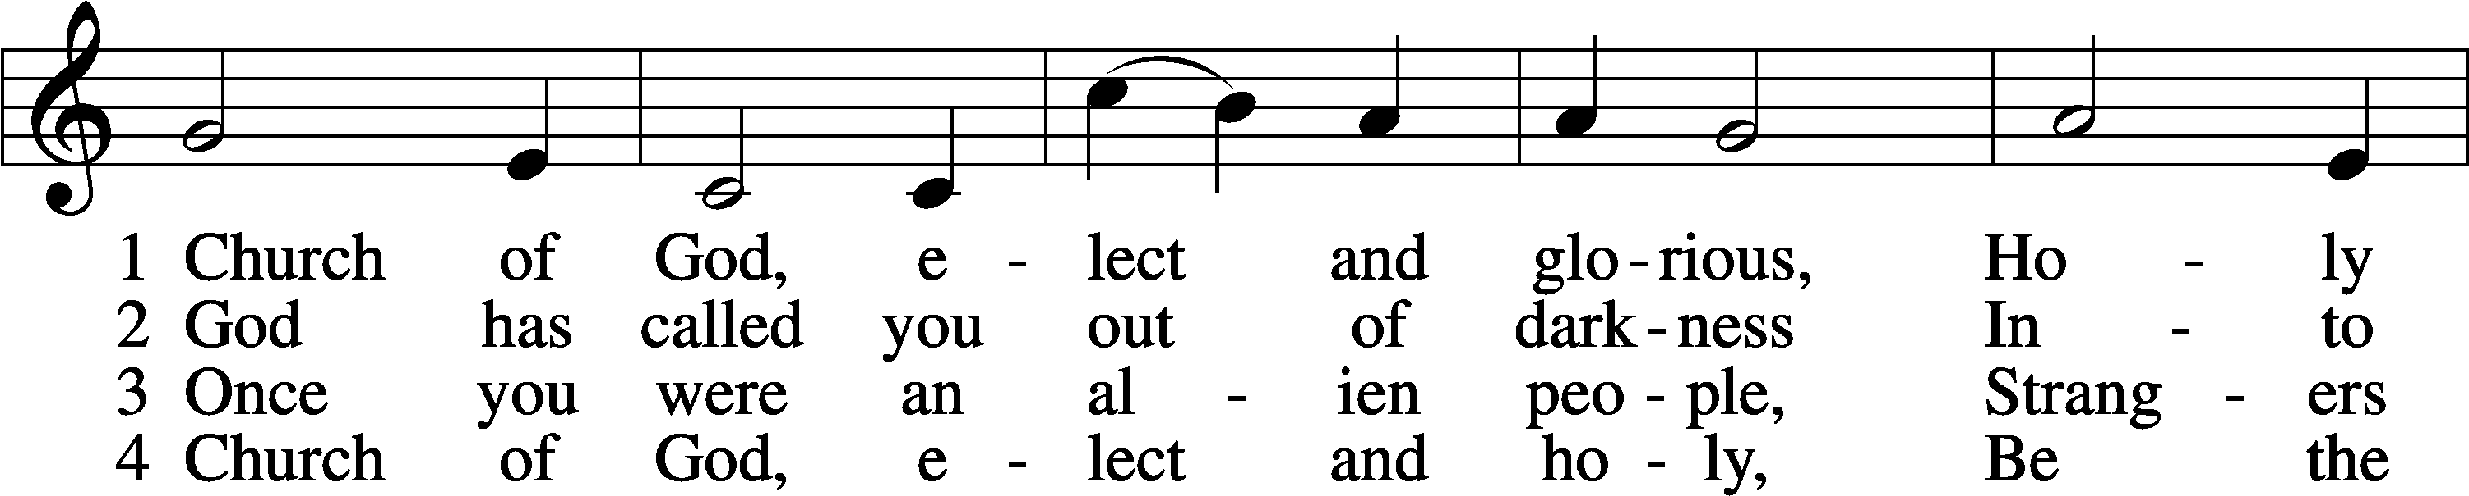
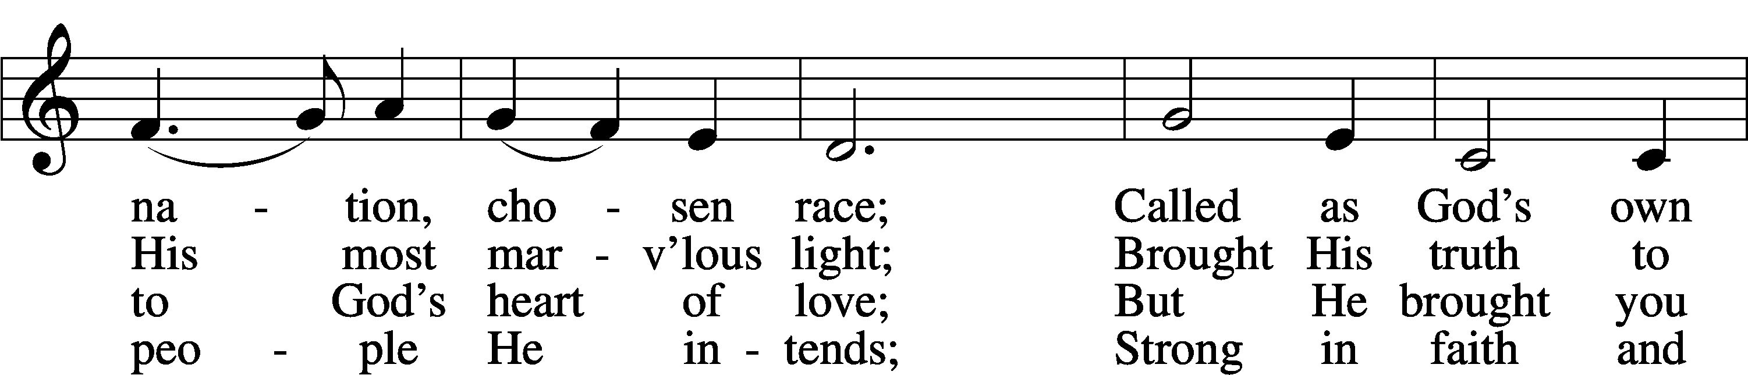
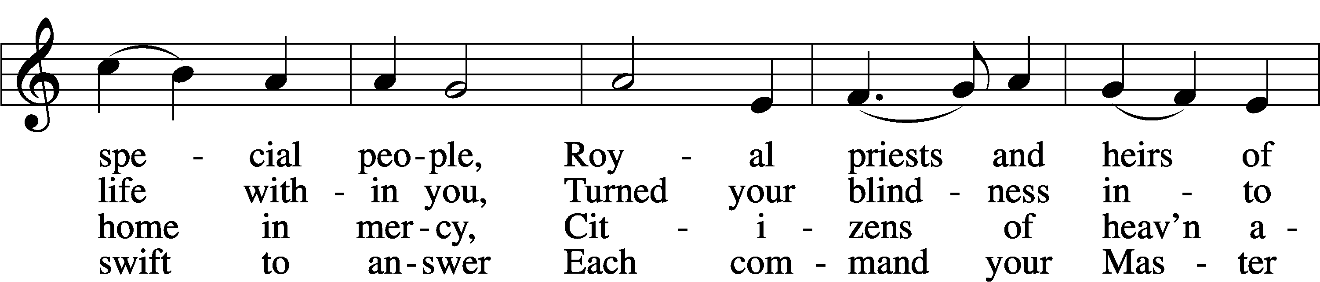
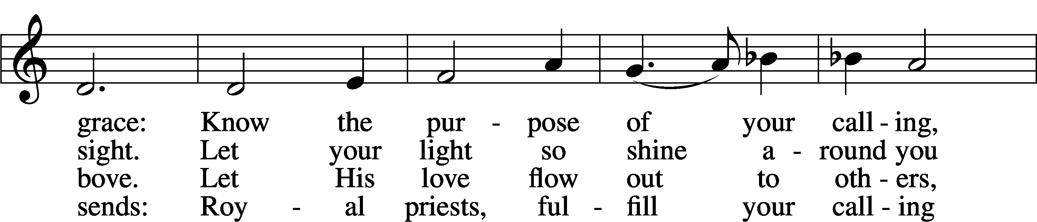
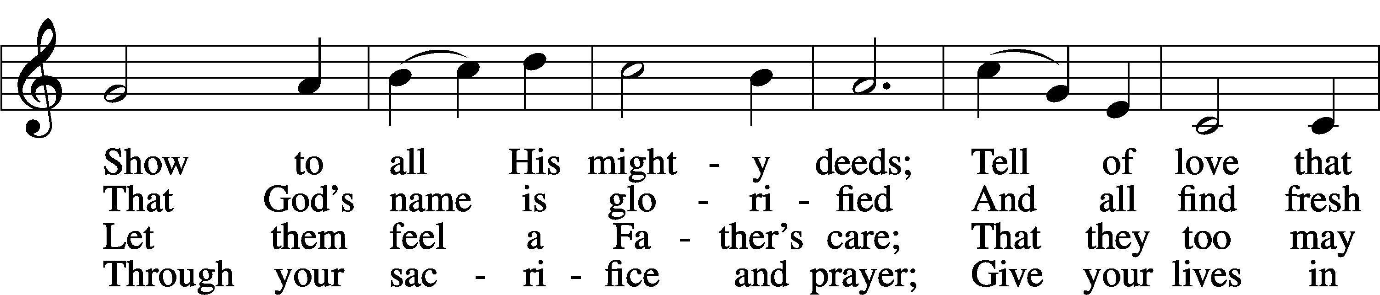
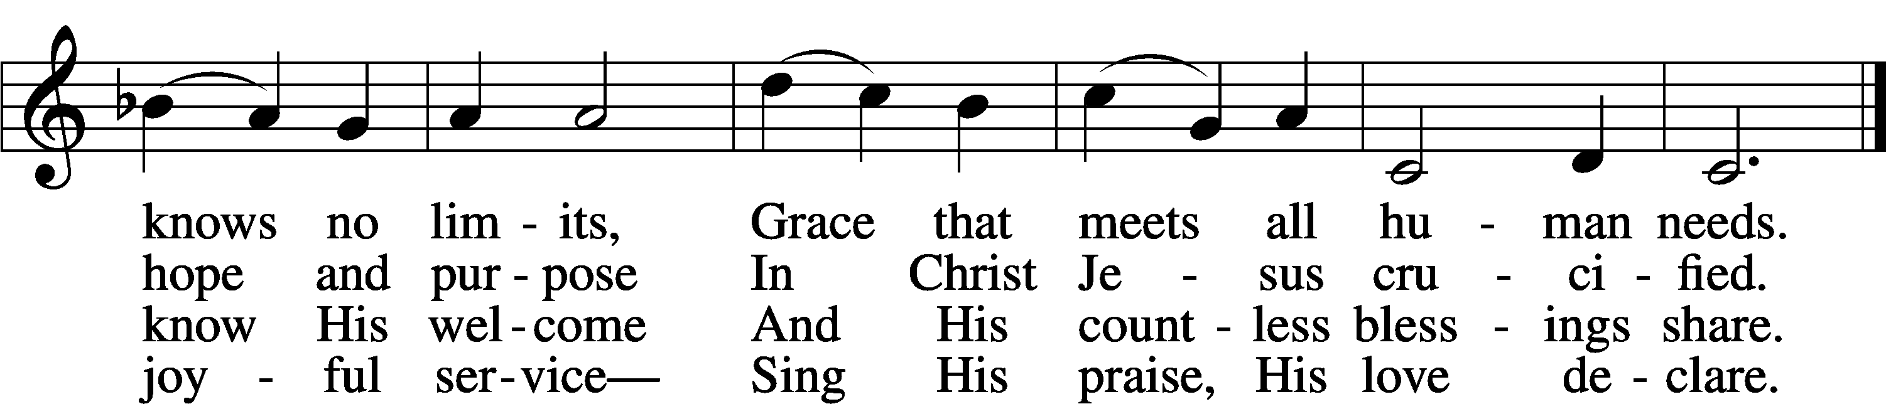
Text: James Edward Seddon, 1915–83
Tune: Cyril V. Taylor, 1907–92
Text: © 1982 The Jubilate Group, admin. Hope Publishing Co. Used by permission: LSB Hymn License no. 110001341
Tune: © 1942, renewed 1970 Hope Publishing Co. Used by permission: LSB Hymn License no. 110001341

Service of the Sacrament
Lord be with you.
AND ALSO WITH YOU.
Lift up your hearts.
WE LIFT THEM TO THE LORD.
Let us give thanks to the Lord our God.
IT IS RIGHT TO GIVE GOD THANKS AND PRAISE.

It is indeed right and salutary that we should at all times and in all places offer thanks and praise to you, O Lord, holy Father, through Christ our Lord; who on this first day of the week overcame death and the grave, and by his glorious resurrection opened to us the way of everlasting life. And so, with the church on earth and the hosts of heaven, we praise your name, and join their unending hymn:

Sanctus LSB 195
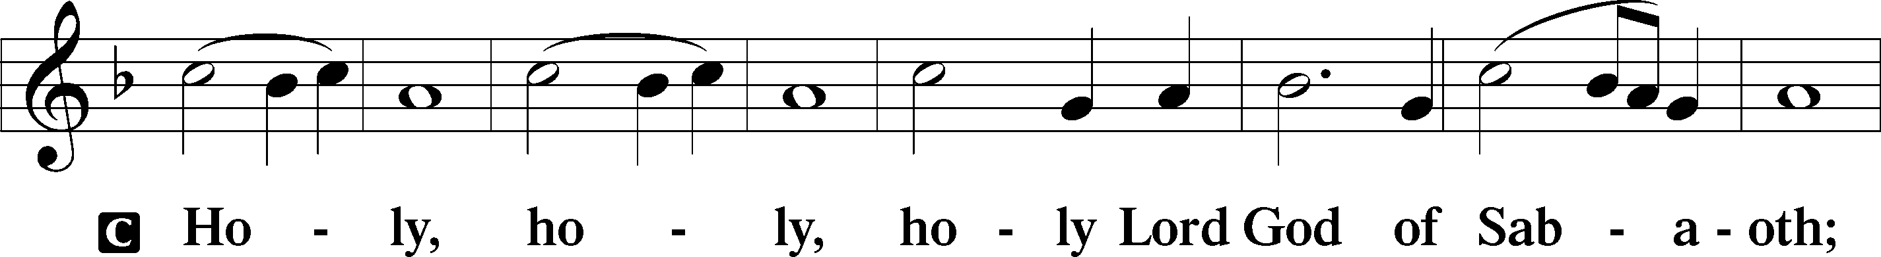
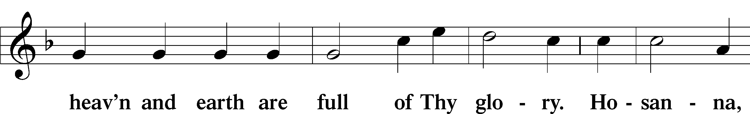
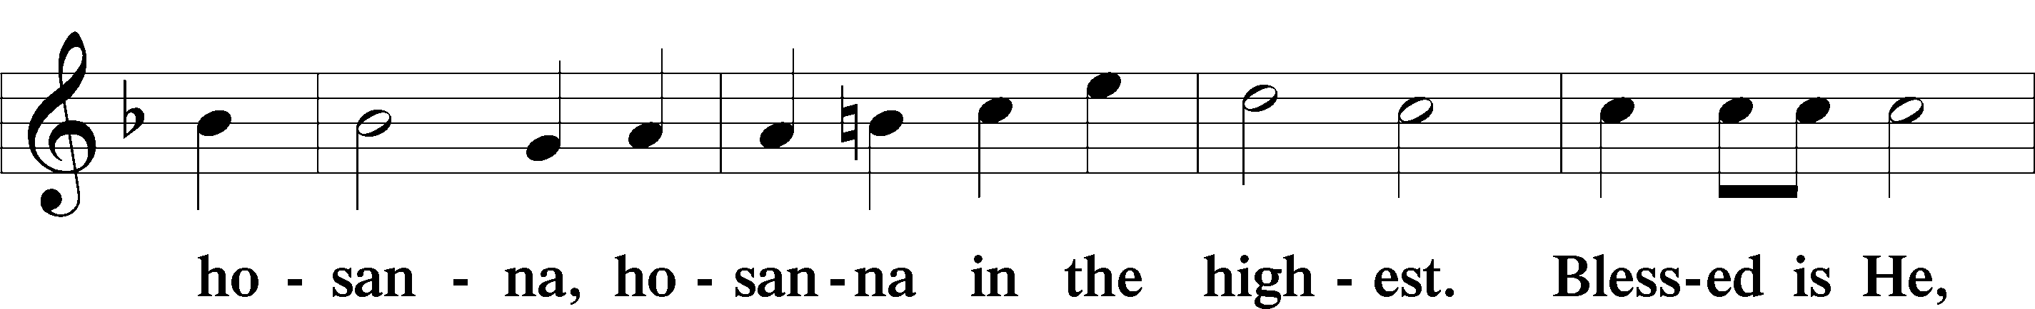
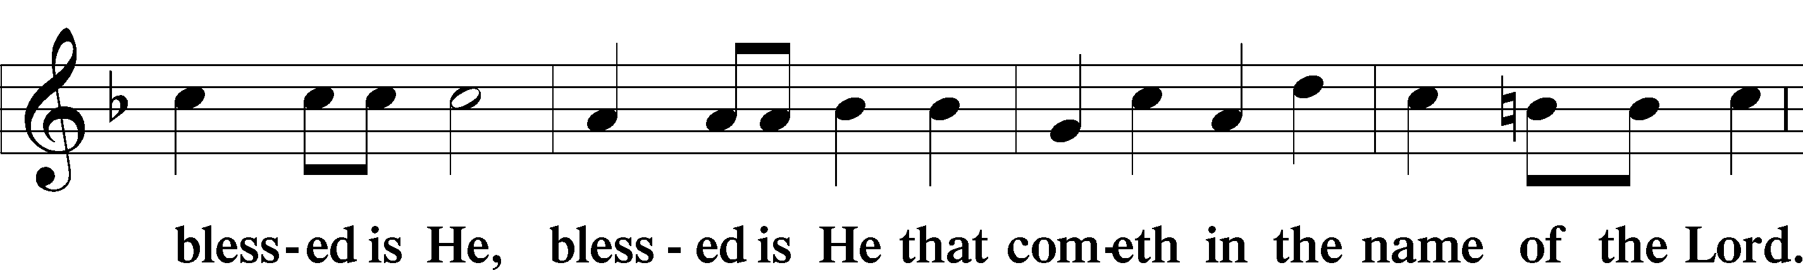
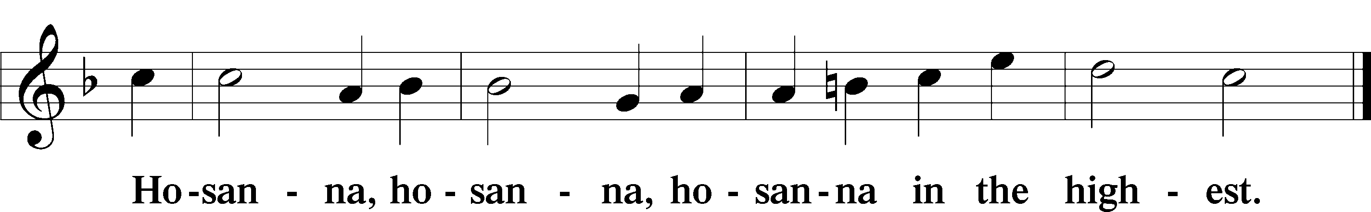

Our Lord Jesus Christ…
As often as we eat this bread, and drink from his cup, we proclaim the Lord’s death until he comes.
CHRIST HAS DIED. CHRIST IS RISEN. CHRIST WILL COME AGAIN.

Join our prayers with those of your servants of every time and place, and unite them with the ceaseless petitions of Jesus Christ, our great High Priest, until he comes as victorious Lord of all.
THROUGH HIM, WITH HIM, IN HIM, IN THE UNITY OF HOLY SPIRIT, ALL HONOR AND GLORY IS YOURS, ALMIGHTY FATHER, NOW AND FOREVER. AMEN.

In the words of our Lord we pray: OUR FATHER....

THE HOLY COMMUNION

The Thanksgiving and Dismissal
O give thanks to the Lord, for he is good.
AND HIS MERCY ENDURES FOREVER.

We give you thanks, O Father, for the food with which you have fed us this day: Your holy word, and the Bread and Wine of the Holy Communion. We ask that you continue to strengthen us in our faith in you, and in our fervent love for one another; through Christ our Lord.
AMEN.

Almighty God bless you, the Father, the Son, and the Holy Spirit.
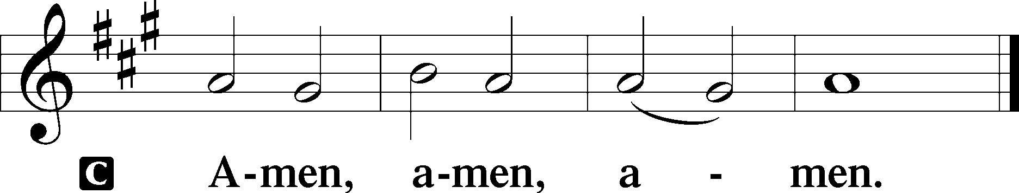

Hymn 920 Forth in the Peace of Christ We Go (over)

THIS WEEK IN THE CHURCH CALENDAR
6/14: Basil the Great, Bishop, 379; Gregory of Nazianzus, Bishop, 389; and Gregory of Nyssa, Bishop, 385
This day commemorates the three Cappadocian fathers. Basil (born c 330) was educated in the best pagan and Christian culture of his day. He decided to become a monk and settled as a hermit by the river Iris, traveling on preaching missions with Gregory of Nazianzus. He was called (c 364) by his bishop to defend orthodoxy against the Arian emperor Valens. In 370 Basil succeeded the bishop in the See of Caesarea. In addition to his eloquence and learning, Basil was renowned for his great personal holiness and is regarded as the father of Eastern communal monasticism. Monastic life in the Orthodox church is still based upon the principles which he laid down. He died at Caesarea on January 1, 379, but his traditional feast day is June 14. Gregory of Nazianzus, called "The Theologian" in the East, was born in 329. He studied in Alexandria and Athens, became a monk, was ordained against his will, and in 372 was consecrated Bishop of Sasima. He never visited his see but remained in Nazianzus as suffragan to his father. In 379 he was called to Constantinople and, by his preaching, restored the Nicene faith. He was appointed Bishop of Constantinople, but resigned to retire to Nazianzus and then to his estate where he died. Gregory of Nyssa, a younger brother of Basil, was born c. 330. He left his occupation as rhetorician to enter a monastery founded by his brother. He was consecrated Bishop of Nyssa, c. 371, and was deposed for a time by the Arians. An eloquent champion of the Nicene faith, he traveled considerably and was in demand as a preacher. He was a thinker and theologian of great originality and learning.

920 Forth in the Peace of Christ We Go
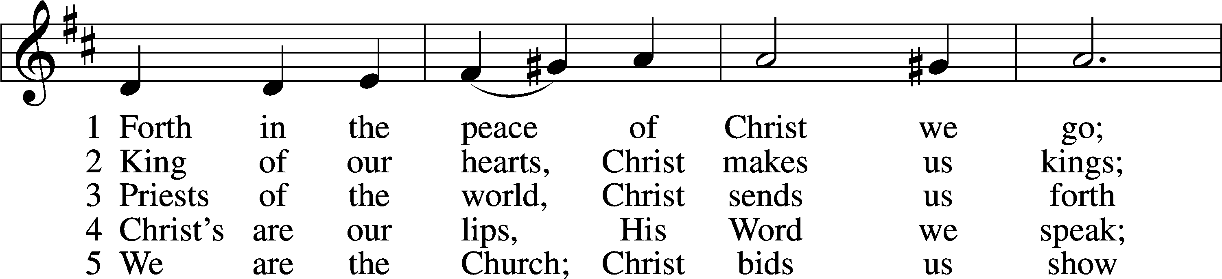
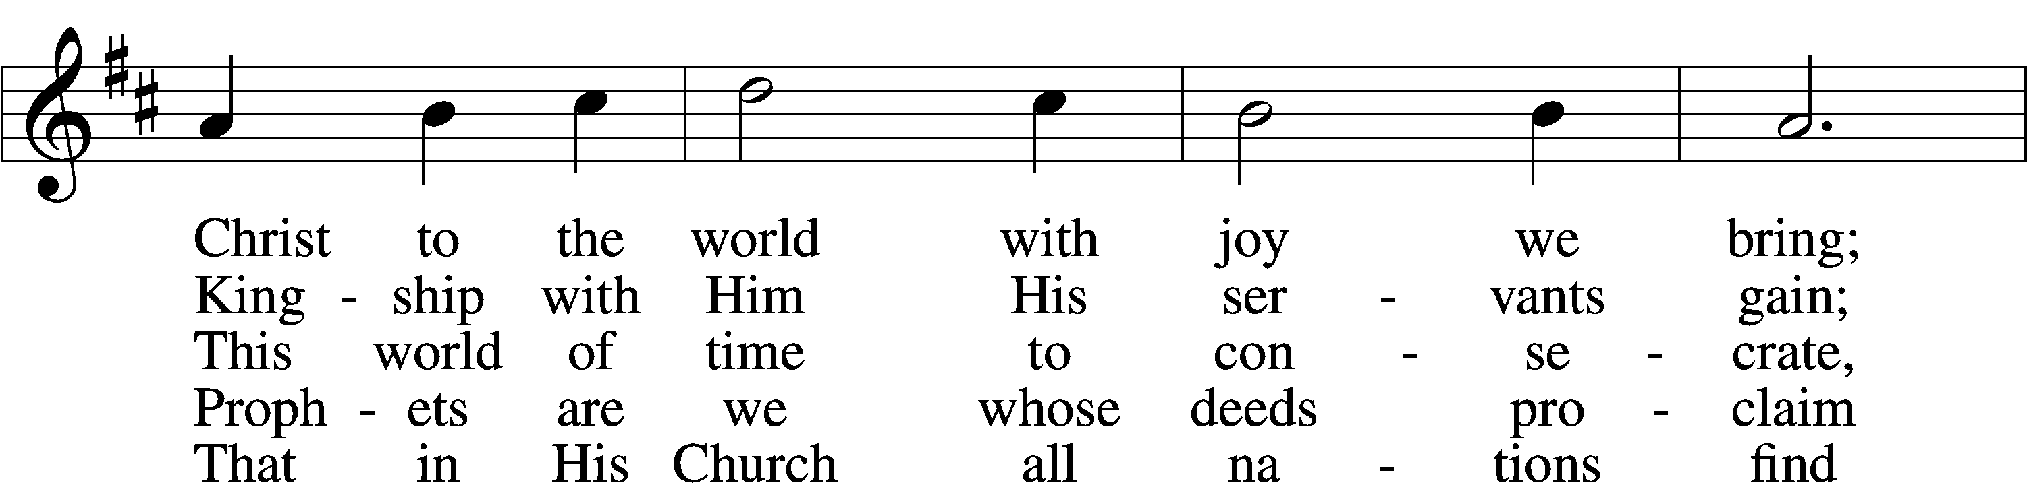
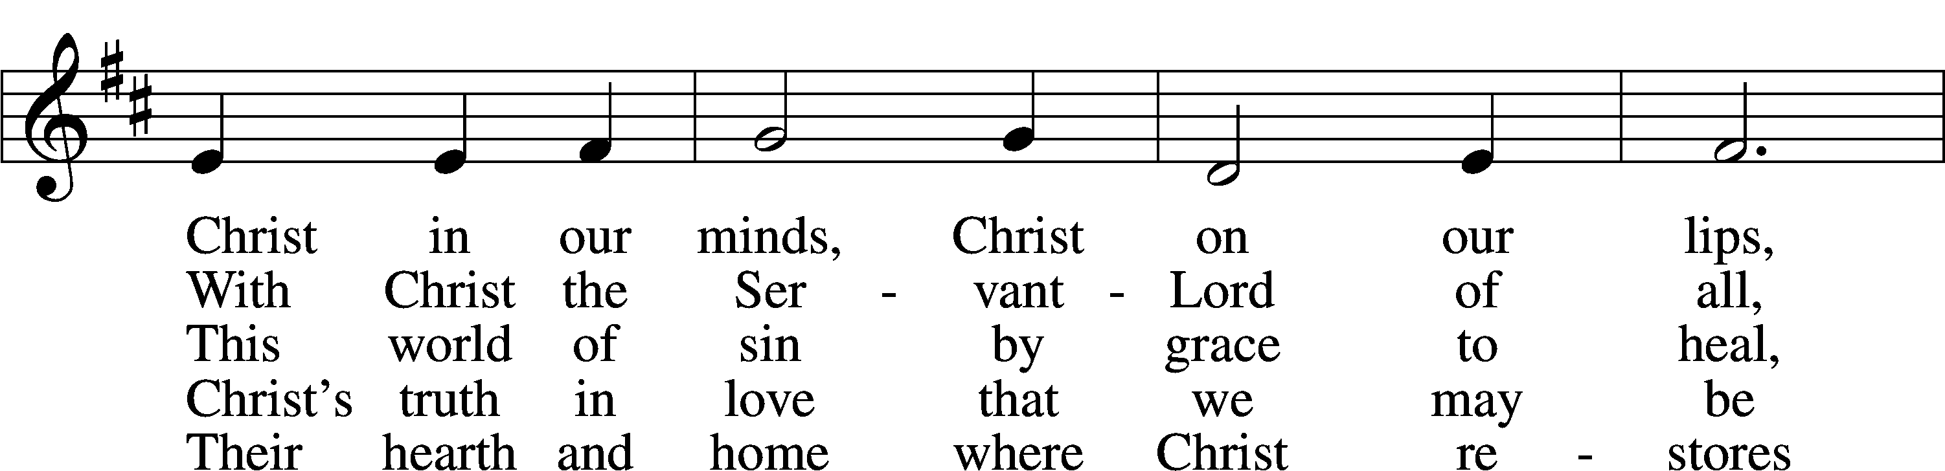
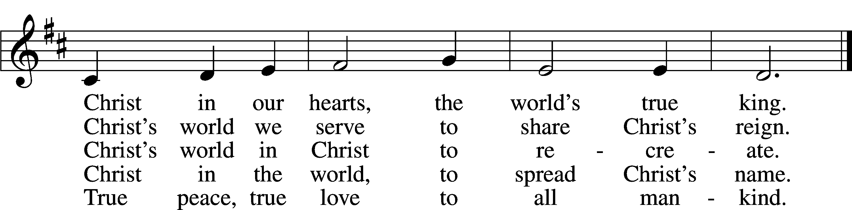

Text: James Quinn, 1919–2010 Tune: Georg Joseph, 17th cent., adapt.
Text: © 1969, 1987 OCP Publications. Used by permission: LSB Hymn License no. 110001341 Tune: Public domain

Happy Birthday this week to: Phyllis King 6/17
Jack Genius 6/17
Chaplain Paul Haberstock 6/20

Acknowledgments
Divine Service, Setting Three from Lutheran Service Book
Created by Lutheran Service Builder © 2026 Concordia Publishing House.

